­

Technology

MLB

5432 Ann St

Terrapin, TX 54321

555.543.5432 ph

555.543.5433 fax

www.mlbtech/booksmarts.org

Technology

MLB

Book Smarts Smarts

Book Smarts

“This creation is game-changing for anyone who is over whelmed and has a busy schedule, you never have to feel like there isn’t enough time to get your work done” – Chandler Bing

“This new product is a god sent” – Sabrina Scott

“I love reading, but I never had the time. I am a professor at NYU but now I can read whatever, whenever I want” – Dr. Ross Gellar

“I love being abel to read various works from all different cultures. Since I am a college student, I never have time to travel and learn about other cultrue. However, with the adio translater, now I can.” – Pheobe Buffay

TESTIMONIALS

Call MLB Tech today to get your revolutionary glasses today to lead a more productive and stress-free life!

Call: 1-800-555-0125

The first 200 buyers will receive a 20% discount off your first pair and lifetime warranty!

MLB Tech Corporstion

Terrapin, Texas

Say Good-bye to All-Nighters and Cram Sessions

Book Smarts: These glasses are able to pass visual information through the optic nerves exponentially faster than normal. With these glasses, one can simply flip through the pages of any book and instantly process the information in their brain as if they read the entire thing!



YOUR EXPERIENCE

Customers will be able expands their education while also having time for a job and a social life. These new glasses will make it possible to live life as they please instead of spending hours behind a book.

TESTIMONIALS

“I am a single working mom with 3 kids. Reading wasnever an option before. Now, I was able to finish my masters degree and read for pleaure with book smarts.” – Rachel Green

“I got book smarts because I wanted to study abroad and I wanted to work on my spanish. Now, I am almost fluent.” Monica Gellar

WE’VE WORKED WITH A DIVERSE CUSTOMER BASE. WOULD YOU LIKE TO TRY BOOK SMARTS TODAY?

1-800-555-0125

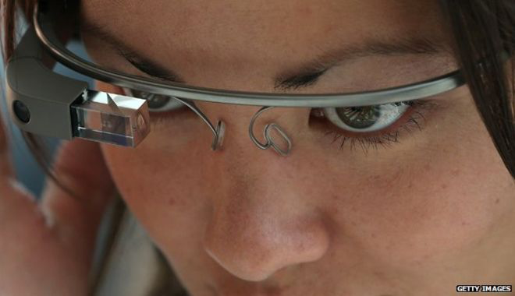

THIS DEVICE

Not only, can you read exponentially fast, you can also read in any other language. With the audio translator feature, it will translate books in other languages so you don’t have to limit yourself to just your language. You are able to learn other cultures without having to travel.

PRICING

Glasses: $1,000

Glasses with translator: $1,100

APPLICATION MANAGEMENT

These glasses come with a lifetime warrenty. If they break or mess up in any way, you can pay $100 to receive a brand new pair. Just send yours in and we will send you another pair.

HOW IT WORKS

These glasses have a special chip that analyzes the information on the pages. once the chip has the information, it is immediately transferred directly throuhg the eyes into the optic nerve that leads to the brain. the whole process happends within milliseconds.