*The following apps or programs may be useful for organization and task management.*
https://www.google.com/keep/ Google Keep Keep works on your phone, tablet and computer. Everything you add to Keep syncs across your devices so your important stuff is always with you. Add notes, lists, photos, and audio to Keep. Try Google Keep on the web at http://keep.google.com and on your Android phone by downloading the app at http://g.co/keep. All it requires is a Google account. The amount of storage space you get in Keep is dependent on your Google Drive storage, which is 15GB by default.
https://www.any.do/ Wherever you are, take your to do list with you. Access Any.do on mobile, laptop, desktop, tablet and even your watch! Your tasks are automatically synced across all of your devices. Free
https://habitica.com/ Habitica is a free habit building and productivity app that treats your real like like a game. With in-game rewards and punishments to motivate you and a strong social network to inspire you. Habitica can help you achieve your goals.
https://www.mystudylife.com/ With our beautifully designed apps available on iPhone, Android, Windows 8, Windows Phone and the web, My Study Life works on all of your devices. Written from the ground up for schools, My Study Life, supports week and day rotation timetables as well as traditional weekly schedules. Get notified about incomplete tasks and upcoming classes and exams with our mobile apps.

Excel student monthly planner: If you have Office 365 Excel, there are weekly and monthly planner templates to download.
*The following apps help manage passwords*
www.lastpass.com Remembers all your passwords across all your devices. There is a free version or upgrade for a fee.
www.dashlane.com Dashlane fills all your passwords, payments, and personal details wherever you need them, across the web, on any device. There is a free version or upgrade for a fee.

*The following apps or programs alone, with a group or sharing notes may be useful when studying*

https://evernote.com/basic A place for your notes, lists, reminders, etc… and you can share. A free basic app or upgrade for a fee.

https://quizlet.com/latest Quizlet is a free app for making flash cards and online quizzes, which can be used privately or shared publicly

https://www.brainscape.com/ Create, share, and study unlimited flashcards. Basic app is free; paid upgrade. Use ready-made flashcards or create your own.

Foreign Language: https://www.duolingo.com/ DuoLingo is a language-learning website and mobile app. Fees may apply to web version.

Safety & Physical Well Being:
www.circleof6app.com Need help getting home? Need an interruption? Two taps lets your circle know where you are and how they can help. Circle of 6 app for iPhone and Android makes it quick and easy to reach the 6 people you choose https://www.youtube.com/watch?v=WWBc74LdWcs 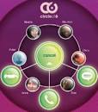

https://www.myfitnesspal.com/ With a free account, you can track food and calories, activity, and weight.
Upgrades with paid subscriptions.
https://www.headspace.com/ Available on iOS and Android for free with the Basics pack. The free version of the app focuses on the basics of meditation and mindfulness, perfect for beginners.
eBooks: Some free, others there is a fee
Open Library: https://openlibrary.org/ How does borrowing a book work through Open Library? The Internet Archive and participating libraries have selected digitized books from their collections that are available to be borrowed by one patron at a time from anywhere in the world for free.

Audible: https://www.audible.com/ Listen to 3 audiobooks/month for $14.95/month: 1 Audiobook + 2 Audible Originals. Use your smartphone, tablet, Amazon device or computer.

Scribd: https://www.scribd.com/ Scribd readers can view and read all such documents and books from their favorite platforms like Android, iOS, Windows, Mac. There is a subscription fee.

Red shelf responds: https://www.about.redshelf.com/redshelfresponds and https://solve.redshop.com are websites to answer specific questions and learn about the program. Students may borrow up to 7 eBooks, and access will be supported until May 25. Standard checkout fees and process beyond the 7 books. After May 25, standards fees apply.

Project Gutenberg: https://www.gutenberg.org/ Project Gutenberg is a library of over 60,000 free eBooks. Choose among free epub and Kindle eBooks, download them or read them online. You will find the world's great literature here, with focus on older works for which U.S. copyright has expired.

Vital source: https://www.vitalsource.com/ VitalSource Bookshelf is an ebook platform that allows you to access course materials whenever and wherever you choose--laptop, desktop or mobile device. You can download texts directly or access them via your browser. Students can rent or buy your ebooks. This is not a free source.

Cengage: https://www.cengage.com/ The new offer, called Cengage Unlimited, will give students access to more than 20,000 Cengage products across 70 disciplines and 675 course areas for $119.99 a semester. https://www.youtube.com/watch?v=ZCb2Dglirac

Video Chats:
https://zoom.us/ Zoom is the leader in modern enterprise video communications, with an easy, reliable cloud platform for video and audio conferencing, chat, and webinars.

https://products.office.com/en-us/microsoft-teams/download-app Microsoft Teams is a chat-based collaboration tool that provides global, remote, and dispersed teams with the ability to work together and share information via a common space. You can utilize cool features like document collaboration, one-on-one chat, team chat, and more. Connect on Teams anywhere with Windows, Mac, iOS and Android devices.

https://hangouts.google.com/ Google Hangouts is a unified communications service that allows members to initiate and participate in text, voice or video chats, either one-on-one or in a group. Hangouts are built into Google+ and Gmail, and mobile Hangouts apps are available for iOS and Android devices.

Group Chats:
https://play.google.com/store/apps/details?id=com.whatsapp&hl=en_US WhatsApp is a messaging app that lets users text, chat, and share media, including voice messages and video, with individuals or groups. WhatsApp Messenger is a FREE messaging app available for Android and other smartphones. WhatsApp uses your phone's Internet connection.
https://groupme.com/en-US/ GroupMe is a messaging app that lets users send direct messages and group messages from mobile devices without message limits or fees. You can also use the app as a one-stop shop for interacting with your friends, from scheduling events to sending each other money. GroupMe doesn't provide end-to-end encryption, which is a technique that uses cryptographic keys to protect content from unauthorized eyes. GroupMe messaging works by associating a number with each group. Users can text or push messages to that number, communicating with the whole group.

Writing:
https://www.grammarly.com/ Grammarly-Advanced Grammar Rules, Contextual Spell Checker, Vocabulary Enhancement, Plagiarism Checker, Corrects Writing Mistakes. These supported platforms include; Apple, Android, Chrome, Safari, Firefox, Internet Explorer, Microsoft Office & Word, Windows and Mac. Grammarly is available for Free but, it also has Premium versions.

Vision:
https://www.nvaccess.org/ NVDA-Non Visual Desktop Access NVDA only works on PCs running the Microsoft Windows operating system. Windows 7 and later are supported
Magnifying Glass on the computer-Built in accessibility
To open Magnifier using touch or a mouse:
- Swipe in from the right edge of the screen, tap Settings, and then tap Change PC settings.
- Tap or click Ease of Access, tap or click Magnifier, and then move the slider under Magnifier to turn it on.
- Magnifier will open in Full-screen view unless you change the settings.
** Settings, adjust the accessibility settings (magnifier) For short cuts, just google and you will see many options.
How do you magnify on a Mac?
Click “Use keyboard shortcuts to zoom,” then start zooming by pressing COMMAND + OPTION + 8. To zoom in, press COMMAND + OPTION + “=” (equal sign), or zoom out by pressing
COMMAND + OPTION + “-” (minus sign). To turn zooming off, press COMMAND + OPTION + 8 again. You can also use the trackpad to zoom the screen. https://www.youtube.com/watch?v=veYJ7E_VKtE

Inspiration:
https://www.ted.com/ TED (Technology, Entertainment, Design) are inspiring talks from experts in different fields. TED is an American media organization that posts talks online for free.

Text to Speech: downloads for your computer, laptop or phone
https://balabolka.en.softonic.com/ Balabolka is a Text-To-Speech (TTS) program for Windows. All computer voices installed on your system are available to Balabolka. The on-screen text can be saved as a WAV, MP3, MP4, OGG or WMA file.
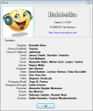
https://www.naturalreaders.com/ NaturalReader is a text-to-speech software with natural sounding voices. This easy-to-use software can read to you any text such as Microsoft Word files, webpages, PDF files, and E-mails. NaturalReader can also convert any written text into audio files such as MP3 or WAV. https://readplease.en.softonic.com/ for Windows. It is a very simple program on the surface but what it actually allows you to do is hear what is written on the screen. The program speaks aloud the text that is pasted into the tool.

Windows has long offered a screen and text-to-speech reader called Narrator, which lets you hear every action you take in Windows spoken aloud. Narrator is a screen-reading app that's built into Windows 10, so there's nothing you need to download or install. This guide describes how to use Narrator with Windows so that you can start using apps, browsing the web, and more.
Let's see how it works in Windows 10. Click on the Start button > Settings > Ease of Access > Narrator
https://support.microsoft.com/en-us/help/22798/windows-10-complete-guide-to-narrator
https://www.youtube.com/watch?v=SMhtY20Zcig
MAC

TTS
- To start, open the System Preferences panel under the Apple icon and click on Dictation and Speech.
- Select the Text to Speech tab.
- Check the option “Speak selected text when the key is pressed.
- Click the Set Key option.
- Choose one modifier key — Command, Control, Option, or Shift — plus one other key of your choice.

Speech to Text:
https://www.youtube.com/watch?v=8f9i7NUjeWM-Office 365 Word Dictate
Windows Speech Recognition Use dictation to convert spoken words into text anywhere on your PC with Windows 10. Dictation uses speech recognition, which is built into Windows 10, so there's nothing you need to download and install to use it. To start dictating, select a text field and press the Windows logo key + H to open the dictation toolbar.

MAC Voice Dictation: https://www.businessinsider.com/how-to-dictate-on-mac
- Click the Apple logo in the top-left toolbar, then choose "System Preferences.”
- Select "Keyboard."
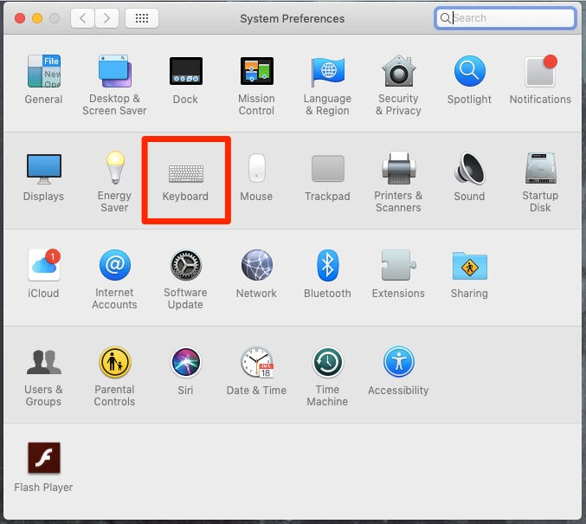
Click on Keyboard in System Preferences. Devon Delfino/Business Insider

- Toggle over to "Dictation" in the menu at the top of the window.
- Next to "Dictation" select "On" and if desired, turn on enhanced dictation by ticking the corresponding box — this allows you to use additional commands, like bold, italics, underline, copy, delete, and undo — and dictate without an internet connection (enhanced dictation is only available for those with OS X Mavericks v10.9 or later).
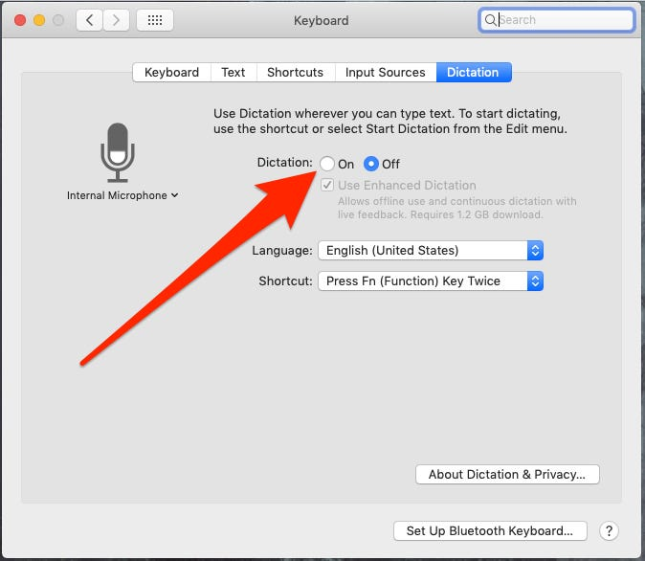
Turn Dictation on. Devon Delfino/Business Insider
5. Set the language and create the desired shortcut.

How to dictate on a Mac
Once you've enabled the dictation feature, here's how to use it:
- Open a document.
- Place your cursor to the desired location for your dictation.
- Use the shortcut you established when setting up dictation; alternatively, you can also select "Edit" and then "Start Dictation."
- Start talking.
You should see a microphone icon appear on the screen after you start the feature.

