“I was amazed that the Pear-Phone was so easy to use, I have struggled to use all of my past phones, but I was able to take full advantage of all the features of this phone because it is so user-friendly.”  -Betty White, Actress  “The Pear-Phone has outstanding cellular coverage, I was able to use my device while vacationing in the Great Smoky Mountains.”  -John Jones  Founder Jenna Smith, devoted 10 years to perfecting the technology that allowed her to create the Pear-Phone that would be accessible to all demographics.  Our Mission  Provide premium products at affordable prices, allowing for every person to have access to the little luxuries in life. |  | Limited-Time Offer  Pear-Phone is offering its aesthetically pleasing phone at 10 percent off for the first 50 customers at all Pear Incorporation stores.  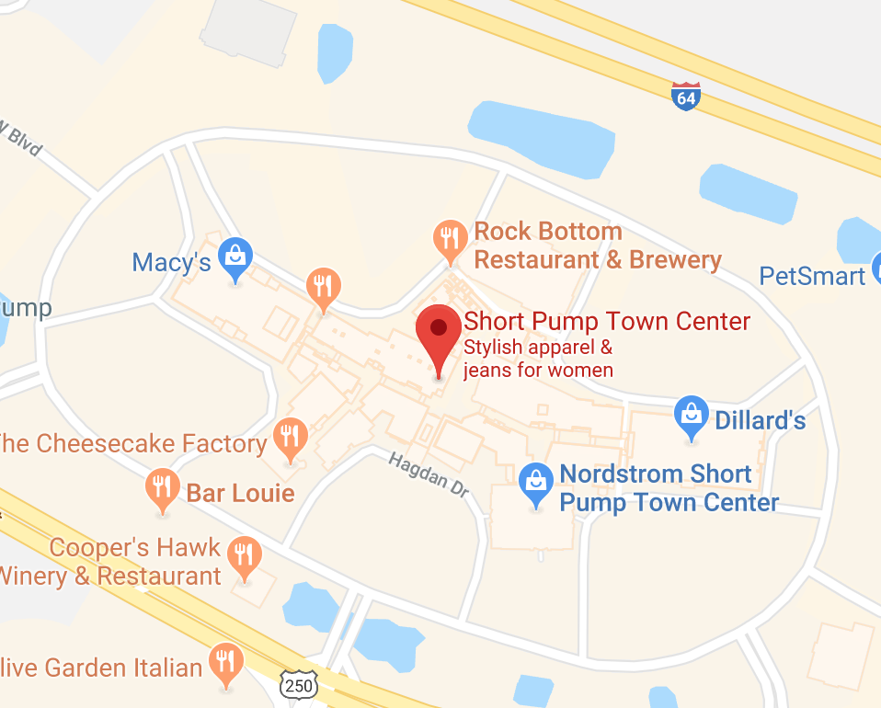  11800 W Broad St, Richmond, VA 23233  Located inside Short Pump Town Center adjacent to Macy’s |  | Pear- Phone  Combining the sleekness of an iPhone with the innovative software of Windows.

Never Compromise  Pear-Phone combines innovative technology with aesthetically pleasing design that will make you never want to settle again.  Pear Inc. has created a new chip that has increased cell phone coverage to rural areas and has international cell coverage, so that you can always stay close with the people that matter to you.  - Pear-Phone Macro  - Larger Screen  - 55 GB of Storage  - 14 Megapixel Camera  - Voice control  - Pear-Phone Micro  - Light Weight  - 45 GB Storage  - 14 Megapixel Camera  - Voice Controls |  | Pear Inc. understands the demand for reliability and affordability when purchasing a phone. The quality of a phone should not be compromised, in order to offer a competing price.  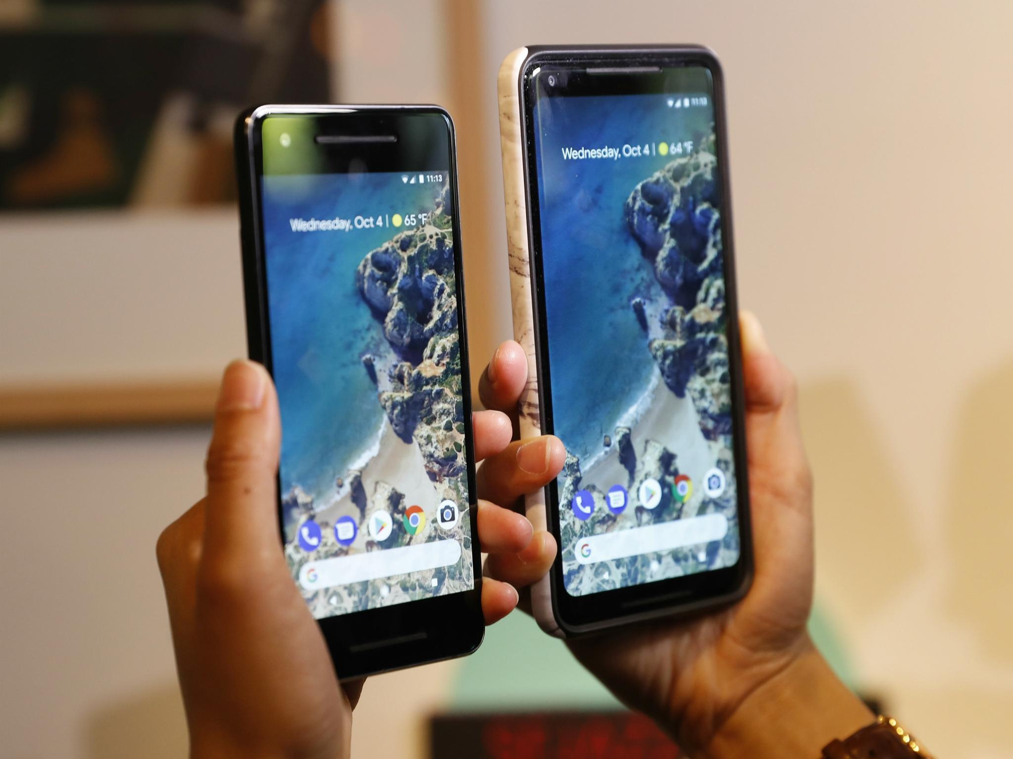  Pear-Phone Micro can be purchased for just $780.  Pear-Phone Macro can be purchased for just $900  Pear Inc. |  | Stay Connected  Pear-Phone is compatible with the majority of phones on the market today, allowing you to facetime or skype anyone on their preferred devices. This phone combines the technology of both Apple and Samsung making it easier for users to communicate effectively with each other no matter a person’s location.  Capture Every Moment  Pear-Phone has been carefully crafted in collaboration with team members at Nikon . This phone allows users to produce “frame-worthy” photos from the same device they use to communicate with others. Pear-Phone flawlessly combines everything individuals seek in a phone at an extremely affordable price.  