Teacher: Ms. Sisson
Topic: Public Service Announcements
Grade: English 10
Essential Questions:
How can we use persuasion in PSA’s to convince an audience to change their behavior?

NCTE/ILA Standard for ELA:
Students use spoken, written, and visual language to accomplish their own purposes (e.g., for learning, enjoyment, persuasion, and the exchange of information).
SOL & Essential Skills from Curriculum Framework:
10.2 The student will analyze, produce, and examine similarities and differences between visual and verbal media messages.
a) Use media, visual literacy, and technology skills to create products.
b) Evaluate sources including advertisements, editorials, blogs, Web sites, and other media for relationships between intent, factual content, and opinion.
c) Determine the author’s purpose and intended effect on the audience for media messages. d) Identify the tools and techniques used to achieve the intended focus.
CF:
- • identify and analyze the sources and viewpoint of publications.
- • analyze, compare, and contrast visual and verbal media messages for content (word choice and choice of information), intent (persuasive techniques), impact (public opinion trends), and effectiveness (effect on the audience).

Anticipatory Set
Remind students of our talks about different problems High School students face that can make them feel discriminated against. All the books we read have problems they could pick. Explain we will be using this knowledge to create a Public Service announcement to convince our audience to change.
Students will be able to. . . | The teacher will. . .
- Discuss public service announcements they have encountered and the effect it had on them personally. | - Have students write on the following question:  Have you ever seen a public service announcement and how did it effect you?
Main Lesson Activities

Students will be able to. . . | The teacher will. . .
- Define and recognize a public service announcement, and the purpose, audience and persuasion they have.  - List ways PSA’s can be an effective way to convince an audience to take action.  - Plan the beginnings of their own PSA’s and brainstorm possible topics.  - Organize their ideas in a graphic organizer and questionnaire. | - Explain to students the aspects of a Public Service Announcement (PowerPoint) including: Purpose, Audience, and Persuasion.  - Show student’s various examples of public service announcements and how they effect an audience or ask an audience to take action on a given topic.  - Model for students a few examples of a public service announcement. Model for them how to fill out the PSA Question sheet.  - Have students get into groups and provide students with the questionnaire sheet provided below and have them start brainstorming their own PSA’s for a social justice issue they believe effects High school students.
Closure

Students will be able to. . . | The teacher will. . .
- Discuss their PSA plans with the class. | - Have students discuss in groups their chosen topic and what they hope to accomplish in their PSA. Students will be asked to share with the group.
Instructional Materials:
https://www.youtube.com/watch?v=QHjS-6f9tMs
https://www.youtube.com/watch?v=2syJ1bAMOvc
https://www.youtube.com/watch?v=j7OHG7tHrNM
https://www.youtube.com/watch?v=0W2Ic5hV28w
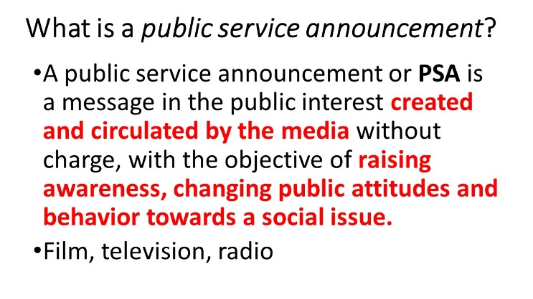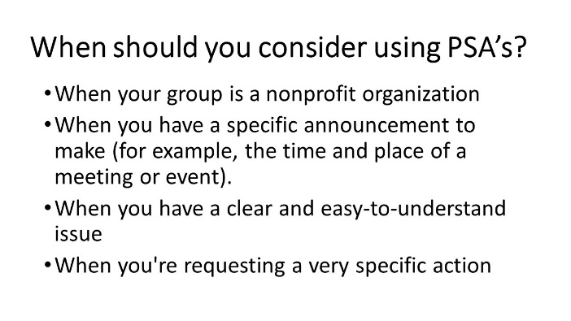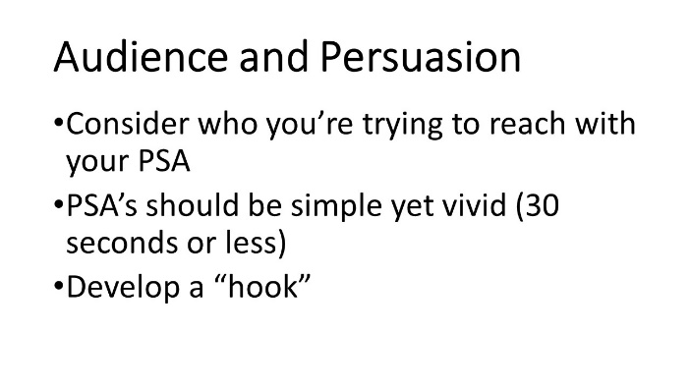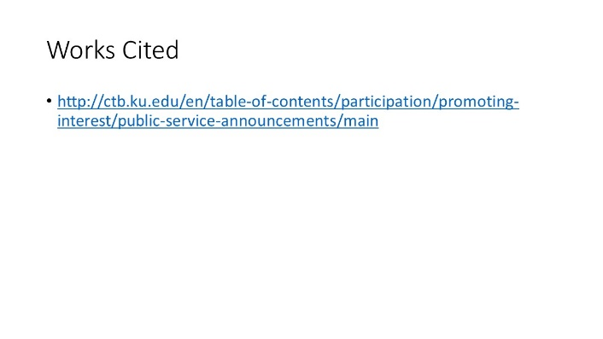

PSA Activity and Questions Sheet
Use this sheet to guide you through the activity of creating a public service announcement (PSA). You can find some good examples of PSAs on the Ad Council: PSA Gallery and BoostUp (click on Videos) websites.

Step 1: Thinking About PSAs
- After watching a few PSAs, discuss each one using the questions below:
- What is the main message of the PSA? Does the message persuade you? Why or why not?
- How did the producers use words and pictures to get across their message? q How did the actors portray the message? Were any voiceovers used? How were they used?
- If you were going to film a PSA about this topic, list two changes you would make in it.
- After answering these questions for a few different PSAs, try to decide which PSAs work best and why.

Step 2: Choosing Your Topic
- Choose an issue that is important to you, such as drug use, online safety, staying healthy, or bullying.
- List possible topics that relate to your issue. For example, if your issue is pollution some topics might be recycling, water pollution, or planting and maintaining more trees. Pick the topic that most interests you.
- Do some research on your topic using the Internet and other sources such as newspapers, magazines, books, and nonprofit organizations. Find statistics if you can.
- Consult a wide variety of sources in your research to get a good sense of all perspectives surrounding your topic.
- Remember that information online is not always reliable, so make sure to confirm any facts you find in at least 2 to 3 resources.
- Make sure you have a good base of research and a strong understanding of the topic before moving on to Steps 3 and 4.

PSA Activity and Questions Sheet (continued)
4. Think about and discuss these questions:
- What did you find in your research that surprised you?
- How is this information different from your beliefs?
- How are the facts different from what you expected?
- What do you think causes this problem?
- Do you have facts to back up this explanation?

Step 3: Thinking About Solutions
Imagine what could be done to solve this problem. Think about these questions:

- What would you do if you were in charge of a national campaign to fix this problem?
- What are some other solutions to the problem?
- Can you imagine what would happen if people started to act differently to solve this problem?

Step 4: Planning Your Own PSA
- PSAs are usually about 30 seconds long or less. Think about how you would create a PSA on your topic. Use these questions as a guide:
- What type of words should flash across the screen to convey your message or goal? Think of a catchy phrase or slogan.
- How could you discuss the reasons in the video?
- How do you convince people to listen to your message?
- What are your facts?
- How will you share these facts dramatically?
Copyright 2008 IRA/NCTE. All rights reserved.
ReadWriteThink materials may be reproduced for educational purposes.

Sources:
Lesson Plan adapted from Elizabeth Stapula’s PSA mini lesson.

http://www.doe.virginia.gov/testing/sol/standards_docs/english/
http://www.ncte.org/standards/ncte-ira
http://www.scholastic.com/browse/lessonplan.jsp?id=1504
http://www.readwritethink.org/files/resources/30157_activity_sheet.pdf

