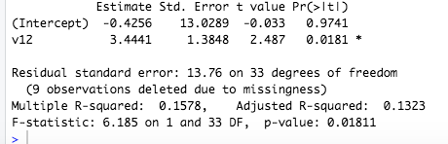
This table shows the results of the Regression test and the relationship between two different variables. The two variables that were chosen were “During a typical day, how many hours do you get to spent interacting with your child/children?” The respondent then replied through the variables on a scale of 0-10 or more hours. The question this was compared to was “On a scale of 0-10 how much did your child enjoy the Animal Dice Activity?” The respondent then replied with a number 0-10.
I hypothesized that the more time parents got to spend with their child on a daily basis the more they enjoyed the Animal Dice activity.
Parent’s rank of their relationship with their child increases 3.4441 units for every one unit increase in how much they enjoyed the Animal Dice Activity. Thus, it appears that the two variables are positively related. Therefore as one increases the other increases. This finding is also significant with p= 0.0181. The R² statistic is 0.1578. This means that the model explains .15 % of the variation in the dependent variable. Therefore a relationship can be seen with parents that spend more time with their children on a daily basis and their enjoyment of the Animal Dice Activity.

