Testimonies from customer’s:  - “After a car accident, I was left with difficult recalling long tern memories. With MemoryPro, I have not only been able to remember them, but I have been able to share these memories with my siblings and reflect on our childhood!” – Miranda  - “I was skeptical about MemoryPro at first but after the super easy procedure, I have been in love ever since! I love that I can easily share my memories with friends and family online!” – Jessica  - “I surprised my grandmother who has Alzheimer’s with MemoryPro. Ever since she has been livelier and happy because she has been able to recall all her memories long and short term!” – Dave | Who we are:  MEMORYPRO  About Us:  We are a company that works with other organizations for memory loss and linguistic disabilities and we are trying to improve technology and provide these individuals with a fun way to enjoy social media.  Contact us:  Phone: 540 – 945 - 2884  Email: Memorypro.info.LLC@gmail.com  Website: Memorypro.LLC.com  MemoryPro  745 Alabama Street  Fredericksburg, VA 22405 | “Ran off mind power!”  MemoryPro  - By: Lindsey Cosner, Bella Corbo, and Danielle Weirup
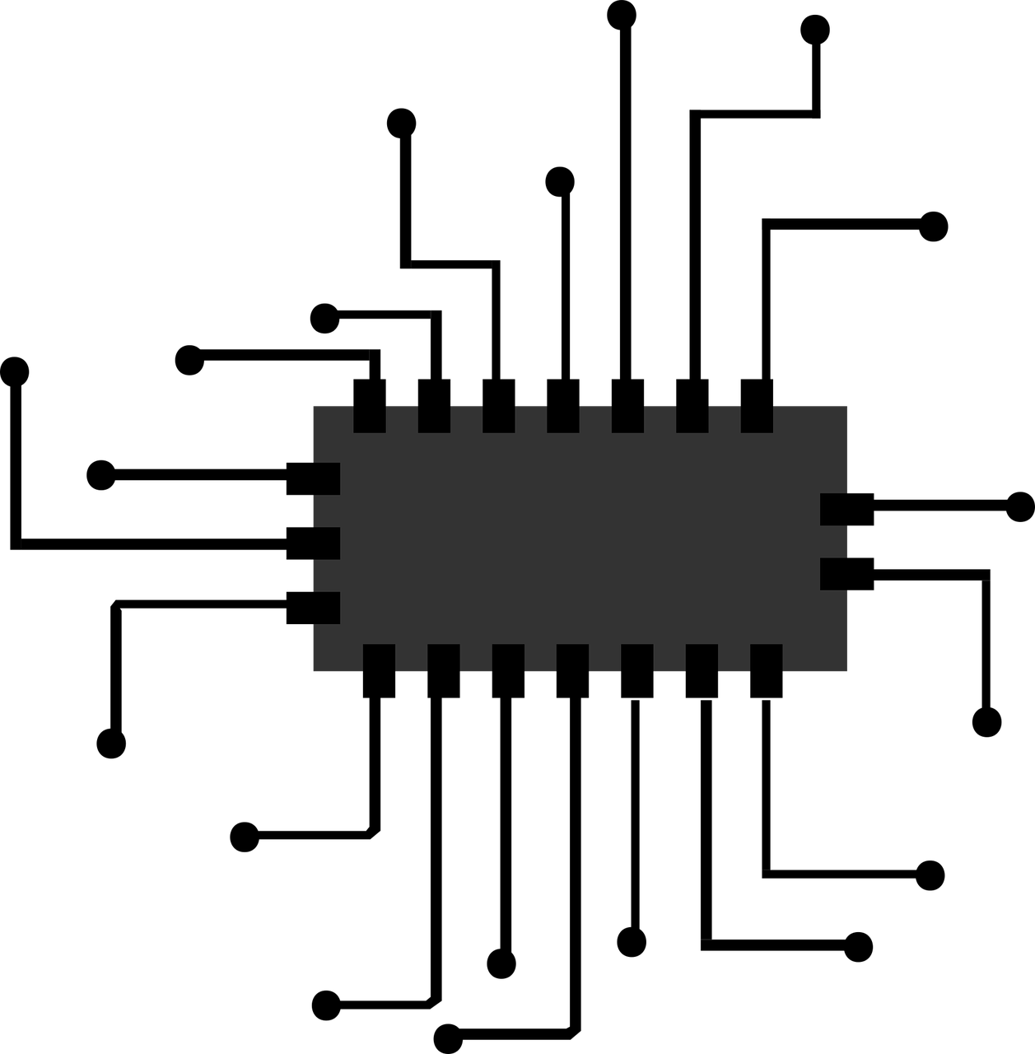  Products and Services:  What is it:  - A small microchip inserted in the temporal lobe  - Non-invasive, minimal surgery (in-patient)  What it does:  - Records user’s memory  - Play-back memory feature  - Share memories with other users through the MemoryPro app.  Some other features are:  - Connect with other users seamlessly  - Can help people who suffer from dementia, Alzheimer’s, or short and long term memory loss. | Prices and Payment Plans!  *** This product can only be sold by licensed technicians ***  Prices:  - Price starting at $450  - Device is $150  - Installation is $300  (Includes anesthetics that may be required)  Note: Antibiotic and pain medication that is required for aftercare of MemoryPro installation is not included in this price.  Payment plans:  - Payment for installation fee is divided into three, $50 a month payments, before installation  - Customer will have to pay for the device in-full by the day of installation | This product creates a new a fun way to share your life with others!  The Benefits of MemoryPro:  - Share memories with your friends and family on social media  - Assist those who have short term memory loss  - Those who suffer from Alzheimer’s and dementia are able to recover memories that they can no longer remember on their own.  - Aid those who have trouble with syntax, pragmatics, articulation, and those who cannot type due to a motor disability.

This citation is for the image on the 4th panel.

T. (n.d.). Benefit vs Cost comparison [Digital image]. Retrieved April 3, 2019, from https://stock.adobe.com/images/benefit-vs-cost- comparison/65928944
This is the only picture I could find that is relevant to the topic we are doing our brochure on. There is a watermark across the picture but there is no copyright infringement intended.

