In our book, Rhetoric in Civic Life, chapter three talks about many different topics that have to do with Visual Rhetoric. The main things that stood out in this chapter to me where two topics under the Types of Visual and Material Rhetoric section. Those two topics were (1.) body rhetoric that deals with enactment and (2.) photographs that deals with iconic photographs. Body rhetoric is rhetoric that foregrounds the body as part of the symbolic act. It is often used by those who are "denied access to more traditional forms of verbal address and of proof" (77). Body rhetoric includes the subject of enactment. This occurs when "the person engaging in symbolic action functions as proof of the argument he or she advances." (77) What this is saying is that if an argument is not said by the person who is trying to defend or justify the argument, it will not be as meaningful or powerful. In the book it says "The power of the visual proof enhances the power of the words" (77). For example, if the President, Donald Trump, had his assistant make the speeches which helped him into office. His audience would not be as convinced because they are not seeing his emotion or true feelings, or why this is meaningful to him, about being elected. His audience would be persuaded more if Donald Trump, himself, gave the speeches. Later on, on page 78-79 in the book it talks about how the ability of bodies to induce memory and answer arguments is illustrated in recent actions by grandchildren of Auschwitz survivors. Where, these grandchildren, are getting the same tattoos that were etched in their parents and grandparents arms and chests while their loved ones where in the camps. Linda Diana Horwitz and Daniel C. Brouwer explains that "These young people articulate that they are not going to forget, and they are also going to help anyone who witnesses their tattoo in the process of never forgetting" (79). They are using this visual representation to make sure people never forget what happened. This is powerful because it affected these children personally but imagine if a child did this without having a loved one go through those terrible times, it would lose alot of significance and power. Significance and power is also found in Iconic Photographs. Iconic photographs  are photographic images produced in print, electronic. or digital mediea that are "(1.) recognized by everyone within a public cultrue, (2.) understood to be representations of historically significant events, (3.) objects of strong emotional identification and responce, and lastly (4.) regularly reporduces or copied across a range of medie, genres, and topics." (82 -83). An example of this is an incredibly known picture that was publsihed in the midst of World War 2, this picture is titled as "US Marines raising flag over Iwo Jima." Even if people did not know the significance of this picture they would still know the picture itself. This picture creates a "strong emotional identification. as citizens identify with the men pictured, with their struggle and victory (83)." It also reflects a particular image of US citizens as "hardworking (not warlike), equal (rank is irrelevant, as all participants labor equally), and proud of their nation (the US flag is a primary indicator of civic pride) (84)."

[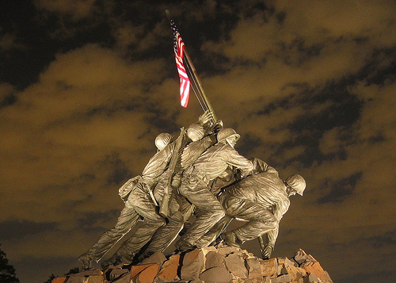](https://www.flickr.com/photos/10101046@N06/3560722399)

Everyone who knows history, knows this picture.

Another Iconic picture would be the firefighters raising the United States flag at the site of the World Trade Center in New York after the terrorist attacks that happened on September 11, 2001. This was such a powerful event that made history and will never be forgotten. I know at my highschool we would go out on September 11th and stand around the flag and send prayers to the families who lost loved ones in this terrible event.

Here is a link where you can find more iconic photos that has influenced the world. Including the picture of the firefighters raising the United States flag at the site of the World Trade Center in New York after the terrorist attacks that happened on September 11, 2001. https://www.cnn.com/2013/09/01/world/gallery/iconic-images/index.html

I learned a lot how visual representations influence the audiences understanding on what point you are trying to get across.