Lindsey Cosner

Dr. Guler

ENGL 400-18

20 March 2018

Damned to Hell: Rhetorical Analysis of a Sermon

*Sinners in the Hands of an Angry* *God* by Jonathan Edwards

**Introduction**

There are many different versions or translations of the Bible. In fact, it has been said that the Bible has been translated into 1,200 different languages. Jonathan Edwards uses one of these translations in his sermon. The translation he uses is known as the King James Version (KJV) which is very proper. A few examples of the words, Edwards uses in his sermon from this version, is thou, ye, didst, castedst, and believeth.

But who is Jonathan Edwards? Jonathan Edwards was born on October 5, 1703, in East Windsor, Connecticut. He studied divinity at an elite school known as Yale college. He then took the pulpit in Northampton, Massachusetts. He was skilled in many different occupations. He was an educator, philosopher, journalist, scholar, theologian, and also a Puritan Minister.

Jonathan Edwards became known widely for his sermon, *Sinners in the Hands of an Angry God*, which was delivered on July 8, 1741. He delivered this sermon in Enfield, Connecticut, which is a response to expanding secularism in an attempt to bring people back to the church. His sermon addresses to sinners worldwide; it is cautioning sinners that God will stand before them on judgement day. God will be judging their actions, and that the sinner’s punishment “may be harsher than they could ever imagine” (enotes.com). Edwards then tries to convince his audience of their sinful nature and the need to undergo a “public conversion” to save themselves from Gods wrath. He tries to scare the people back to their religion, and realize their religious significance. Therefore, the tone of Jonathan Edwards’ sermon is enraged, urgent, fiery, and angry. This sermon is giving the chance for sinners to look at what will happen if they do not face Gods wrath and repent. If they do not, they will be damned to hell for eternity.

**Aristotle’s Rhetorical Perspective**

Aristotle started off being one of Plato’s students. Later, Aristotle used the basic ideas of Pluto to develop his own view of rhetoric. (Palczewski 14) Aristotle was an ancient Greek philosopher and scientist. It is said that he is one of the greatest intellectual figures of Western history (Amadio and Kenny). One reason why he is referred to as one of the greatest, is because of the three appeals he discovered. His discovery consists of three different appeals of persuasion. Those three appeals are logos, pathos, and ethos. These appeals of persuasion are indeed an older idea of how people address to one another but it is still a great example of how human communication works today.

The first appeal of persuasion that will be addressed is **logos**. The text book, *Rhetoric in Civic Life,* defines logosas, “that which relies on “argument itself, by showing or seeming to show something” (Palczewski 15). It is also identified as the logic, reasons, or argument of a given artifact. Some things that help identify this appeal are quotations, statistics, facts, examples, and informed opinions. What is the effect of logos on the audience one might ask? Well, it provokes a reasonable response. The audience gets a sense of, “Oh, that makes sense.” Or “Hmm, that doesn’t prove anything.” An example of logos in relation to the artifact chosen would be the Bible verses given throughout the sermon.

The second appeal of persuasion is **pathos**. Pathos is defined as, “that which leads the audience “to feel emotion” (Palczewski 15). It is words that get at our feelings and emotions. Some things that help identify this appeal is vivid description, figurative language (similes, metaphors, personification), and emotional tone (humor, sarcasm, or excitement). Pathos has an effect on the audience which provokes an emotional response. It persuades the audience by emotion. And lastly, pathos evokes fear, sympathy, anger, or sadness in the audience. It is said that pathos plays as a major and important component of the persuasions appeals because, “emotions play a significant role on the human experience… Many decisions people make are based on emotion, taste, and individual preferences” (Palczewski 15). This is true because authors will use different speech or symbols for the audience to connect with. The author is doing this because he wants to produce emotion from his audience so they will have a better connection with the book, sermon, or lecture. An example of pathos in relation to the artifact is when Jonathan Edwards is explaining what hell will be like in his sermon.

The last appeal of persuasion by Aristotle is **ethos**. Ethos is defined as, “in the character of the speaker” (Palczewski 15). This means ethos refers to the authors character or credibility. It is how the author gets the audience to trust him/her. Some things that help with the credibility of an author is their profession or background. His knowledge and sincerity of the topic in which they are addressing. The appropriate vocabulary and grammar used in a speech, sermon, or book. And lastly, the appropriate language for a specific audience and subject. Aristotle argued that “ethos was the most effective form of proof because an audience who trusted the rhetor would be more receptive to the message” (Palczewski 15). Knowing that, a good question to ask is what effect does ethos have on the audience. The answer to this, is that it helps the reader to see the author as trustworthy, competent, and credible. The reader might respect the author or his/her views. An example of ethos in relation to the sermon is that Jonathan Edwards is a Puritan Minister. That makes him credible to give this sermon and for his audience to trust the words he is teaching because he has years of great education, experience, and occupations.

**Relative Course Concepts**

Out of the text, *Rhetoric in Civic Life*, many course concepts can be found. These concepts can be connected to the artifact, *Sinners in the Hands of an Angry God* by Jonathan Edwards. The first course concept is **vivacity**. It is defined as, “a sense of immediacy or presence created through the use of descriptions, imagery, and colorful language that make an idea come alive” (Palczewski 139). Another course concept in relations is **civic engagement**. Civic engagement is when “people’s participation in individual or collective action to develop solutions to social, economic, and political changes in their communities, states, nations, and world” (Palczewski 16-17). The third concept that relates to the sermon is **ideology**. Ideology is defined as, “the ideas, values, beliefs, perceptions, and understandings that are known to members of a society and that guide their behaviors” (Palczewski 28). The last course concept that will be talked about is a **metaphor**. A metaphor is “a figure of speech in which two dissimilar things are said to be similar, offering a new perspective on a known issue” (Palczewski 50). All these course concepts that will be talked about can relate to the rhetorical artifact chosen and can relate to Aristotle’s appeals (logos, pathos, and ethos).

In the case of Jonathans Edwards, in his sermon, he used vivacity which also relates to Aristotle’s appeal, pathos. There is vivacity throughout this sermon due to the vivid description and the use of figurative language in this whole sermon. Edwards brings frightening images throughout his sermon to persuade his audience into believing they are vulnerable to Gods wrath. The sermon, Jonathan Edwards mentions that “there is nothing between you and hell but the air; it is only the power and mere pleasure of God that holds you up”, figure one is a great picture that someone drew for the audience to put the words to a picture. Edwards also mentions something that goes along the lines of that quote. He says a sinner’s “wickedness makes you as it were heavy as lead, and to tend downwards with great weight and pressure towards hell; and if God should let you go, you would immediately sink and swiftly descend and plunge into the bottomless gulf…. And all your righteousness, would have no more influence to uphold you and keep you out of hell, than a spider’s web would have to stop a falling rock” (Edwards 4). These two quotes from his sermon is a good use of imagery and vivacity, because the use of a vivid description promotes fear in the audience. This is showing the audience that God can let someone go at any time and that even though in their life they did good it did not matter to God. It is explaining how without God; our efforts are as ineffective as a spider web is at catching a rock, which is shown in Figure 2. Any individual who has ever felt like they could never do anything good enough to someone standards, so they would stand out, they could relate. People could also relate to this if they have felt powerless. As the sermon continues, there are more examples of vivacity. The non-direct audience, those who have heard the sermon through a lecture through college or in high school, could find that they may relate to the sinners. This is true because if they do not get their life on the right path, then they will also be damned to hell. Another reason that they could relate is that they think they are on the right track but this sermon scares them into re-evaluating their life, just like the sinners of the direct audience did. Another Concept that relates to Aristotle’s appeal of pathos is a **metaphor**. It relates because figurative language helps the audience distinguish what pathos is. An example of a metaphor found in the sermon, Jonathan Edwards gave is, “the bow of Gods wrath is bent, and the arrow made ready on the string” and figure 3, shows this metaphor. This metaphor is explaining Gods wrath. It is explaining how Gods wrath is the bow and the arrow is justice and that He is going to shoot us to hopefully bring the sinners sins to justice. Vivacity and metaphors are course concepts that relate to pathos but the course concept that relates to ethos is civic engagement.

**Civic engagement** is a concept that relates to ethos because they both relate to credibility. Civic engagement relates to credibility because a person is participating in “an action to develop solutions to social economic, and political changes in their communities, states, nations, and world” (Palczewski 16-17). While ethos is the author’s character or credibility. For example, Jonathan Edwards has credibility to give the sermon, *Sinners in the hands of an angry God*, because he has the background, education, and knowledge. Therefore, with his knowledge, background, and education his audience trusts him and are willing to listen to him. Johnathan Edwards also is portraying civic engagement because he is a man who went out there, created a sermon, which he hoped to give realization of hell and scare people back to their old ways of religion. Johnathan Edwards can show how even with civic engagement his previous sermons have not been successful. But, since he continued to be involved and engage with the community of religion, his sermon, *Sinners in the Hands of an Angry god*, flourished. Which when people encounter failure, many give up, but this shows a man who does not give up after failures. Which then once he found what he was truly passionate about, he flourished.

The last course concept that will be talked about is ideology. **Ideology** goes hand and hand with Aristotle’s appeal of logos. These are the beliefs in the religion of church that guide us to behave because people do not want to test God and his wrath. Jonathan Edwards uses the Bible verses to back up the sermon he is giving. In the sermon, an example of logos, would be if you sin it is logical you will go to hell. Another example is that, God is above all people and it is logical because he created all things. One last example is that because everyone is a sinner, everyone will go to hell. And God was holding them over the flaming pits of hell. Figure 3 shows God holding sinners over the pit of hell. People who relate to this is people who do not want to push their luck; who have their own values and beliefs. They know the importance of peoples values and beliefs and therefore they do not want to see what would happen if they break them. With this being said, that is why it guides individual’s behaviors out of fear.

**Conclusion**

Deciding between many rhetorical artifact, this sermon seemed to speak to many different religious individuals. In today’s society, religion is a big part of what makes up who an individual is. Aristotle’s rhetorical perspective plays a primary role when evaluating the sermon or other different types of artifacts. It helps bring aware many key insights that may have been overlooked when first reading it. The use of vivacity and metaphor help communicate Jonathan Edwards sermon, as well as opening the eyes of the audience to why they should fear Gods wrath and being damned to hell. Civic engagement gave Edwards the credibility he needed to prove why his audience should trust them because he has been involved, knows the knowledge, and experienced the education he needs to give the sermon. Lastly, the use of ideology, “gave the ideas, values, beliefs, perceptions, and understandings that are known to members of a society and that guide their behaviors” (Palczewski 28). Therefore, the versus backed up Jonathan Edwards ideas, which makes his audience fear what will happen if they disobey God, which leads to them using the Bible as a guideline to their behaviors. The course concepts relate to the sermon and both the sermon and the course concept relates to Aristotle’s rhetorical perspective about the fear of being damned to hell by Gods wrath.

Figure 1, God showing sinners that their lives are in His hands completely. Related to the course concept of vivacity.

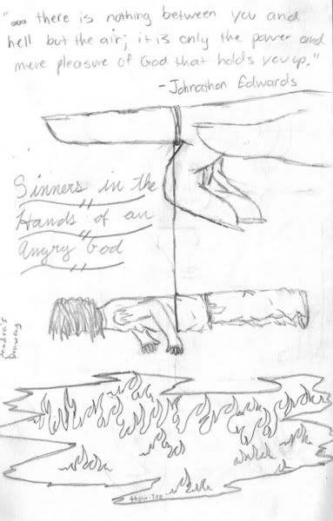

Figure 2, It is explaining how without God; our efforts are as ineffective as a spider web is at catching a rock.



Figure 3, An example of a metaphor found in the sermon, Jonathan Edwards gave is, “the bow of Gods wrath is bent, and the arrow made ready on the string.”



Figure 4, God holding sinners over the pit of hell. Showing how our beliefs, determine our future because it guides our behavior.

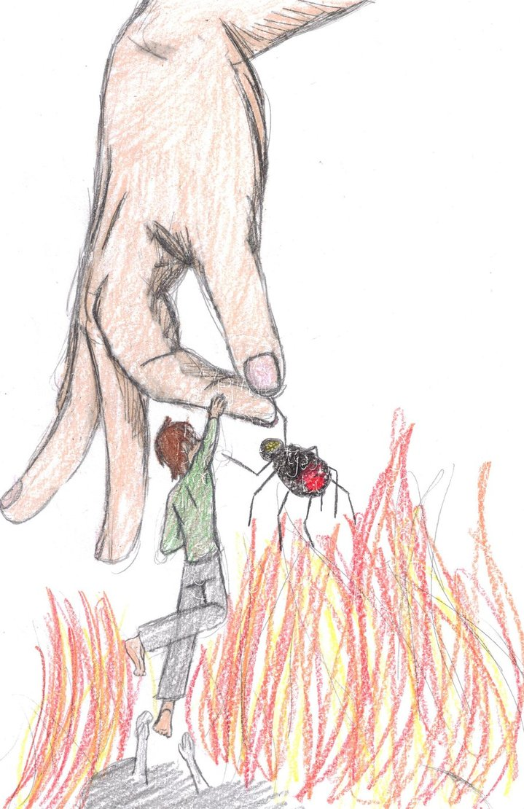

Works Cited

Amadio, Anselm H., and Anthony J.P. Kenny. *Aristotle*. 14 Mrs. 2018,

[www.britannica.com/biography/Aristotle](http://www.britannica.com/biography/Aristotle)

Edwards, Jonathan. *Sinners in the Hands of an Angry God*. International Outreach Inc.,

www.jonathan-edwards.org/Sinners.pdf.

*Identifying Rhetorical Strategies: Logos, Pathos, and Ethos,*

<https://www.dvusd.org/cms/lib/AZ01901092/Centricity/Domain/2891/Rhetorical%20Strategies%20Chart.pdf>

"Sinners in the Hands of an Angry God - Summary" Critical Survey of Literature for

Students Ed. Laurence W. Mazzeno. eNotes.com, Inc. 2010 eNotes.com 20 Mar, 2018

<http://www.enotes.com/topics/sinners-hands-an-angry-god#summary-summary-

summary-the-work>

Palczewski, Catherine Helen., et al. Rhetoric in Civic Life. Strata Pub., 2016.