In chapter eight of Rhetoric in a Civic Life, it talks about many different topics. Something that stood out to me was exigence. On page 227, it defines exigence as, “an imperfection marked by urgency; it is a defect, an obstacle, something waiting to be done, a thing which is other than it should be.” It says that the exigence needs a rhetorical response and if the rhetoric cannot create a change in exigence, then it is not a rhetorical situation. An example that the book gives is that, although a hurricane is a problem, it is not a rhetorical exigence because rhetoric cannot stop the onslaught of wind and water. Peoples reaction to a hurricane (usually panic) do present an exigence. Then it goes on and says that rhetorical appeals not to panic, to prepare, and to evacuate in an orderly manner can alter the exigence. With this being said, it was panic that was the exigence not the hurricane. For a better understanding, exigence is an issue, problem, or situation that causes or prompts someone to write about it or speak about it. It is a problem that needs to be addressed.

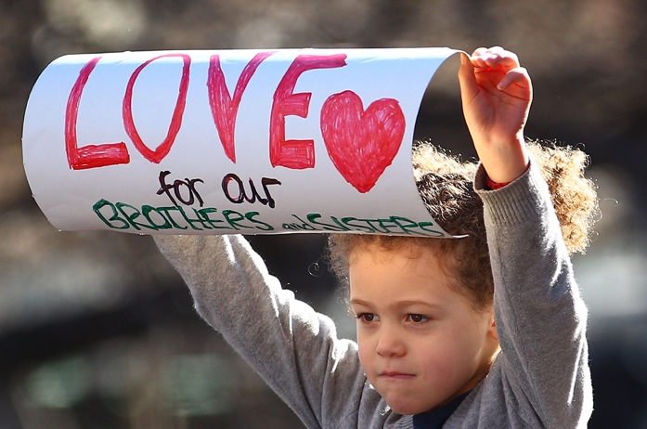

For example, in Hawaii Five-0, there are many different problems Steve McGarrett and his team have to address. There was a time in the show where Steve McGarrett’s team had to go save, Chin Ho Kelly, one of his team members, from prison which he got mistakenly placed there by the bad guys in that episode. The team had a problem which they addressed by asking one of their friends, Kamekona, helicopter, and flying it to prison and rescuing Chin Ho Kelly before he dies by the criminals he put in prison. Another example from the book is when the planes crashed into the Twin Towers of the World Trade Center, the Pentagon, and a field in Pennsylvania. The public reaction to the events created an evolving exigence.

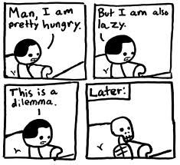

This is a picture of someonenot addressing the exigence. They are too “lazy” to address it and so they hypothetically starve and became a skeleton.

Then another topic that stood out a fitting response. A fitting response is defined as, “a response that meets the expectations of the rhetorical situation” (Palczewski 233). Then it says that to be fitting, a response must also meet the expectations established by responses preceding situations that the audience perceive to be analogous. So relating back to Hawaii Five-0, a fitting response to when Chin Ho Kelly ended up in prison, was when the team took action to go save him.