Tyler Cosley
MUSC 332
4-7-21

Bernhard Heiden’s Sonata for Alto Saxophone and Piano

My enhancement for MUSC 332, History of Music II, is a look at the life of the German American composer Bernhard Heiden and how his Sonata for Alto Saxophone and Piano is an outstanding representation of his compositional style. Throughout this process I have studied, learned, and performed the second movement of Heiden’s sonata on the alto saxophone. I worked on this piece in my private saxophone lessons with my professor, Dr. Kinzer, so I could accurately portray the character of Heiden’s music. This process helped me learn more about Heiden as a composer and gave me a greater appreciation for his musical choices. All my findings are presented in poster format to bring awareness to a lesser-known composer while providing concert notes and analyses of one of his most famous works.
Bernhard Heiden was born in Frankfurt, Germany, on August 24, 1910, to his father Ernst Levi and his mother Martha Heiden-Heimer. His name at birth was Bernhard Levi, but he later changed his sur name (Wikipedia). His mother played violin and piano and would often rehearse her music at home so Heiden grew up around music (Walsh, 1999). He began to show his own love for music around age five, and he began writing short compositions at the age of six. When Heiden was 15 years old, he studied under a man named Bernhard Sekles. Sekles was a former teacher of the famous composer Paul Hindemith (1895-1963); he was also the director of the Hoch's Conservatory. It was at this time that Heiden learned clarinet, violin, continued his studies of piano, and took lessons in theory and harmony. He also was given an opportunity to direct his school orchestra, which had a huge impact on his career (Walsh, 1999). Bernhard Heiden “was admitted to the Hochschule for Musik in Berlin in 1929, and studied composition under Paul Hindemith, whom he considered his principal teacher” (Keiser Southern Music). From 1929 to 1933, Heiden was a student at the Hochschule for Musik, where he began as a clarinet major but later changed his major to conducting. Paul Hindemith had a profound impact on his career; they were both originally from Frankfurt although they did not know each other personally (Walsh, 1999). Hindemith was a very harsh critic of Heiden, but nonetheless, Heiden continued to work hard and excel. In 1933, his final year at the Hochschule, he was given the honor of the Mendelssohn Prize in Composition for his piano concerto (Walsh, 1999).
In 1934 Bernhard Heiden married Cola de Joncheere, a pianist and a fellow classmate at the Hochschule for Musik. In 1935, the young couple moved to Detroit, Michigan to leave Nazi Germany as political tensions were rising, and there he began to teach at the Art Center Music School. Around this time, Heiden “also served as staff arranger for local radio station WWJ and conducted the Detroit Chamber Orchestra, as well as giving piano, harpsichord, and chamber music recitals, and supplying incidental music for theatrical productions at Wayne State University” (Keiser Southern Music). Bernhard Heiden became a US citizen in 1941, and he was inducted into the U.S. Army in 1943. There, he “became Assistant Bandmaster of the 445th Army Service Band, for which he wrote over one hundred arrangements” (Composition Today)
After he was released from duty in 1945, he went to Cornell University, studied musicology with Donald Grout, and earned his master’s degree in musicology. He then went to teach at Indiana University School of Music, where he eventually served as the department chair of the composition department until from 1946 until 1974. In his tenure at Indiana University, Heiden taught composition, counterpoint, score- reading, twentieth-century analytical techniques, and served as chairman of the composition department for several years. He retired from the Indiana University School of Music in 1981 but he continued to compose and pursue his love of music until he died on April 30th, 2000 (Walsh, 1999).
Bernhard Heiden's music is described by composer Nicolas Slonimsky as "neoclassical in its formal structure, and strongly polyphonic in texture; it is distinguished also by its impeccable formal balance and effective instrumentation." (Wikipedia, Wikimedia Foundation 2021). Heiden’s compositions are neotonal and heavily chromatic. Thomas Walsh notes that “the harmonic language Heiden employs in his saxophone music is tonal, though he generally does not employ traditional harmony” (Walsh 1999). Many of Heiden’s compositions are written for wind or string chamber groups or solo instruments with piano, like his sonata for saxophone. Heiden made extensive use of counterpoint in his compositions, much like his teacher, Paul Hindemith. In fact, one of his characteristic “contrapuntal devices is to state simultaneously two previously heard themes” (Walsh 1999). This is most evident in the second movement of his Sonata for Alto Saxophone and Piano. Bernhard Heiden composed a lot of music in his time; some of his most popular works are an opera called “The Darkened City,” a ballet called “Dreamers on a Slack Wire,” two symphonies, and some music for poetry and a few of Shakespeare's plays. Some of Heiden’s best known students are Carol Ann Weaver, Frederick A. Fox, and Donald Erb (Wikipedia, Wikimedia Foundation 2021).
Bernhard Heiden’s Sonata for Alto Saxophone and Piano was his very first published work. It is now one of the most performed pieces of saxophone repertoire ever; it was the first sonata to become a standard part of collegiate alto saxophone repertoire and is considered a cornerstone for classical saxophone performance. It was premiered by Larry Teal (1905-1984), a famous saxophonist, on April 8th, 1937. This work is very instrumentally conceived, and not at all in vocal style. The sonata has three movements: Allegro in G major, in sonata form, Vivace in C minor, in Rondo form, and Adagio-Presto in G major, an elaborated rondo. The sonata is polyphonic; while it is written for solo saxophone, both piano part and saxophone part have independent melodic lines throughout the piece.
The second movement of Sonata, marked Vivace, was what I focused on the most in my own musical studies. This movement order is interesting because a fast 2nd movement is not common; in most instances the second movement is slow and lyrical. This movement is a five part Rondo in C minor. It is a model of motive-based composition, with remarkable economy of material and unity between sections. Below is a diagram outlining the form of the movement.

Section: A B A C A’
Measure: 1 58 106 133 209
Key: C Minor A Minor C Minor A-flat Minor C Minor
Tonal area: i vi i b/vi i

This movement is very rhythmic; it features long, driving lines with a constant quarter note-driven melody. The melody has a motivic construction and is very angular in contour. An example of this angular motion can be seen below, with the alteration of ascending and descending fourths in the opening motive of the B section, measures 58-61:
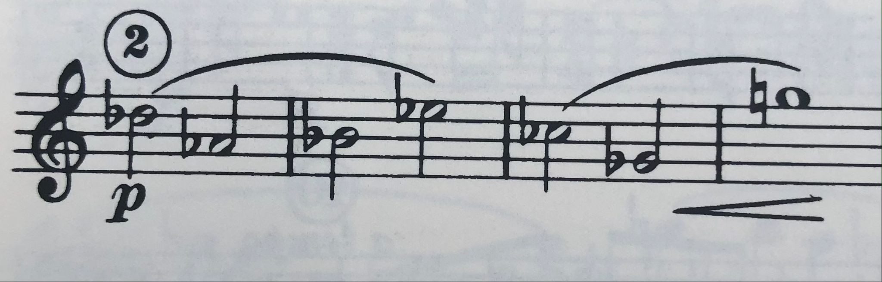

Heiden’s melody is freely chromatic, non-tertian (avoids outlining triadic arpeggios), and features a strong use of intervals of half & whole steps, fourths, and sevenths. Heiden’s use of chromaticism is evident in a sequence found in measures 17-19. It is based on a motive that appears on 11 of the 12 possible pitch classes throughout the course of the movement. This example is pictured below:
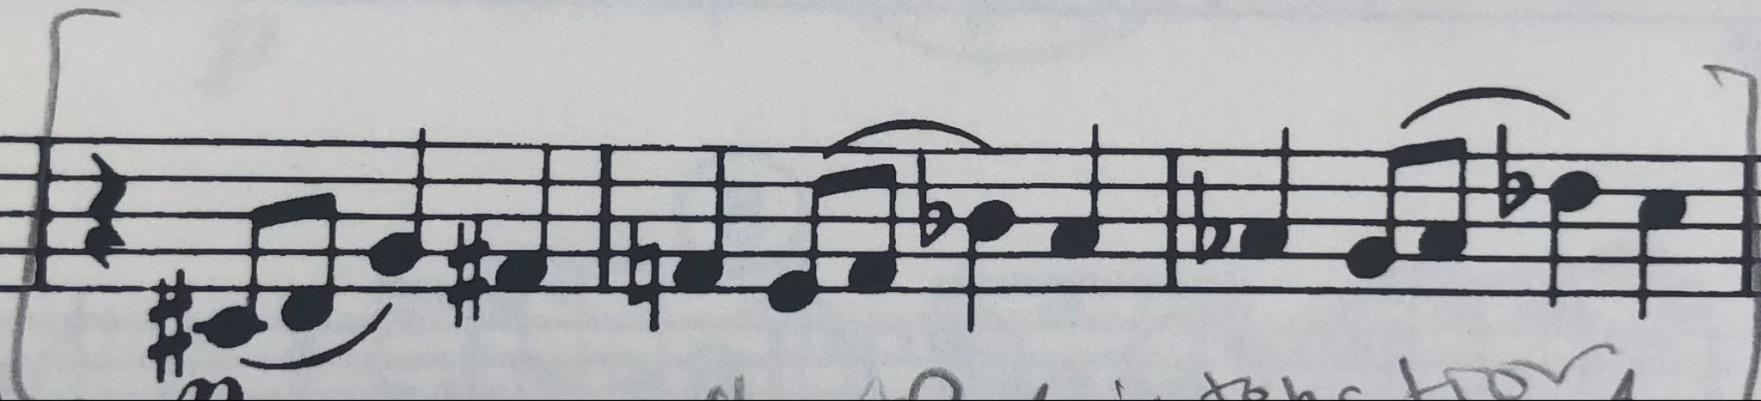
In this movement there is a frequent use of melodic sequences, and as I previously noted, there are very strong instrumentally conceived lines. The melody is contrapuntal between piano and saxophone, and between right and left hand of piano.
There are many examples of motivic unity within this movement of Bernhard Heiden’s Sonata for Alto Saxophone and Piano. The opening motive of the A section (beginning of the primary theme of the movement) shows the unity within this sonata because it is explicitly derived from the opening of the primary theme of the first movement:

Mvt 1 opening theme Mvt. 2 opening theme
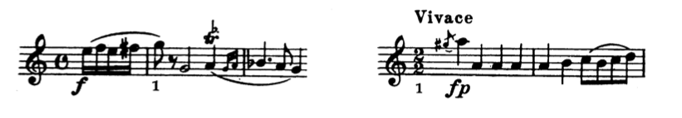
This idea of unity is seen again in measure 133. The dotted half followed by an eighth rhythm seen in this section, section C, is derived from material found in measures 8-9. The opening motive of the A section in the second movement, pictured above, is sounded 3 times within the section. This same motive repetition is seen in the B section, where the angular half note melody (its opening motive) is sounded 7 times, alternating between saxophone and piano. The primary melody alternates between the piano and saxophone often, showing Heiden’s use of counterpoint. This technique is seen again in the second portion of the C section, starting in measure 166, as the C theme and the A theme are presented against each other in counterpoint between saxophone and piano simultaneously. The voices are immediately exchanged for a repetition of the counterpoint, moving from A above C to C above A in measure 178. The final section, A’, presents a combination of motives from sections A, B, and C.
Bernhard Heiden was a composer and music teacher who does not receive enough recognition for the outstanding composition work he created in his lifespan. His Sonata for Alto Saxophone and Piano is an extremely complex work, but after learning, analyzing, and performing it, I understand why it is considered a core repertoire for the classical alto saxophone. His neoclassical composition style and use of counterpoint can be attributed to his thorough absorption of techniques learned from Hindemith. My research has confirmed that Sonata for Alto Saxophone and Piano is an outstanding example of Heiden’s compositional style.

Source list (alphabetical according to source):
BruceDuffie.com, “Bernhard Heiden Interview with Bruce Duffie,”
www.bruceduffie.com/heiden.html.
Composition Today, “Bernhard Heiden,” www.compositiontoday.com/composers/263.asp.
Keiser Southern Music, “Bernhard Heiden.”
www.keisersouthernmusic.com/composers/bernhard-heiden.
Kozinn, Allan. “Bernhard Heiden, 89, Composer And Indiana University Professor.” The
New York Times, The New York Times, 14 May 2000, www.nytimes.com/2000/05/14/nyregion/bernhard-heiden-89-composer-and-indiana-university-professor.html.
Walsh, Thomas. "A Performer's Guide to the Saxophone Music of Bernhard Heiden," D.M. doc.,
Indiana University, 1999.
“Bernhard Heiden.” Wikipedia, Wikimedia Foundation, 27 Oct. 2020,
en.wikipedia.org/wiki/Bernhard_Heiden.

.

