Academic Article
Tyler Cosley
ENG 165
Professor Green
April 22, 2020

Literature Review
Writing Across the Curriculum is a major movement in academics. It has been studied by numerous experts who seek to expand its reach and grow its impact on scholars everywhere by ensuring that writing is a focus in academic settings. Writing is proven to be instrumental in students’ ability to learn, and it is essential to prepare them for their life as a student, and as a person in the workforce. So often writing is thought of in relation to an English class, with its focus on grammar, punctuation, and sentence structure, when this is not the case. WAC is crucial in all areas of academic study for student development.
Many scholars argue the importance of using writing as a way of learning in every academic setting. In a broader scope, writing is crucial for learning because it is active, engaging, and personal. Janet Emig expresses this idea in her journal, “Writing as a Mode of Learning” to implore her audience to take writing seriously because it is proven to be vital for learning material. Further, in Anne Herrington’s journal, “Writing to Learn: Writing across the Disciplines”, Herrington expands on Emig’s idea of writing’s importance by emphasizing this importance in all academic situations. She believes writing should be used as a medium, to allow writers to better express their thoughts. This idea of writing being crucial in all disciplines puts a heavier emphasis on writing in the sense that it should not be limited in any way. For example, scholars often witness students who use writing as a simple means to get the job done, focusing only on fulfilling the assignment. Emig addresses this idea as what not to do when it comes to writing in academics because it will negatively impact those fields.
In “Writing to Learn: Writing across the Disciplines”, Herrington introduces this idea of teachers limiting the value of writing by only focusing on writing errors. If it is to be seen as a medium, as she expresses it should be in her journal, it should be respected as such. Emig and Herrington both believe in and convey the importance of writing and how it should be held in higher esteem and avoiding this limitation on writing is how their audience can carry out their ideas and thoughts. Seeing writing as a medium is the biggest step in recognizing the importance of writing to learning, as told by Emig, because any medium has to do with expression. Art, music, and film are all mediums that people use to communicate their ideas and thoughts with an intended audience. The focus with these mediums is not limited to a certain set of rules, and while everything in life has rules and regulations, they certainly are not the focus. Writing should have the same effect that other mediums have: to express or evoke emotion or a certain mindset to its intended audience.
Writing Across the Curriculum is such a major field, that just like any other field, common misconceptions can be made. Inferences of the goal of WAC, or the ideals of WAC can begin to change the way people see the movement even though the facts they are hearing are false. Two experts, Susan McLeod and Elaine Maimon, use their vast knowledge of WAC to expel some of the rumors that are related to their field. A journal like this is extremely important because they use their expertise to debunk the incorrect things they have heard throughout their time. This is necessary for people who may or may not have had the experience of sitting in a conference related to WAC or WID and are not as knowledgeable as they are. People need to have a solid foundation of understanding to be able to use the field to its fullest extent. This cannot be done if people are working with incorrect facts or ideas. People need to be able to work with only valid information if they are to be able to write successfully in their field of study. It is because of experts like McLeod, Maimon, Herrington, and Emig that WAC is able to thrive.
Communicating to students how critical writing is to their learning is no easy task, and if this idea is to be conveyed successfully, it should be taught at a crucial time of development in a writer’s life; when they are beginning in the field. This does not necessarily have to be when children are beginning to write, or even when they begin to write more critically in high school. This mindset just needs to be taught at a time in their writing career when the student is a beginner, because it is proven that the beginning stage of a writer’s development is the most vital stage for their advancement as writers. In their journal, Nancy Sommers and Laura Saltz focus on the freshman year of college and its impact on the college writer. Sommers and Saltz go deeper into what Emig and Herrington focused on in terms of writing’s impact on academics by finding out when exactly writers develop in their life as a student. They learn that the freshman year is the most important year developmentally, but the writer needs to adopt two mindsets before they can progress. They need to be okay with being a “novice”, and they need to see writing as more important than just fulfilling the assignment they have. This is more commonly referred to as a “growth” mindset versus a “fixed” mindset.
A fixed mindset is often accompanied with a student who has a sense of arrogance about them; they do not see themselves as a “beginner”, because they believe they are far more advanced than that. Someone with a growth mindset would be okay with being a beginner, and therefore they develop more in their writing. The idea of having a growth mindset needs to be taught at a younger age, so by the time these students enter the crucial time for developing as a writer, they can progress quickly and not get held back. Because this beginner stage of a writer’s development has been proven to be the most crucial, it is the perfect time to begin to change the writer’s focus and understanding. Sommers and Saltz offer the solution to one of the issues of writing in academics that Emig illustrates in her journal. If writers are taught in their biggest stage of development to write with a different focus, then they can adopt this mindset easier and begin to apply it to their writing earlier, which will allow for better writers, and better writing.
Barbara Walvoord discusses in her journal “The Future of WAC” the many factors that make the future of WAC uncertain. Lack of support and high costs are some challenges being faced within the field. Much like Herrington, she expresses how a major issue is the focus of “fixing” students’ writing. Unfortunately, the biggest take away is that the future of WAC is unclear. Walvoord conveys these uncertainties in an informative way, but rather than just stating the issues, she offers hope and optimism in the field. Walvoord answers the “what now?” question most people will have after coming in contact with the journals of Emig, Herrington, Susan McLeod and Elaine Maimon, and Sommers and Saltz. She believes that WAC will flourish if it is seen as a reform movement, and treated as such, to change the stigma that threatens the future of the field.
The future of Writing Across the Curriculum may be hazy, and there may be common misconceptions of the goals or morals of the field, but a mindset of optimism and hope is the only way writers can begin to spark change across all disciplines. Changing people’s mindsets will be no easy task, but there are so many journals and experts within the field of writing that can be learned from and advice can be taken from. Writing is incredibly important for student development in all fields of academics. It is not “dying off” as some people believe. It is simply facing changes like all things in life do. It is how writers choose to see this opportunity that will impact the future of writing across the curriculum.

Introduction
In this Academic Article I will focus on three specific disciplines: the humanities, the natural sciences, and the social sciences. There are many distinct differences between these disciplines, but overall, they each serve to answer a specific question. The questions differ from focusing on human experience, studying natural world occurrences, or why humans do what they do. From the humanities, social sciences, and natural sciences, I will focus on art, education, and medicine. From these fields of study my goal is to compile sample articles to answer my research question: What are the similarities and differences in language, structure, and reference in writing in three academic fields?
From the arts, I will study Alfred M. Brooks’ Drawing, and Charles Hatfield’s article Comic Art, Children’s Literature, and the New Comics Studies. From the field of education, I will study Music Education, a journal by George H. Kyme, and a reviewed work on Educational Philosophy: A History from the Ancient World to Modern America by Edward J. Power written by William Casement. Finally, from the field of medicine, I will study an editorial by Lezley-Anne Hanna, Carmel Hughes, and Margaret Watson titled Where’s the evidence? Over-the-counter medicines and pharmacy practice and the journal Eczema by Andrew Sohn, Amylynne Frankel, Rita V. Patel, and Gary Goldenberg. In each of these articles I will research the various conventions of language, structure, and reference. Language refers to the author's choices in words and their manner of writing. Structure is the way the author organizes their writing, and reference refers to the author's use of citations or giving credit to another person’s work. Language, structure, and reference are all conventions used in Writing Across the Curriculum and have a major impact on the way we write in academics.

Methods
I never knew what Writing Across the Curriculum (WAC) was before I began laying the early foundations for this research project. My Literature Review gave me new perspective into the thoughts of authors who specialize in WAC, so my knowledge on the field grew. Reading and analyzing the different perspectives was a good experience for me as I was expanding my knowledge on something I would dig even deeper into for my research. My research was focused around the humanities, the natural sciences, and the social sciences. In the humanities, I focused on art. In the natural sciences, I focused on medicine. Finally, for the social sciences, I focused on education.
All three of these fields mean a lot to me, so I knew they would be good choices for research. As an artist, specifically focused on cartoons and drawing, I chose two articles that fully touched on those two areas and I was able to look at the writing from a WAC perspective. I deal with daily health issues, and this led me to read articles on over the counter medicine and eczema, which are areas of study I read numerous journals on daily. For my social sciences I focused on education, because that is major. I am in music education, so I found articles that revolved around music education and educational philosophy. In choosing topics that meant something to me, I was able to combine previous knowledge with new knowledge to research language, structure, and reference in these fields.
My approach to these articles was the same as anyone who would approach a new novel; I sat down and read them thoroughly. I made sure my focus was not necessarily on content as I read, because I was trying to read with a purpose of finding evidence to support my research. After studying these articles I went through and reread them and took notes as to what I was finding and where they were in the article. When it came time for me to compile my research, I was quickly and easily able to find ideas in my notes. My notes were detailed and thorough enough to only have to refer to the articles to pull out direct quotes or screen captures to include in my research.
The very first thing I did was study my textbook, An Insider’s Guide to Academic Writing, very closely. I read, reread, analyzed, and took notes on the specific sections of the textbook that focused on the disciplines I had chosen to research. Once I had a greater understanding of the disciplines, I knew what to look for in each of my chosen readings. From article to article, what I looked for was different, and that made it easier for the comparisons because language, structure, and reference all differed across each discipline. There were certain similarities they shared, though they were small in comparison. It was interesting to see how closely the authors’ choices in the articles I read followed the “rules” of WAC I had studied and learned about.

Language Section
Authors in the humanities try to understand the meaning of something and how it may impact human experience. They seek to learn and make sense of various questions through interpretation. Arts, history, music, and literature are examples of fields in the humanities. Authors in the humanities work from a research question that develops a thesis statement. Alfred M. Brooks creates an example of a clear thesis in his journal that states “By practice I mean thinking of these suggestions, that is, applying them while reading the daily papers or turning the pages of illustrated magazines and books” (Brooks, 1920). Here, Brooks outlines a thesis statement that is effective, and contributes to a scholarly conversation. These writers often use language that authors in other disciplines may not use. Figurative language and rhetorical devices are examples of this creative language choice. In the humanities, the use of transitional phrases or words is implemented. Charles Hatfield implements transitional phrases such as “For example” or “In fact,” numerous times. He states, “In fact, a burgeoning, multidisciplinary field of comics study already exists; it is a field as yet unresolved and inchoate in its self-image…” (Hatfield, 2006). This use of transitional phrasing allows readers to better understand shifts in the argument or in the writing in general. Writing in the humanities must use an active voice, rather than a passive voice. Using an active voice is the clearest to the reader, as transparency is an ideal of writing in the humanities. Another major language choice authors in the humanities use is hedging. Hedging is used for interpretation in the humanities, which as I have discussed previously, is a key element of this form of writing. Interpretations must be understandable, giving thoughtful evidence and reasoning behind the ideas present. Writing in the humanities follows a set of language devices that are necessary to convey the human experience they attempt to understand.
Experts in the discipline of social sciences study human behavior. While that seems to be in close relation with the studies of the humanities, it differs in that it focuses on the systems and structures we as humans create in our society. They seek to grasp why humans do what they do and how certain societal processes impact our daily lives. Language use of authors in the social sciences can really vary from author to author, as it all depends on the audience or genre for the writing. All in all, social sciences deal with similar language use found in the humanities. Hedging is used widely in this discipline. George H. Kyme states “The guiding light in the search for quality seemed indeed to be the light of experience” (Kyme, 1961). The key word in this sentence is “seemed”, as an example of hedging. Hedging is a way for authors to protect themselves from those who may not agree with certain claims that are made. In contrast to the humanities, writers in the social sciences are actually encouraged to write using a passive voice. The use of an active voice is not necessarily prohibited, but using a passive voice conveys to the audience that the author is maintaining objectivity and neutrality. In a reviewed work, William Casement explains “On the other hand, the reader must be counted on to supply a great deal of background material that most people, including many professionals in education, and even many of those who train teachers, are lacking” (Casement, 1998). In this statement, “the reader” replaces what could be the word “you”. This is an example to convey how these authors do not use personal pronouns or perspectives as a means to write in the passive voice.
Writing in the natural sciences stems from observation, and the questions that stem from that observation. “Why?” or “How?” are questions that drive these authors in the natural sciences, that spur them to conduct research to answer those questions. Scientific method and the scientific writing process are crucial to this specific discipline. The language use of these authors is formal, as they must convey their ideas in a clear, understandable way. Much like writing in the social sciences, objectivity is key. There must be no bias, or hint of personal opinion that may harm the reliability of their study. An editorial by Lezley-Anne Hanna, Carmel Hughes, and Margaret Watson titled Where’s the evidence? Over-the-counter medicines and pharmacy practice is an example of a title found in writing in the natural sciences. These authors create very descriptive titles that stay away from creativity; they simply and blatantly relay what the writing will be about. This title on over the counter medicines states the question the authors have, and then precisely what the article will discuss. Writers in this field pay very close attention to detail, ensuring everything they are writing is extremely specific. The use of numbers is another language feature these authors utilize. Numbers are not fluid like words. They amplify the detail that these authors wish to convey more than words can. In addition to numbers, jargon is a language feature used to communicate precisely what needs to be conveyed to the audience. In Eczema, the very first sentence uses jargon. “Atopic dermatitis, commonly known as eczema, is a common chronic, relapsing skin disease characterized by pruritus, disrupted epidermal barrier function, and immunoglobulin E–mediated sensitization to food and environmental allergens” (Sohn, Frankel, Patel, Goldenberg, 2011). Not everyone that reads this article is going to have a vast understanding of every scientific word used in this one sentence. These authors are professionals in their field, writing to other professionals who will have an understanding of these scientific words or phrases. Writing in the natural sciences is very “fixed” and there is very little deviation from the rules and regulations of this discipline.

Structure Section
Writing in the humanities requires creating arguments that are driven by a thesis. A claim is made, and evidence is shown to support that claim. These thesis statements are used to show what the author is trying to convey, and maybe even how they plan on conveying it. Titles are used in the humanities, but these titles are different from titles in the sciences. These titles can be creative and have subtitles to explore that creativity further. Alfred M. Brooks states how his “purpose (is) to say a few elemental things about the art of drawing” (Brooks, 1920). His entire article is about drawing, so his title is simply Drawing. It may seem bland and uninformative, but the humanities have an ability to go against standards when it comes to creating their titles. After the thesis is presented, normally in the introduction, the paragraphs explore this thesis further by showing evidence and expanding on the reasoning behind the claim. Transitional words are used to connect these paragraphs and guide the readers so they can follow the argument. Finally, after the introduction and the body to support the thesis, a conclusion is included to reinforce the argument to the reader one last time and to connect everything by wrapping it up neatly and carefully. The conclusion of Charles Hatfield’s journal does just that. He personally addresses his audience, imploring them that “we may, at last, reasonably hope for a change- that is, for a critical handclasp between comics study and children’s literature. Such a reconciliation could rewrite the very boundaries of both fields” (Hatfield, 2006). Here, Hatfield concludes his work by stating one last time what his argument needs and offers a statement of hope conveying the positivity that would result from his claim being carried out. This is the use of an effective conclusion written in the humanities.
The structure of writing in the social sciences can vary depending on what is being conducted, whether it be quantitative or qualitative. More often, these authors write in the IMRaD format. The IMRaD format consists of the introduction, methods, results, and discussions sections in that consecutive order. Occasionally, before the introduction authors in this field use what is called an abstract. Abstracts typically come before the introduction to provide a quick summary discussing the article as a whole so the readers have an understanding going into it. After the abstract, should the author choose to implement one, is the introduction. The introduction simply introduces the study and gives background information the reader may need to know beforehand. This is a great example of an introduction from William Casement’s review that catches the reader's attention by providing the information they need to know before getting into the rest of the article.
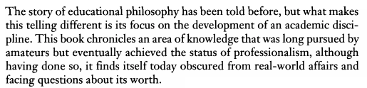
Following the introduction is the methods section. The methods section allows the author to convey how they carried out the study and why they made those decisions, and the results section shares the results of the study. The results section can often use visual aid to represent the findings. The “final” section, the discussion section, conveys to the audience why the results are important. Occasionally, a conclusion is used to discuss any limitations or future research the article may have. In Kyme’s journal, there is an excellent example of this kind of discussion of limitations.
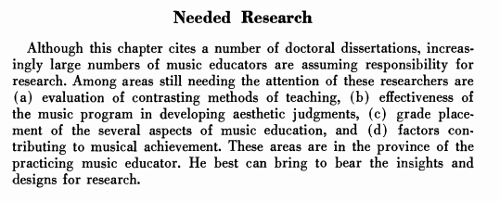
The author simply states how certain areas still need research and need to be worked on, providing insight into those limitations in list format. At the end of social science writings, acknowledgements, references, and the appendices may be found.
The structure of writing in the natural sciences does not differ far from writing in the social sciences. Both use the IMRaD format, as discussed previously. Titles of written works in this discipline are often a structural theme on its own, much like titles of the social sciences. Abstracts are also used in this discipline for the same reason, although in the natural sciences the abstracts often use jargon, as seen in the abstract from Eczema. 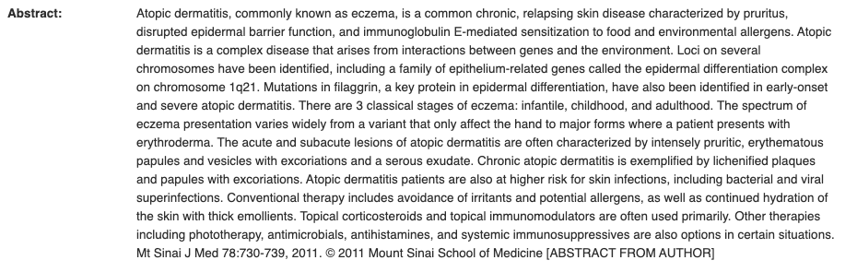
This example also illustrates how often due to the complexity of the content, abstracts vary in length from journal to journal. Authors in the natural sciences must write in great detail, especially when it comes to reporting. One way the natural sciences differ from the social sciences is the use of hypothesis statements that predict the outcome of the study. Another differing structural element is their inclusion of researchers' names, listing those who contributed in some way to the study. These lists often share the names of the people and the professional institutions they work for. In Where’s the evidence? Over-the-counter medicines and pharmacy practice, immediately following the title is an example of this practice. 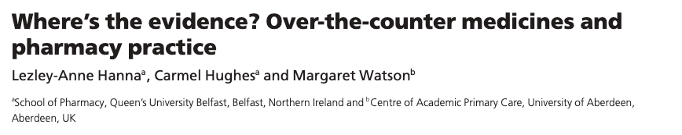
Often, the names listed first are those who were more heavily involved in the research. This practice shows the major amount of work that goes into the research process.

Reference Section
Authors in the disciplines constantly reference other works in their writing as a means of providing evidence to support their claim. They often use direct quotes, incorporating them into their text. It can allow the author to show arguments that may dispute their claim, but more often quotes are used as evidence. They are necessary for the authors to better convey their ideas and claims.
In Brooks’ article he states, “My subject then is drawing, a fundamental and wonderful art and, verily, what Leonardo da Vinci called it, "father of all the arts” (Brooks, 1920). This implementation of da Vinci’s quote shows an author using an extremely well-known artist to support his own claims. These writers have to treat the reference’s ideas and quotes respectfully, giving full credit to the author. With MLA in text citations, the authors names are often given and then the page number. This differs from APA, when page numbers are only necessary for full, direct quotes. This is evident in this example from Hatfield’s article: “In "The Future of the Profession," Jerry Griswold provocatively argues that "the time has come to begin separating . . . children's reading from children's literature," to distinguish the field of Children's Literature from "the new field of Childhood Studies" (241).” There is a direct quote, and in the parentheses, he cites the page number. This is because earlier in the sentence, he already provided the name of the author, thus completing the citation.
Typically, the social sciences adhere to APA format when it comes to reference and in-text documentation, rather than MLA. The main difference in these in-text citations is the year it was published is used in APA, because recency is an ideal that authors in the sciences strive to uphold. These scientists more often summarize ideas rather than use direct quotes, because they are not necessarily focused on the language, they are more focused on the methods and results. For example, in Casement’s review, he states “That presumption, coupled with a stiffness in style (figures of speech such as "hyperbole was conscripted to solicit notice," (p. 78) will limit this book's audience” (Casement, 1998). This is an in-text citation used because the author directly quoted someone else's work, whereas in the article Music Education, a different type of referencing is seen. The author states “Johnson (1958) made an impassioned plea for research into the history of American music as a starting place for research in music education” (Kyme, 1961). This type of reference is not a direct quote, it is a summarization of an idea, so the author pays respect to the person who formed the idea and the year it was relevant. Reference lists are seen at the conclusion of these writings and they include full citations of the works referenced or used in compiling research.
The natural sciences adhere to these same guidelines in their references, with very little variation. When quoting direct information from a source, authors can put parentheses around the information, and include a footnote number to lead to the reference section. Lezley-Anne Hanna, Carmel Hughes, and Margaret Watson state “The over‐the‐counter (OTC) medicines market is thriving. In 2011, the expenditure (in millions) on OTC medicines placed the Russian Federation highest (€9340), Germany second (€5614) and France third (€5521), followed by the United Kingdom (UK) (€3973)” (2012).This information is followed by a number that directs the reader to the end of the article, in the references section. Depending on the complexity of the article, many references may be used. In Eczema, over ninety references are listed at the end of their article. These references are necessary to pay respect to the work of others that the authors needed to study or reference in order to further that specific conversation.
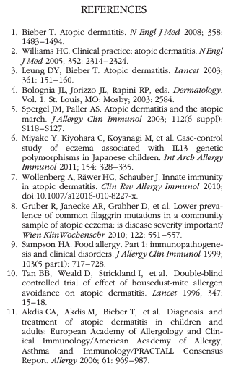

Discussion Section
Writing in the university is much more complex than I thought possible at the beginning of this project. The rules and regulations can vary across the disciplines, even with the certain similarities shared between them. It has been eye opening to work on this research, as I have learned that writing is much more than a format used to complete assignments. It is a medium, a means of expression used to convey thoughts, information, and ideas in every discipline. So often we pair writing with English class, when that is just one field of many. WAC furthers academic conversations and allows people to work upon the foundations that others have set. In this project, through the various requirements, readings, and rubrics, I have been taught the value of writing. I believe my research study conveys the value I have learned. My findings have helped me understand the differences and similarities in the various disciplines, specifically, in the fields of art, medicine, and education. It is my hope that my research study will present WAC in a new, fresh way to other students who may come in contact with it. Writing across the curriculum is facing developmental changes in this day and age, and with more awareness through the spread of knowledge, those changes will be positive. If I were to complete this research again, I would give myself more time to compile even more examples from other fields outside of art, medicine, and education to offer different comparisons. I believe that if more studies like this are done by students, more and more people will come to understand the power of writing, and they will come to respect WAC like I have. Further research can be conducted to see if these studies have an impact on a younger audience. It has been found that the freshman year of college is the most crucial stage in a college writer’s life, so if these studies on WAC are presented to younger students, maybe the value of writing can be understood earlier than the freshman year. This research was informative and impactful, and I know my own mindset was changed in a positive way.

Citations: (listed in alphabetical order according to author)

Brooks, A. (1920). Drawing. The Art Bulletin, 2(3), 137-147. doi:10.2307/3046357

Casement, W. (1998). History of Education Quarterly, 38(2), 227-229. doi:10.2307/370005

Emig, J. (1977). Writing as a Mode of Learning. College Composition and Communication, 28(2), 122. doi: 10.2307/356095

Hanna, Lezley-Anne, et al. “Where's the Evidence? Over-the-Counter Medicines and Pharmacy Practice.” International Journal of Pharmacy Practice, vol. 20, no. 5, June 2012, pp. 275–276., doi:10.1111/j.2042-7174.2012.00244.x.

Hatfield, C. (2006). Comic Art, Children's Literature, and the New Comic Studies. The Lion and the Unicorn, 30(3), 360–382. doi: 10.1353/uni.2006.0031

Herrington, A. J. (1981). Writing to Learn: Writing across the Disciplines. College English, 43(4), 379. doi: 10.2307/377126

Kyme, G. (1961). Music Education. Review of Educational Research, 31(2), 208-216. Retrieved April 6, 2020, from www.jstor.org/stable/1169141
Mcleod, S., & Maimon, E. (2000). Clearing the Air: WAC Myths and Realities. College English, 62(5), 573. doi: 10.2307/378962

Miller-Cochran, S. K., Stamper, R., & Cochran, S. (2019). An insiders guide to academic writing: a brief rhetoric. Boston, MA: Bedford/St. Martins, a Macmillan Learning.

Sohn, Andrew, et al. “Eczema.” Mount Sinai Journal of Medicine: A Journal of Translational and Personalized Medicine, vol. 78, no. 5, 2011, pp. 730–739., doi:10.1002/msj.20289.

Sommers, N., & Saltz, L. (2004). The Novice as Expert: Writing the Freshman Year. College Composition and Communication, 56(1), 124. doi: 10.2307/4140684

Walvoord, B. E. (1996). The Future of WAC. College English, 58(1), 58. doi: 10.2307/378534

