Jacob Compton

Distance Traveled by Golf Balls
Introduction.
Recently, a premier golf club manufacturer released a newer version of their golf balls. We are interested in the average distance traveled by these new golf balls, and whether the mean is greater than mean distance traveled by the old golf balls. A sample of data (SRS), which consisted of 36 new golf balls, was conducted. Each ball was hit using a mechanical driver to ensure accuracy. Does the data support the hypothesis that the mean distance traveled by the new golf balls is greater than the mean distance traveled by the old golf balls?

The manufacturer stated that the mean distance traveled by the old golf balls was 250 yards.

Graphs and Analysis.
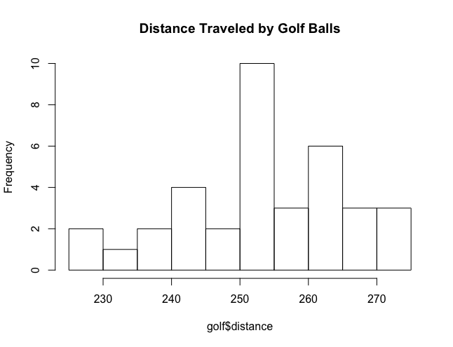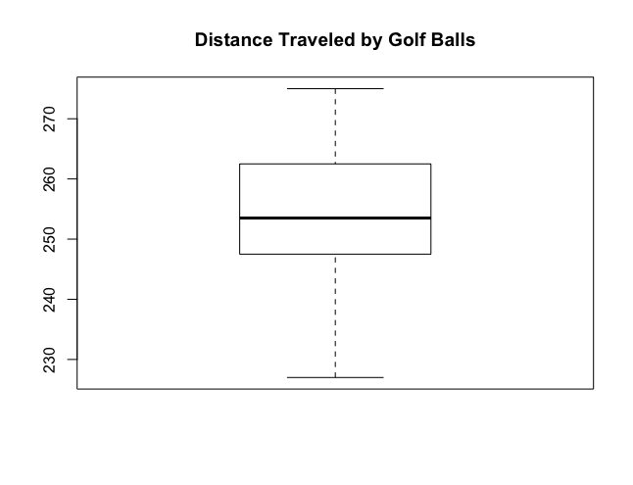

These graphs indicate that the mean distance traveled by the newer golf balls is slightly greater than the mean distance traveled by the old golf balls. On the histogram, the data points are more prevalent on the right side of the graph, which suggests that the mean will be higher than 250 yards. On the boxplot, the median is slightly greater than 250 yards, which also shows good inclination that the mean is greater than 250 yards. Neither graph shows a strong skew or outlier.

Hypothesis Test.
We define μ as the mean distance traveled by the newer golf balls distributed by the manufacturer.
We will test the hypotheses: H_{0;} μ ≤ 250 versus H_{a}; μ > 250
At the 5 percent significance level, we have strong evidence (t statistic = 1.992, p-value = .0271) to suggest that the mean distance traveled by the new golf balls (mean = 253.97) is greater than the mean distance traveled by the old golf balls (mean = 250).

One Sample t-test
data: golf$distance
t = 1.9915, df = 35, p-value = 0.02714
alternative hypothesis: true mean is greater than 250
95 percent confidence interval:
250.6022 Inf
sample estimates:
mean of x
253.9722

Conclusion.

We reject the null hypothesis and have strong evidence to suggest that the mean distance traveled by the new golf balls is greater than the mean distance traveled by the old golf balls.

Type I Error- An error of this type would occur if we had rejected the null hypothesis, which stated that the mean distance traveled of the newer golf balls is less than or equal to the mean distance traveled by the old golf balls, and then found out that the null hypothesis had been correct.
Type II Error- An error of this type would occur if we had failed to reject the null hypothesis, and stated that the mean distance traveled by the old golf balls was greater than or equal to the mean distance traveled by the new golf balls.

