Jacob Compton
Results

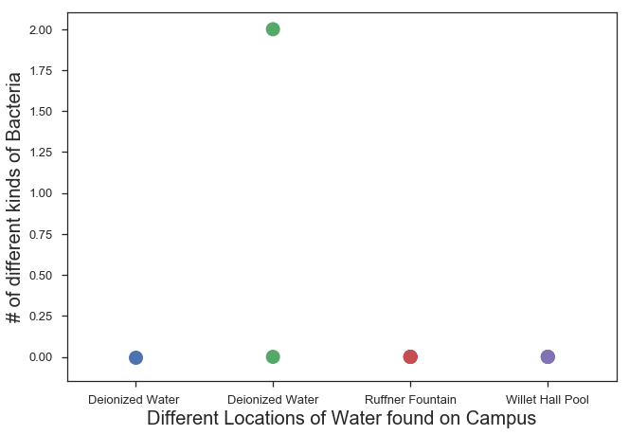

Figure 1. Number of Different Kinds of Bacteria This graph shows the number of different bacteria that grew in a specific location on campus. Only 2 kinds were found, both on the second trial for Deionized Water, the control of the experiment.

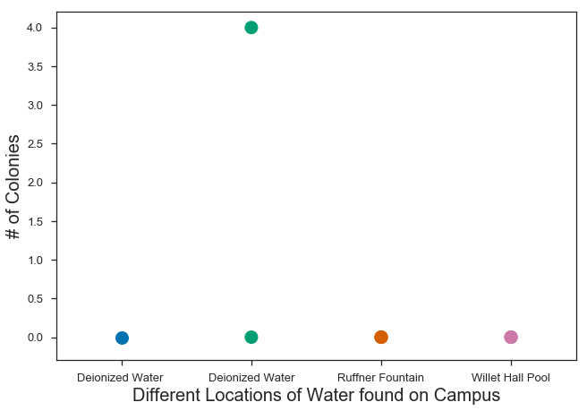
Figure 2. Number of Bacterial Colonies This graph shows the number of colonies that grew on the sample from each location. In this case, four colonies were found on the second trial for
Deionized Water.

Table 1. Color of Bacteria This table shows the diversity of color that was found when looking at the bacteria growth. 3 of the colonies were white, while one of the colonies was yellow.

TREATMENT | REPLICATE | WHITE | YELLOW
Deionized Water | 1 | 0 | 0
Deionized Water | 2 | 3 | 1
Deionized Water | 3 | 0 | 0
Ruffner Fountain | 1 | 0 | 0
Ruffner Fountain | 2 | 0 | 0
Ruffner Fountain | 3 | 0 | 0
Willett Hall Pool | 1 | 0 | 0
Willett Hall Pool | 2 | 0 | 0
Willett Hall Pool | 3 | 0 | 0

Table 2. Shape of Bacteria This table shows the different shapes of the bacteria growth. All of the colonies were circular in shape.

TREATMENT | REPLICATE | CIRCLE | SQUARE
Deionized Water | 1 | 0 | 0
Deionized Water | 2 | 4 | 0
Deionized Water | 3 | 0 | 0
Ruffner Fountain | 1 | 0 | 0
Ruffner Fountain | 2 | 0 | 0
Ruffner Fountain | 3 | 0 | 0
Willett Hall Pool | 1 | 0 | 0
Willett Hall Pool | 2 | 0 | 0
Willett Hall Pool | 3 | 0 | 0

Within this experiment, only two different kinds of bacteria grew on the agar dishes, from the samples that was collected that contained deionized water (Figure 1). The two kinds of bacteria, however, were spread out into four colonies (Figure 2). Within these four colonies, three of them were white in color, while one of them was yellow in color (Table 1). Although the previous figures and tables showed differing results, all of the bacterial colonies were circular in shape (Table 2).

