The Manual
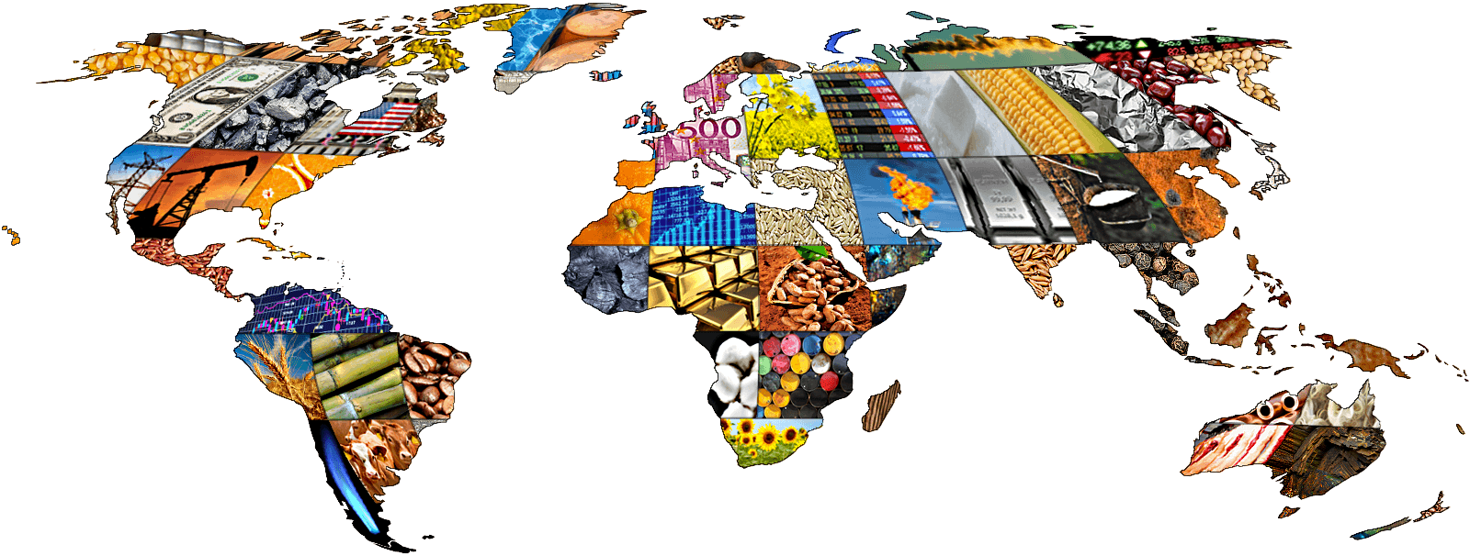
? = Wealth
[Benefiting from International Trade]

David Peirce
Longwood University
Department of Business & Economics

Real-world Document
ENGL 319
Dr. Guler

Table of Contents

Introduction

About the Author……………………………………………..….3
Overview………………………………………………………………3

Unit 1: Why do we Trade?.............................4

Main Idea…………………………………………………………….4
The Public Opinion….…………………………………………..4
Reference Definitions…………………………………….5 & 6

Unit 2: How to Benefit from International Trade…7

Main Idea…………………………………..………………………….7
[Step 1] Globalization……………………………………………..7
[Step 2] Specialization………………...............................8
[Step 3] Determining Trading Opportunities……………8
[Step 4] Determining the Terms of Trade…………….….9
Free-Trade Conclusion…………………………………………...9

Work Cited……………………………………………………10

Introduction

About the Author

David Peirce is a student at Longwood University. He is majoring in General Economics and is also pursuing a minor in Mathematics. David is a member of Theta Chi Fraternity, Sigma Alpha Pi: Leadership and Honor Society, and the Ultimate Frisbee Club. He intends to go to graduate school after finishing his undergraduate degree and hopes to one day be employed as an investment banker.

Overview

Businesses and corporations that attempt to internalize all costs of production have unknowingly capped their profit maximization capacity. The purpose of this manual is to highlight the benefits of free trade within a corporate entity or business. The application of free trade is an ideal strategy that can facilitate large and small corporations alike, and the processes to implement it will be outlined here.

Unit 1: Why Do We Trade?

Note: Underlined words are defined below in the “Reference Definitions” section.

Main Idea

International organizations exchange goods with an understanding that the transaction is mutually beneficial. Countries import commodities that they cannot or do not produce domestically and export the commodities they can produce domestically. How does this tie into why countries trade?

International trade as it relates to business offers great potential for the parties to incur revenue. Businesses or organizations that engage in these mutual transactions are more likely to profit than those who rely on self-sufficient means of internal production.

The Public Opinion

The public or stakeholders may have reservations about participating in international trade. Some commonly asked questions about trade are:

- What can poor countries offer their wealthy partners?
- Are there winners and losers from trade?
- Doesn’t outsourcing through international trade reduce the availability of jobs within a country?

These are all valid questions that can be answered with one common conclusion: trade indeed benefits all parties involved, and this manual will explain how.

Note: This manual will present the information as it is connected to companies. Countries are used in Unit 1 to show a more general perspective.

Reference Definitions

Commodity | A commodity is a marketable item produced to satisfy wants or needs. Economic commodities comprise goods and services.
Corporation | A company or group of people authorized to act as a single entity (legally a person) and recognized as such in law.
Economic Globalization | Is the increasing economic integration and interdependence of national, regional and local economies across the world through an intensification of cross-border movement of goods, services, technologies and capital.
Economic Resources | Are the factors used in producing goods or providing services
Exchange | Is an economic transaction where goods or services are transferred from the provider for a return of relative value (compensation) from the receiver in a manner that advances the economic interests of both parties.
Expansion | The phase of the business cycle when the economy moves from a trough to a peak. It is a period when business activity surges and gross domestic product expands until it reaches a peak
Exports | Sending (goods or services) to another country for sale.
Free-Trade | Trade in goods and services without taxes or other trade barriers.
Factors of Production | An economic term to describe the inputs that are used in the production of goods or services in the attempt to make an economic profit. The factors of production include land, labor, capital and entrepreneurship.
Internalization | A transaction conducted within the confines of a corporation rather than in the open market.
Industry | A classification that refers to a group of companies that are related in terms of their primary business activities.
Import | A good or service brought into one country from another country.
Outsourcing | A practice used by different companies to reduce costs by transferring portions of work to outside suppliers rather than completing it internally.
Profit Maximization | In economics, profit maximization is the short run or long run process by which a firm determines the price and output level that returns the greatest profits.
Productivity | An economic measure of output per unit of input. Inputs include labor and capital.
Specialization | A method of production where a business or area focuses on the production of a limited scope of products or services in order to gain greater degrees of productive efficiency within the entire system of businesses or areas.
Self-Sufficiency | (Also called self-containment) is the state of not requiring any aid, support, or interaction, for survival.
Trade | An economic concept that involves multiple parties participating in the voluntary negotiation and then the exchange of one's goods and services for desired goods and services that someone else possesses.
Terms of trade | Refers to the relative price of exports in terms of imports and is defined as the ratio of export prices to import prices. It can be interpreted as the amount of import goods an economy can purchase per unit of export goods.
Wealth | A measure of the value of all of the assets of worth owned by a person, community, company or country.

Unit 2: How to Benefit from International Trade

Note: Underlined words are defined above in the “Reference Definitions” section.

Main idea

Unit two will outline the procedures a company should follow to reach the goal of expansion through trading. Trading allows companies to expand while simultaneously cutting costs. These steps should be followed chronologically. The steps represent conceptual ideas that need to be understood in some cases and applied in others.

[Step 1] Globalization:

Globalization is the advance of human cooperation across national boundaries. Complete comprehension of this definition is crucial to understanding the benefits of international trade.

In summary, this theory claims that by including all countries (poor and rich alike) in the free-trade economic system, the world will be better off. Globalization theorizes an end to poverty, inequality, and other issues of morality and ethics.

Globalization as it relates to production is significant, because it demonstrates how international cooperation can reduce production costs of goods and services. It’s unreasonable to assume that a single country is capable of creating every element of a product within its national boundaries—the resources necessary for production may be unavailable or more cost-effective through outsourcing.

Figure 2.1 is a graphical representation of Globalization. The image depicts how we are all just pieces in a bigger puzzle.
Figure: 2.1

[Step 2] Specialization  The geographic separation of people and resources creates a need for specialization. Globalization offers a solution by proposing international cooperation as a means to simplify production through segmentation. A society’s resources determine what industries are realistic for that country to specialize in within the global market. Resources can range from opportunities for education and training, natural resources like rainforests, to any other factor of production.  - For an individual, specialization can come from extensive study of a single subject in school or vocational training. Professionals like doctors, engineers, plumbers, cosmetologists, and actors are all examples of specialists in a field.  - For a corporation, specialization is the specific good or service that is produced for consumption. For example, Apple and Microsoft specialize in technology, while Merry Maids specializes in domestic maintenance. Both exemplify the specificity of corporate specialization. | [Step 3] Determining Trading Opportunities  The most logical method of expansion is the reduction of production costs. Investigating alternative resources for the factors of production can sometimes lead a business to trade opportunities with an international market that offers those factors at a lower cost. A particular business will import goods that are cheaper to outsource than produce internally. Those outsourced goods are called exports.

Figure 2.2 is an example of trading opportunities. The illustration shows different countries trading partners and the goods and services they exchange.
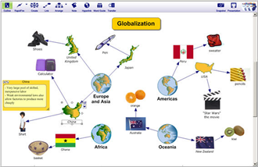
Figure 2.2

[Step 4] Determining the Terms of Trade  After a company has figured out where to acquire the individual elements necessary for production, the terms of trade can be established between the two parties. Terms of trade are the costs accepted for the purchase or exchange of another company’s commodities. Typically, these are long-term transactions of large quantities. The costs should remain relatively constant over the set length of time so that each party can appropriately allocate funds each quarter and maintain presence in the competitive marketplace.  Terms of trade, or exchange rate are established as a ratio of one party’s goods to another. For example: An American grocery store franchise partners with a similar business overseas. Their terms of trade establish that the American company will exchange 3 apples per 2 bananas imported from the foreign company. The ratio 3 apples per 2 bananas demonstrates the exchange rate. | Free-Trade Conclusion  Free-Trade as an economic practice is mutually beneficial for all parties. It encourages competitive exchange rates; a sign of a healthy global economy. Similarly, it benefits the two entities when production costs are reduced through importation of goods. If it is more costly for a business to produce factors of production domestically than it is to have those same factors of production imported from overseas, the logical step is to engage in international trade. In addition to financial incentive, free-trade as it relates to globalization encourages a sort of international cooperation that promotes intercultural relationships with a professional pretense.

Work Cited

- http://dictionary.reference.com/ (For majority of reference definitions)

- http://www.investopedia.com/terms/f/factors-production.asp?header_alt=true (other reference definitions)

- http://www.britishchambers.org.uk/assets/downloads/RBS_Guide_to_international_trade.pdf, The Royal Bank of Scotland, 2011

- Mattoo, Aaditya. "A Handbook of International Trade in Service." 2007. Web.

- "A Troubling Trajectory." The Economist. 2014. Web.

- "GLOBALIZATION : Good or Bad?" A Global Forum. SocioCosmo, 2013. Web. (graphics)

- "The Benefits of International Trade." Class Lecture. Farmville. 1 Sept. 2015. Lecture.

- Corbett, Micheal. "The Outsourcing Revolution." The Economist. The Economist, 2004. Web.

