

Troy Clift December 4, 2017

* 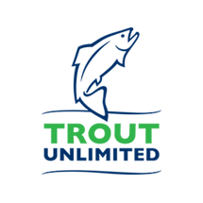 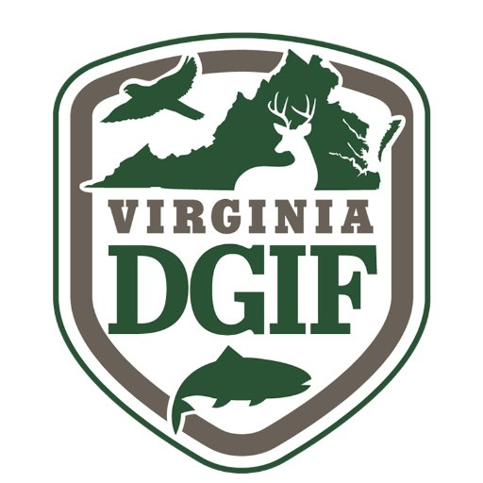 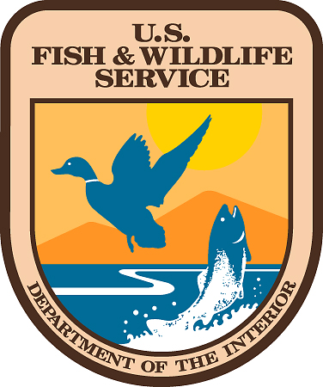 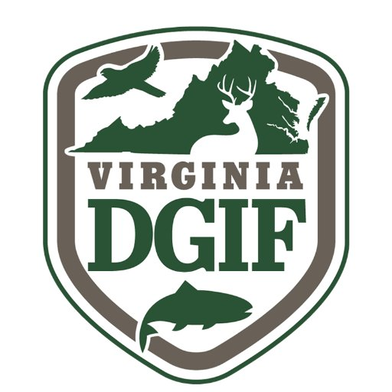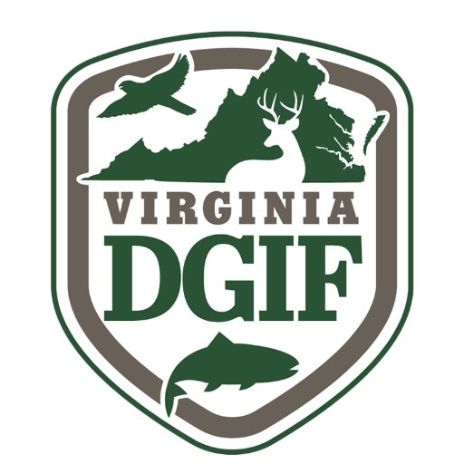

## Didymo is a harmful alga native to the cold, freshwater streams of Scotland. This is an invasive organism introduced to Virginia trout streams on the boots of fisherman. This newly introduced alga can reduce forage for game fish. A reduction of forage can lower fish stocks because there is far less food for the fish.

## Stop the Spread of Invasives

## Wash all fishing equipment with soap and water to remove any debris that may contaminate other trout streams with this harmful invasive alga.

Rock Snot

*Didymospenia geminata*

# Didymo