Statistical Analysis Conducted From Longwood University’s Student Survey

Joely Clawson-Keeton
Math 171, Dr. Steven Hoehner, Spring 2020

Introduction
Before conducting my confidence interval, I hypothesized that the Female BMI would be slightly higher than the Male BMI on average. After generating my random numbers and the mean, I realized that was true, but the male BMI has a much wider set of data than female BMI, throwing off the mean and not showing my beliefs that female BMI are higher. This statement is supported by graphs 3 and 4.

Data Collection
The population in this study is the students who registered for Math 171 and Math 304 courses in spring of 2019. The sex, class, and presidential approval are categorical while the weight or BMI of students is quantitative, and continuous because people gain and lose weight throughout the rest of their life. I obtained my random sample by going onto my TI-84 calculator, going to the Math button, then going to probability and then scrolling down to 8, which is randIntNoRep, which means that I can generate random values which will all be different. I put my lower number as 1, because that’s where the list of students starts, and for my upper number I put 219, because that’s where the list ended for the girls. I then put 40 for the amount of numbers I wanted generated because I need 40 for girls and 40 for boys. I then generated more random intervals using the randIntNoRep, where my lower number was 220 because that’s when males started appearing on the list. My upper number is 349 because that is where the data ends. For the amount of numbers I wanted generated I put 40 again. My random samples do represent both the 300 level classes and introductory statistics courses, so I feel confident using my samples to represent the population.

Data Description
For the female range of presidential approval the mode was 22 women reporting disapproval with the president. I arranged my histogram approval ratings into 3 columns, 1-1.42 indicated approval, 1.83-2.25 indicated uncertainty, and 2.67 to 3.08 indicated disapproval. However, males mode differed with the mode being 15 men reporting uncertainty. Between my two samples the data differed drastically, with over half of the female sample indicating disapproval and a quarter indicating uncertainty, while the male sample was nearly evenly divided between the three ranges with uncertainty being the most prominent. Overall I would say that females tend to disapprove of the president while the male population is fairly divided. For the male population 20 men were in the 22-29 BMI area while the mode for women was 13 women in the 21-24 BMI range. Men tended to have a lower BMI than women but that is natural because women have more fat than men, found in breasts and other regions to assist with pregnancy. However, the men had a much wider range in BMI, with one person going above 60. The shape of the female BMI range is nearly symmetrical, but slightly skewed right, and is unimodal. The male BMI chart is skewed right and unimodal but is much more skewed than the other BMI chart due to a much wider range of values. The male BMI data has an outlier of 62.9, which I verified by firstly finding my median, 24. I also found in between my two quartiles and subtracted 1.5 times IQR and subtracted 62.9, and then determined it was an outlier.

Data Analysis
The first condition in the hypothesis test is if the samples were selected randomly, and they were generated randomly. My hypothesis was that the two BMI’s would be nearly similar but with the female BMI slightly higher. I calculated the test statistic to be -2.289, the degrees of freedom to be 65.87%, and the p value to be 1%. My data helped me determine that the confidence interval of my two population samples to be between -1.7145 and 4.3545. To find all this I determined the standard deviations for both populations in my graphing calculator, and the means for both populations as well. By having all that and my population number I was able to plug everything into different formulas and end up with my confidence interval realization.
Appendix
Graph 1)
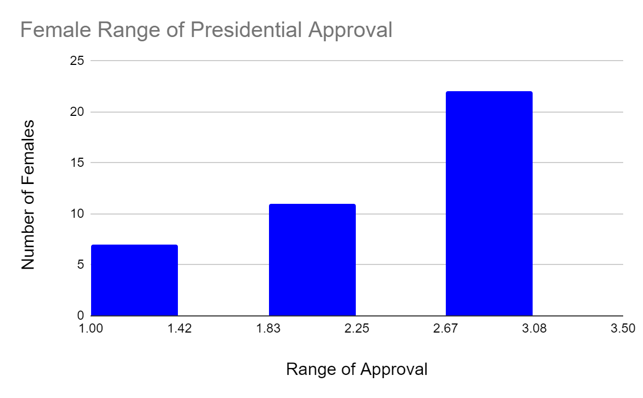

Graph 2)
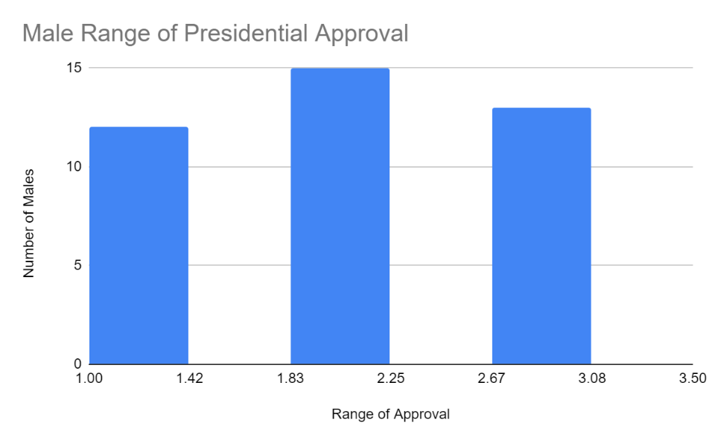
Graph 3)
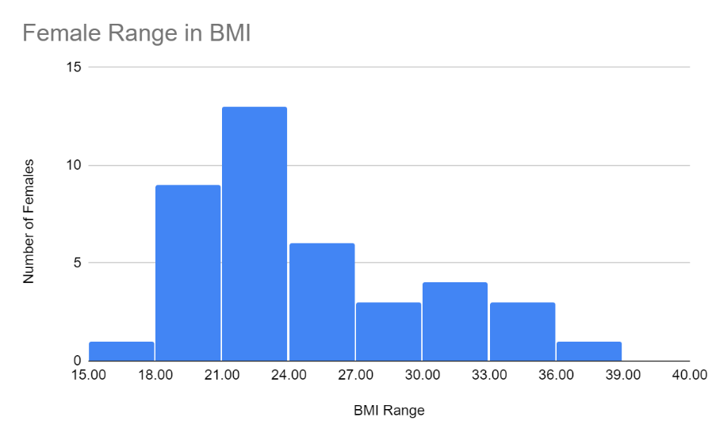
Graph 4)
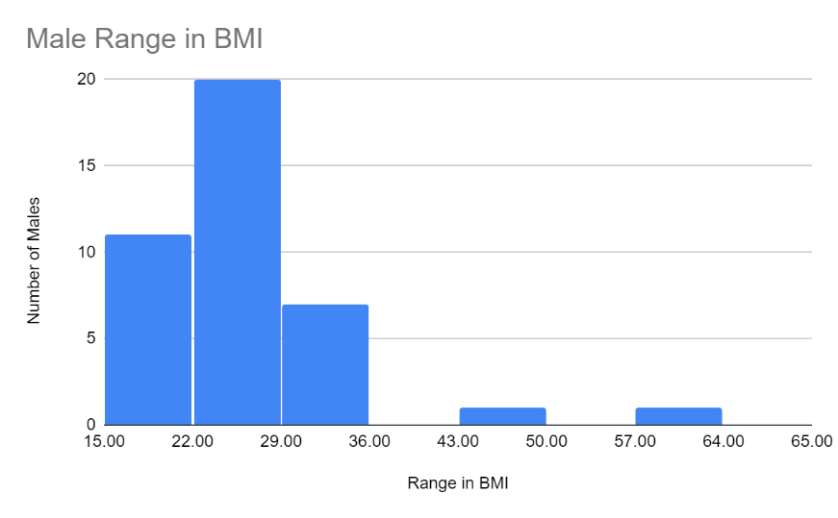
Graph 5)

Graph 6)

Male BMI 5 Number Summary
Minimum | 16.8
First Quartile | 21.5
Median | 24
Third Quartile | 28.35
Maximum | 62.9
Female BMI 5 Number Summary
Minimum |  | 17.1
First Quartile |  | 21.05
Median |  | 23.5
Third Quartile |  | 28.25
Maximum |  | 37
Table 1 and 2)

