This is a map of Sugar Hollow Trail to Blue Hole located in Crozet, Virginia. The map is for me, when I go hiking at Sugar Hollow Trail to Blue Hole. The map is designed to help me strategically plan my trip. I set in place a start destination, finishing point, breaks,and mountain view lookout. I hope to pace myself when hiking the trail so I can be able to fully enjoy the 6 mile hike.

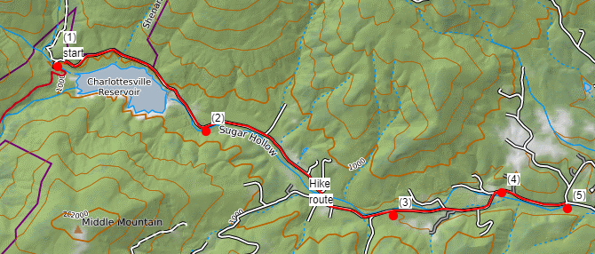
.

- Start of the hike Main entrance. Address 6796 Sugar Hollow Rd, Crozet, VA 22932
- Resting point one mile in.
- Resting point two miles in, Lunch break.
- Mountain overview.
- End of hike point. Turn back to the starting point (1) of the hike. Then I will use the same markers as my resting points on the way back.

