CRISPR Cas9, The Cure For Disease, The Cure For Hunger, The Cure For All… Or Is It?
By Reece Theakston

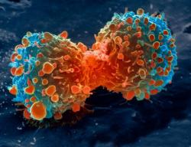

In the past for years the world of science, genetics, and diseases has had and explosion of new technologies that can allow us to make the world a better place, a place where there is no hunger no disease and no problems. At least that’s the goal for this new and constantly developing technology CRISPR Cas9, but unfortunately its not that simple. There are a list of problems that are preventing the scientific community from moving forward with this world changing method. First, before we take a look at what all the hype behind CRISPR is we need to understand what it is and how it works and then you can decide if we should stop with the progress
What is CRISPR and where did it come from?
CRISPR stands for Clustered Regularly Interspaced Short Palindromic Repeats, which are the hallmark of a bacterial defense system that forms the basis for CRISPR-Cas9 genome editing technology. These repeats are then turned into RNA which can be used to guide the system to matching pieces of DNA. When the target DNA is found, the protein Cas9 will bind and cut out the DNA strand allowing for scientists to select and pick which genes in an organism to be expressed. Now that you have a brief understanding of how CRISPR works the question remains, where did it come from and who discovered it? CRISPR was first discovered off the coast of Spain by Francisco Mojica who was studying microbes whose protein functions were altered by high salt concentrations. This change in function showed the main characteristic of CRISPR and that is the ability to cut DNA. Once Mojica noticed these cuts and decided to take and closer look and where these cuts were being made he saw regularly clustered repeats which were also found in other forms of bacteria.
CRISPR’s influence on HIV treatment
Now that we have a basic idea as to how CRISPR works and where it came from and can start to look at how it is being applied throughout the scientific community. This technique is being used to treat a wide variety of dieses but one of the most recent break throughs is the use of CRISPR on HIV. Currently about 36.7 million people were living with HIV around the world in 2016, and an estimated 1 million people died from AIDS-related illnesses in 2016. When dealing with HIV some of the virus tends to remain stuck in the persons chromosomes undetectable and asleep. This part of the virus is untreatable and can “wake up” at any time resulting in the person with the disease to once again be infected. This is where CRISPR is changing lives and our understanding of diseases. Scientists and using CRISPR to go in and purposefully “wake up” this part of the virus allowing for them to be treated in what scientists using this method call “shock and kill”.
CRISPR’s influence on Cancer treatment
In todays society cancer is one of the most feared diseases known to mankind and currently is one of the top killers of humans with about 7.6 million people dying from cancer worldwide every year. In order to understand how CRISPR is being used to treat cancer we need to know how cancer forms. Cancer is formed when there is a mutation in a cell that causes the cells signaling to mess up resulting the cell having the ability to multiply rapidly and never die. This is what a tumor is, a collection of cells that is ever growing. Scientists are using CRISPR to treat cancer by taking advantage of how CRISPR can target specific locations and are using that to edit the RNAs affecting cancer growth and reproduction. This method of cancer treatment is revolutionary in today’s world and possibly life changing to those suffering from this terrible disease, if perfected this method could change the world.
Other applications of CRISPR/Cas 9
The past few years have been booming around the idea of CRISPR and how it could be used to solve many of the problems that the world faces today such as ever decreasing fossil fuels, world hunger, and the deadliest of genetic diseases. These models can be used to observe changes in the genes, diseases, and how they affect different organisms by changing which genes are being expressed. Another use of CRISPR is to change biological pathways to create synthetic materials that could be used for administrating medicines. A third application of CRISPR is to genetically edit crops in order to make them more resistant to infection and weather conditions. One of the main promotions behind CRISPR is that foreign DNA isn’t being used so the term genetically modified or “GMO” does not pertain to the results of CRISPR. Another application of CRISPR as mentioned above is the treatment of diseases such as HIV and Cancer, two of the most notable diseases of humankind.

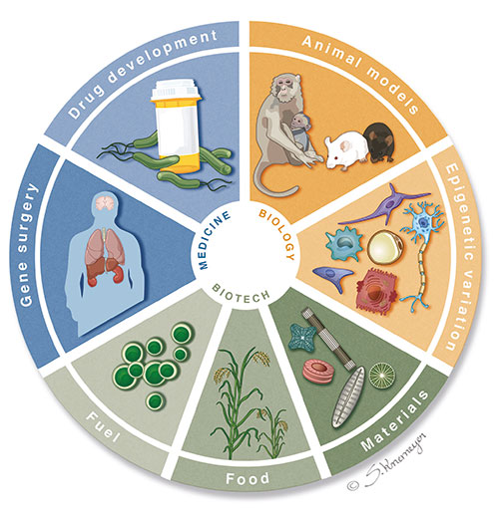
Figure 1. Wheel of CRISPR Applications
This figure shows some of the main ways CRISPR can be used. Including but not limited to better and more efficient fuel, more resistant crops, synthetic materials, epigenetic variations, animal models to better understand diseases, drug development resulting in cheaper pharmaceuticals, and gene surgery.

Cons of CRISPR
There is a reason that CRISPR isn’t as commonly used in today’s world despite all of the possibilities for helping people, in reality CRISPR can be extremely dangerous especially when being used on people. CRISPR/Cas 9 is a method used to cut and edit DNA in order to express specific genes, but this method doesn’t always work as planned. One of the major cons of CRISPR is that if a subject where to go through CRISPR treatment it is possible that a multitude of unwanted mutations could occur. Another con to using CRISPR in the near future is that if we start meddling with the genetics of people, crops, and animals we could have a huge effect on basic evolution leading to a “Frankenstein future” -Dr.Leech. The most important con to CRISPR which is the main reason for the delay in CRISPR research is the ethical dilemmas that come with it, should we be allowed to edit the genes of people, embryos, animals, and crops. Even if the scientific community could agree with todays society and go ahead with experiments do we release these specimens into the real world?
Keep it or get rid of it
Many people do believe that we should to continue the advancement of CRISPR applications especially the possibility of curing life threatening diseases such as HIV and Cancer. So, as the debate stands, do we continue to watch China take the lead in the field of genetics and the application of CRISPR or should we continue our research toward the possibility of fixing world problems?
References
Baumann, M. (2016). CRISPR/Cas9 genome editing - new and old ethical issues arising from a revolutionary technology. Nanoethics, 10(2), 139-159.
Dyall-Smith, M. (2011), Dangerous weapons: a cautionary tale of CRISPR defence. Molecular Microbiology, 79: 3–6. doi:10.1111/j.1365-2958.2010.07451.x
John J. Mulvihill, Benjamin Capps, Yann Joly, Tamra Lysaght, Hub A. E. Zwart, Ruth Chadwick, ; Ethical issues of CRISPR technology and gene editing through the lens of solidarity, British Medical Bulletin, Volume 122, Issue 1, 1 June 2017, Pages 17–29,
Karenarchey. “The Pros and Cons of CRISPR and DNA Editing.” e-Flux Conversations, 13 Jan. 2017, conversations.e-flux.com/t/the-pros-and-cons-of-crispr-and-dna-editing/5855
Lu, X., Qi, X., Zheng, D., & Ji, L. (2015). Modeling cancer processes with CRISPR-Cas9. Trends in Biotechnology, 33(6), 317-319.

