Reece Theakston
Dr.Znosko
Bio Lab 120
3-29-17

Results
In this experiment, the samples of bacteria were tested were found on different sections of the floor ranging from no traffic (Control section), to medium traffic (Lab section), to high traffic (Hall section) on agar plates. These sections were tested to find which section had the highest average of bacterial growth, large number of colonies and what type of colors each sample produced. Observations of the agar plates showed that for average percentage covered by bacteria, the high traffic section (Hall section) had the highest average covered by bacteria with an average of 93%. The no traffic area (Control section) had the second highest average covered by bacteria with an average of 70%, and the medium traffic area (Lab section) had the lowest average covered by bacteria with an average of 63% (Figure 1). A second observation of the agar plates revealed that each section had several large colonies of bacteria on them, each large colony was counted per section. This information was then averaged and graphed, resulting in the high traffic area (Hall section) having the highest average of 2.66 large colonies. The medium traffic area had the second highest average of 2.33 large colonies. The no traffic area (Control section) had the lowest average of large colonies with an average of 2 large colonies (Figure 2). A more thorough look at the agar plates reveals that each section had different colors of bacteria growing. The Lab section was the most colorful with white and orange bacteria growing on the first section and white and yellow bacteria growing on the other two sections. The Control section was the second most colorful with white bacteria growing on the first section, white and brown bacteria growing on the second section, and white and yellow bacteria growing on the third section. The Hall section had the least amount of color with white bacteria growing on the first two sections and white and yellow bacteria growing on the third section (Figure 3).

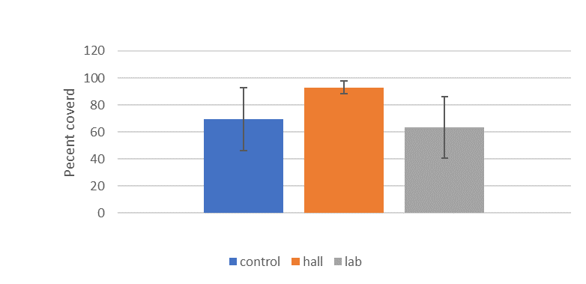
Figure 1. Percentage of Ager Plates Covered by Bacteria. Percentage averages of designated areas in a petri dish covered by bacteria. Data shown for Control section, Hall section, and Lab section. The Hall section had the greatest average amount covered by bacteria on it, then the Control section and the Lab had the smallest average amount covered by bacteria. Bar heights are average amount covered by bacteria and error bars are the standard deviation of the three trials for each section.
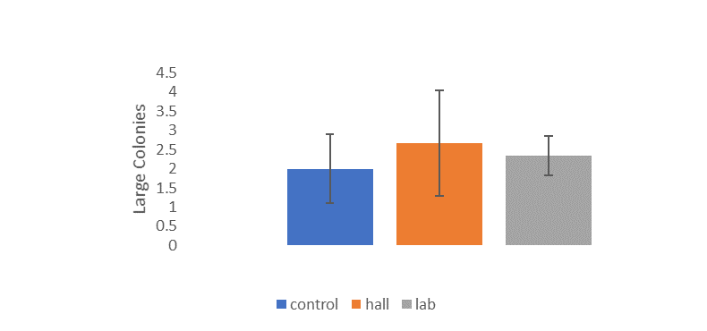

Figure 2. Number of Large Colonies Found on Ager Plates. Average number of large colonies found on the different sections of the petri dishes. Data shown for Control section, Hall section, and Lab section. The Hall section had the greatest average number of large colonies on its sections, then the Lab section had the second greatest average number of large colonies on it, the Control section had the smallest average number of large colonies found on each section of the petri dishes and error bars are the standard deviation of the three trials for each section.

Colors of Bacteria per Section
Sample Sections | dish 1 |  | dish 2 |  | dish 3
control | white |  | white & brown |  | white & yellow
hall | white |  | white |  | white & yellow
lab | white & orange |  | white & yellow |  | white & yellow

Figure 3. Color of Bacteria per Ager Plate Section. Different colors of bacteria were found on different sections of the petri dishes. Data is shown for the Control section, Hall section, and Lab section. The Lab section was the most colorful because it had the most colored bacteria per section, the Control section was the second most colorful because it had less color per section when compared to the Lab section but more color per section when compared with the Hall section. The Hall section had the least amount of color per section when compared to the Lab and control sections.

