Reece Theakston
Dr.Shanle
Biology 250
11-2-17

Results
In this experiment, water samples of different water fluidity were taken from two sites in Buffalo Creek and were put through sequencing in order to determine which fluidity, flowing or stagnant, would have the most microbial diversity and abundance. The samples were first put onto agar plates which grew colonies which were used to determine which site had the most diversity (color) and abundance (quantity of colonies). Observations of the cultured agar plates revealed that Site A had the most abundance of bacteria on the agar plates as seen in figure 1. Site B had the most color diversity due to its diversity in colony color Figure 2. Once the cultured agar plates were observed, a single colony from site A, plate 10^0 and site B 10^0 were selected for sequencing to determine what species of microbes were in Buffalo Creek. After the samples were put through PCR 16s sequencing and DNA sequencing the results were put through gel electrophoresis to determine the fragments in the DNA which were used to compare the fragments of the top BLAST hit, Image 1. The sequence results were also run through snap gene viewer and BLAST analysis. Snap gene viewer showed that sample A was properly sequenced with very little unknow bases while site B was shown to have very many unknown bases, this meant that the sample was contaminated with different DNA. The BLAST analysis showed that site A had a top BLAST hit of Bacillus mycoides with a 99% identity.

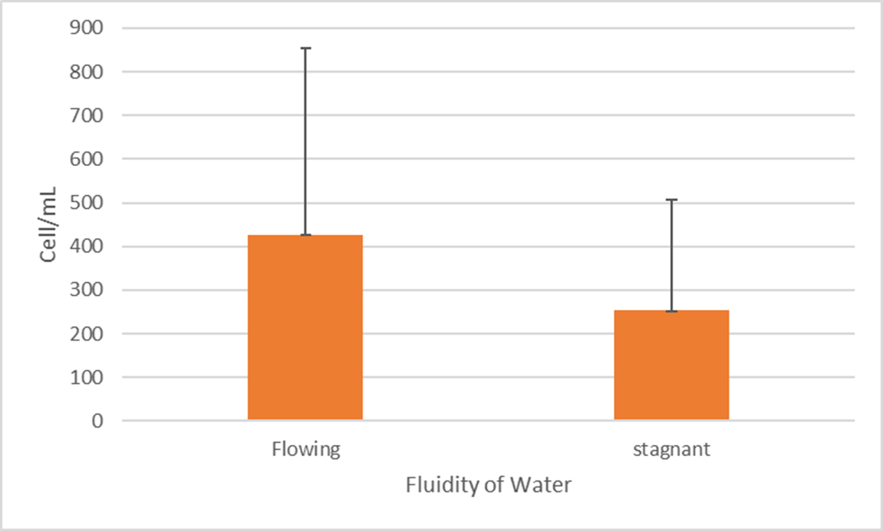
Figure 1. Abundance of Bacteria in Flowing and Stagnant Water. Site A which was the flowing water sample had the most microbial abundance due to its cell/mL count being around 425cell/mL. Site B which was the stagnant water sample had the least microbial diversity due to its cell/mL count being around 250cell/mL.

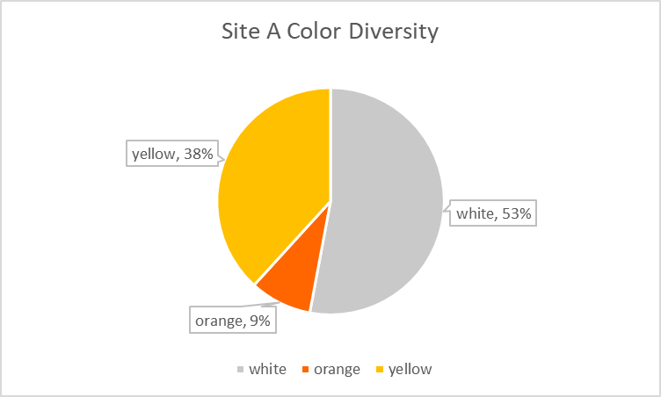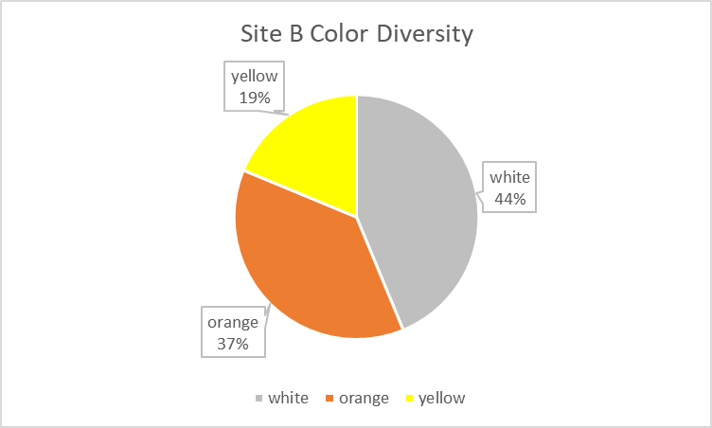
Figure 2. Bacterial Color Diversity Between Flowing and Stagnant Water. Site B had the most color diversity due to its more evenly distributed bacterial colors between white, orange, and yellow. Site A had the least color diversity due to the bacterial color percentage being mostly between white and yellow and very few being orange.

Image 1. Gel Electrophoresis Results. Left to right- Positive Control, Ladder, PCR Flowing, MspI Flowing, PCR Stagnant, MspI Stagnant.

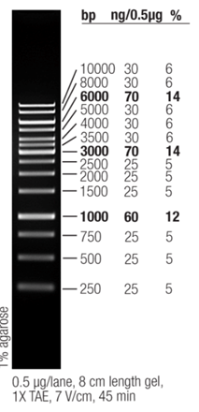
1500bp 1000bp
800bp
600bp
350bp

