Reece Theakston
Dr. Fortino
Bio 251
12/3/17
Introduction
The non-indigenous Corbicula fluminea is a bivalve filter feeding species of freshwater clam, often referred to as the Asian or Asiatic clam due to its Eastern Asia origins (Sampaio and Rodil, 2013). C. fluminea filters microscopic organisms, such as plankton and other organic matter from the water(Naumann,1999). This is important when trying to determine how heavily populated an area is with C. fluminea. C. fluminea are most commonly found in lakes or streams that have sandy or gravel bottoms (Naumann,1999). C. fluminea can also be located underneath large boulders and in soft silts of deepwater lakes(Naumann,1999). C. fluminea have a better fitness in fast flowing waters due to the currents which supply a constant source of the particulate food that the clam consumes(Naumann,1999). C. fluminea is hermaphroditic, with single genopores on each sides of the body. Reproduces biannually in the spring and in the late summer. Corbicula fluminea is believed to practice self-fertilization, enabling rapid colony regeneration when colony populations are low(Naumann,1999). This process of reproduction allows for the rapid colonization of an area and for a rapid increase in population which can affect the overall levels of organic matter. Settlements of Corbicula fluminea occur with a population density ranging from 100 to 200 clams per square meter(Naumann,1999). However, populations can grow as large as 3000 clams per square meter(Naumann,1999). There appears to be no competition for food among individuals within the species, however within high density populations, space competition is often important(Naumann,1999). C. fluminea also create problems for power plants by blocking the ventilation systems and the water intake valves. Combined costs of outages, reductions in efficiency, capital investment in equipment, labor and chemical control, exceed 1 billion annually (Naumann,1999). The C. fluminea found behind buffalo creek which is a part of the Appomattox river are non-indigenous to that area, little is known about how they originally populated this river and little to none is documented about the effects C. fluminea had on this environment and the organisms that inhabited it. The introduction of non-indigenous species is one of the main reasons for the loss of biodiversity worldwide due to their competition for habitat and nutrient resources with native species (Stachowicz et al., 2002). This invasion of C. fluminea is an important topic to study because if C. fluminea continuously reproduces and grow in population we could see devastating impacts to our local environments. For instance, a decrease of biodiversity in a base level of the trophic web could lead to a collapse in the abundance of predatory commercial fishes, in case that fish does not feed on the introduced species (Sousa, 2008). The colonizing process of this invasive species can lead to repercussions in the food webs and biogeochemical cycles due to direct competition with native species and the clam’s strong capability to influence the availability of phytoplankton and nutrient resources in the new hosting ecosystem (Sampaio, 2013).
Although there are some reports of some faunistical groups responding positively to C. fluminea’s abundance (Ilarri, 2012), the introduction of this invasive species has been shown to diminish the abundance and diversity of macro and micro-fauna in North America and Europe (Hakenkamp, 2001). Similar findings are likely to be found in buffalo creek due to high populations of C. fluminea. If corbicula is present in many sites on Buffalo Creek, then we will see a decrease in the amount of organic matter at those sites. If there is a decrease in organic matter then there will be a decrease in other natural habitats. One purpose of this study is to find out which/ how many organisms are being impacted directly or indirectly. Also, to see which organisms are being impacted the most such as other filter feeding organisms. If there is a decrease of other filter feeding organisms in Buffalo creek where corbicula are present, then we can assume that the corbicula have successfully invaded that area.
Methods
Sterile sample containers, a D-shaped sampling net, and two-meter sticks were collected and taken to three different locations in Prince Edward County (two times each) and four samples were taken at each location each time. At each location the meter sticks were used to determine a meter by meter square from which the flow of the water, a sample from the D-net, amount of corbicula, corbicula depth, water depth and an underwater soil sample were taken and recorded. First a random location was chosen for sampling. Then, the water flow was recorded, a meter stick was placed horizontally in the water at the sample site and a sterile container was placed in the water at the top of the meter stick. Then, when the container flowed past the tip of the meter stick a stopwatch was started and was then stopped when the container flowed past the bottom tip of the meter stick, the data was then recorded. Next the meter stick was placed in the water vertically until it touched the water bed and the water depth of the sample site was recorded (in inches). Then the D-net was used to take a soil sample inside of the square meter sample site and then the organic material was shifted through to find the invasive species corbicula. The sizes (in centimeters), abundance, and depth in the soil (in inches) of the corbicula were recorded along with the type of soil and rate of water movement. Finally, a soil sample slightly upstream of the D-net sample area but still within the sample site was scooped up with a sterile sample container. These steps were repeated for each sample site at each location.
Once all the samples were collected they were put into an incubator at 70 degrees Celsius and left to dry. After all the samples were dried the soil samples were put through shifters which ranged between sieve #5-sieve #230. This was used to determine the type of soil in each sample site. Next, crucibles were collected and weighed in grams. After the crucibles were weighed an unset portion of each sample was poured into its own crucible. These crucibles that contained sample material were then put into a furnace which burned off the organic matter which left only ash in the crucibles. The crucibles were then weighed again and the difference between the first crucible weight and the ashed crucible weight were recorded.
Results
In this experiment samples from the creeks in Prince Edward County were taken to determine if the invasive species Corbicula fluminea had a negative impact on the amount of organic matter found throughout the creeks. This information is best highlighted through Figure 1, which compares the amount of organic matter found at each site to the density of C. fluminea found in the matching site. This figure illustrates the effect of C. fluminea density on organic matter levels. In Figure 2, the current velocity of each site was compared with the density of C. fluminea found at each site. This figure illustrates the preferred current velocity of C. fluminea by seeing which current velocity had the highest density of C. fluminea in that area.
In conclusion the main findings in the figures being that there is no correlation of organic matter levels to C. fluminea density and that the optimal current velocity for C. fluminea being between 1 and 8 meters per square inch goes against previous research about C. fluminea.
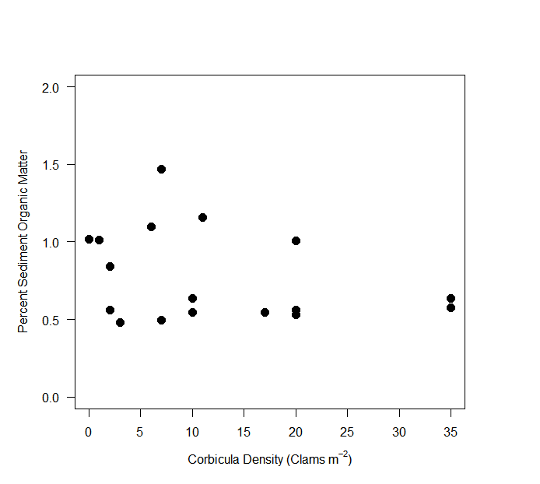
Figure 1. No Correlation when Comparing C. fluminea Density Per Square Meter to Percent of Sediment Organic Matter. The amount of C. fluminea per square meter was taken at each site along with a sediment sample. Once the sediment sample was ashed the difference in weight before and after determined the amount of organic matter found at each site. The amount of organic matter found at each site was then compared to the amount of corbicula found at the matching site. The results show that the density of C. fluminea did not have an impact on amount of organic matter.

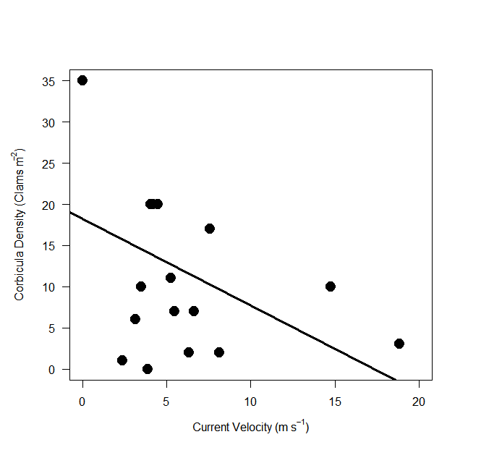
Figure 2. The Correlation between Current Velocity and C. fluminea Density. The current velocity at each site was taken and compared to the density of C. fluminea at the matching site. The majority of C. fluminea were found between a 1 and 8 meter per second current flow.

Discussion
This experiment was conducted to determine the effect of C. fluminea on the amount of organic matter found in Prince Edward County creeks. Three different locations were sampled from for a total of sixteen samples. The main information recorded being amount of C. fluminea present, current velocity and amount of organic matter present to see if a higher density of C. fluminea would have an impact on amount of organic matter when compared to other sites and location. It was hypothesized that the higher the density of C. fluminea in an area the lower the amount of organic matter there would be.
It was found that when comparing the amount of organic matter from a site and the density of C. fluminea, there was no correlation to the amount of organic matter found. This finding contrasts the findings that C. fluminea have a noticeable organic matter consumption level (Naumann,1999). It was also found that when comparing the current velocity to the density of C. fluminea, 1-8 meters per second was of the slower velocities measured and the preferred velocity for C. fluminea. This finding also contrasts with research done prior to the experiment which states that C. fluminea were more commonly found in faster flowing currents which provide more nutrients (Naumann,1999).
The information gathered in this study of the invasive species C. fluminea can be used in future to help recreate preferred conditions for in lab studies of C. fluminea and to help with combating the invasive species where C. fluminea are not wanted by creating controlled environments that can reduce C. fluminea population.

Literature Cited
Hakenkamp P, C. C., S. G. Ribblet, M. A.Palmer, C. M. Swan, J. W. Rein, AND M. R. Goodson. 2001. The impact of an introduced bivalve (Corbicula fluminea) on the benthos of a sandy stream. Freshwater Biology 46:491–501.
Ilarri, Martina & Souza, Allan & Antunes, Carlos & Guilhermino, Lúcia & Sousa, Ronaldo. (2014). Influence of the invasive Asian clam Corbicula fluminea (Bivalvia: Corbiculidae) on estuarine epibenthic assemblages. Estuarine Coastal and Shelf Science. . . 10.1016/j.ecss.2014.03.017.
Naumann, Robert. “Corbicula Fluminea.” Animal Diversity Web, 1999, animaldiversity.org/accounts/Corbicula_fluminea/.
Sampaio, Eduardo & F. Rodil, Iván. (2013). Effects of the invasive clam Corbicula fluminea (Müller, 1774) on a representative macrobenthic community from two estuaries at different stages of invasion. Limnetica. 33. 249.
Sousa, Ronaldo & Nogueira, António & Gaspar, Miguel & Antunes, Carlos & Guilhermino, Lúcia. (2008). Growth and extremely high production of the non-indigenous invasive species Corbicula fluminea (M??ller, 1774): Possible implications for ecosystem functioning. Estuarine Coastal and Shelf Science. 80. 289 - 295. 10.1016/j.ecss.2008.08.006.
Stachowicz, J. J., et al. “Biodiversity, Invasion Resistance, and Marine Ecosystem Function: Reconciling Pattern and Process.” DSpace Home, 1 Jan. 1970, repository.si.edu/handle/10088/3321.

