Editing the genome of Drosphila melanogaster using CRISPR-Cas9 technology to express the gene Wds (will die slowly)
Reece Theakston 4-23-18 Genetics 324 Spring Semester Longwood University

Introduction
The field of genetics is constantly growing due to new technology such as CRISPR Cas 9 (Clustered Regularly Interspaced Short Palindromic Repeats, Cas 9 is an enzyme used to cut DNA). CRISPR Cas 9 is the latest advancement in genome editing allowing for certain genes in a subject to be edited so that favored genes are expressed, allowing for specific phenotypes to be prevalent. This method starts by selecting the gene you want expressed and locating the base pairs of the DNA that control the regulation of said gene. Then a specific guide RNA is made to lead Cas 9 to the loci that it removes a double strand piece of DNA. Once the DNA is removed this results in the inhabitation of one gene and/or promotion of another gene. CRISPR Cas 9 has recently been used to help with reducing and curing cancer cells along with HIV. This is the method being used in order to change the genome of Drosophila melanogaster to express the gene wds or “will die slowly” which causes several WD repeats resulting in early termination during the early stages of development. This early termination of Drosophila melanogaster larvae is to be expected if CRISPR and PCR colony were performed correctly. Genome editing is possibly the way of the near future and it is important that the scientific community should continue practicing and experimenting with CRISPR in order to fully understand all of its world changing possibilities.

Methods
Digest pAc-sgRNA-Cas9 with BspQI
Six microliters of sterile water, 10 µl pAC-sgRNA-Cas9 (100 ng/uL), 2 µl 10X NEB buffer 3.1, and 2 µl of BspQI enzyme were added to a 0.5 mL microcentrifuge tube and gently pipetted up and down to mix. Once mixed the reaction was incubated at 50 degrees Celsius for two hours. After four hours the instructor placed the reaction at negative twenty degrees Celsius.

Anneal oligos to prepare for ligation, and dephosphorylate and purify the digested pAc-sgRNA-Cas9
Oligo 1 (100 uM) 2 µl, oligo 2 (100 uM) 2 µL, 10X T4 Ligation Buffer (NEB) 2 µl, T4 Polynucleotide kinase 1 µl, and Nuclease-free water 13 µl were added to tubes and annealed in a thermocycler for 30 minutes at 37 degrees Celsius and then at 95 degrees for five minutes and then ramped down to 25 degrees Celsius at 5 degrees Celsius per minute. Once thermocycling was complete 2 uL of Quick calf intestinal alkaline phosphatase (NEB) to the 0.5 mL tube from Lab 3 (BspQ1 digested pAc-sgRNA-Cas9). The tube was then incubated at 37 degrees Celsius for ten minutes. After incubation 110 uL of Binding buffer was added the tube and mixed via pipet. Next the mixture was added to a spin filter column and spun for 1 min at 13,000 rpm (16,000 x g). After the tube was spun the flow through was discarded and 200 uL of DNA Wash Buffer was added to the spin filter column and spun for 1 min at 13,000 rpm (16,000 x g), this step was repeated. Once the flow through was discarded for the second time the spin filter column was transferred to a clean 1.5ml tube. Next 20 uL of sterile water was added to the center of the white filter, without touching it directly. After the final spin two uL of the sample was placed on the nanodrop and the DNA concentration (ng/uL) and 260/280 values were recorded in the lab notebook.

Ligate the annealed oligos into pAc-sgRNA-Cas9
First the annealed oligos were diluted 1:10 in sterile water. Next, the dilution was added to a 1.5 mL microcentrifuge tube and 45 µL sterile water and 5 µL of annealed oligos (from the PCR tube) were added to the water. The mixture was then mixed via vortexing. Next, the volume of digested pAc-sgRNA-Cas9 vector was calculated for the ligation reaction with the formula 50 ng / ng/µL. Then X µl of 50 ng digested vector, 1 µL of annealed oligos (diluted 1:10), 2 µl of 10X 4 Ligation Buffer (NEB), 1 µl of T4 DNA Ligase (NEB), and 14.1 µl of nuclease-free water were added to a tube and then incubated at room temperature for ten minutes.

Transform ligation reaction into E. coli
A tube of 50 µl of NEB 5-alpha Competent E. coli cells was obtained from the instructor and kept on ice. Then 5 µl of the ligation reaction was added to the cell mixture. The tube was carefully flicked 4-5 times to mix cells and DNA. The mixture was put on ice for 30 minutes and then heat shocked at exactly 42 degrees Celsius for exactly 30 seconds. After 30 seconds the mixture was placed on ice for five minutes. After five minutes 950 µl of room temperature SOC was pipetted into the mixture. The mixture was then placed at 37°C for 45 minutes and shaken vigorously (250 rpm) or rotated. Then 50-100 µl of each dilution was spread onto a selection plate containing ampicillin and incubated overnight at 37°C.

Colony PCR
Up to 6 colonies that are separated from neighboring colonies by at least 0.5 cm were identified and circled on the agar-side of the plate. A culture tube containing LB and ampicillin was labeled for each colony. Next a strip of PCR tubes was labeled. All tubes were then put on ice. A sterile pipette tip was gently slid over the surface of the agar to collect the colony. The colony was wiped onto the bottom of the PCR tube. After transferring the colony was transferred the pipet tip was immediately ejected into a culture tube. Then a 1.5 mL Eppendorf tube with ‘MM’ (for master mix) was labeled and kept on ice. The volume per reaction was multiplied by the number of colonies plus one for the PCR master mix. Next 6 µl of nuclease free water, 3 µl of pAC Primer mix, 1 µl of sgRNA_For oligo (10 uM), and 10 µl of Q5® Hot Start High-Fidelity 2X Master Mix were vortexed and quick spun. After the collecting the liquid from the quick spin 20 µl of the master mix was added to each PCR tube. Then 1 uL of the original pAc-sgRNA-Cas9 was added to the tube labeled ‘N’. The PCR tube was capped, transferred to a PCR machine and thermocycled, Initial Denaturation - 98°C - 30 sec, 30 Cycles - 98°C - 5 seconds, 52°C - 15 seconds, 72°C -- 20 seconds, Final Extension - 72°C - 2 minutes, hold - 4°C.

Gel electrophoresis
The electrophoresis chamber was filled and covered the with 1X TAE buffer (about 275 mL of buffer). Next the walls of the agarose gels are checked so that they are near the black (-) electrode and the bottom edge of the gel is near the red (+) electrode. Then 5 uL of Quick-Load Purple 100 kb DNA Ladder was added followed by 4 uL of 6X loading dye. After that, 10 μL of each sample was loaded into separate wells in the gel chamber. Once loaded the lid was placed on the chamber and the leads were connected. The gel was run at 120 V for 30 minutes or until the dye was a little over half way down the gel. After the gel was ran the gel was removed from the tray and visualized under a UV camera.

Plasmid purification and sequencing analysis
First, a frozen pellet of DH5alpha E. coli was collected from the liquid cultures you prepared last week during colony PCR. Next the pellet was suspended in 250 uL of resuspension buffer and vortexed until the pellet was completely resuspended. Then 250 uL of lysis buffer was added to the tube which was then inverted the 4-6 times to mix. Next 350 uL of neutralization buffer was added to the tube which was then invert the tube 4-6 times to mix. After inverting the tube, it was centrifuged for 5 minutes centrifuged for 1 minute at maximum speed. The flow through was discarded and the previous step was repeated. The blue spin column was then transferred to ta clean 1.5 mL microcentrifuge tube. 50 uL of sterile water was added to the white silica matrix and incubated for 1 minute. The flow through was collected and a sample was nanodropped to determine the concentration of DNA (ng/uL) and purity (absorbance at 260/280 value). The formula X uL = 800 ng / 475.2 ng/uL was used to calculate the volume needed to deliver 800 ng to a sequencing tube. Then the formula uL water = 8 –X was used to calculate the volume of water needed to obtain a total of 8 uL in the sequencing tube. Finally, 2 uL of U6For sequencing primer was added (5’ – GTTCGACTTGCAGCCTGAAATACG – 3’).

Confirmation PCR
Up to 8 colonies that are separated from neighboring colonies by at least 0.5 cm were identified and circled on the agar-side of the plate. A culture tube containing LB and ampicillin was labeled for each colony. Next a strip of PCR tubes was labeled. All tubes were then put on ice. A sterile pipette tip was gently slid over the surface of the agar to collect the colony. The colony was wiped onto the bottom of the PCR tube. After transferring the colony was transferred the pipet tip was immediately ejected into a culture tube. Then a 1.5 mL Eppendorf tube with ‘MM’ (for master mix) was labeled and kept on ice. The volume per reaction was multiplied by the number of colonies plus one for the PCR master mix. Next 8 µl of nuclease free water, 1 µl of U6 For primer (10 uM), 1 µl of sgRNA_For oligo (10 uM), and 10 µl of Q5® Hot Start High-Fidelity 2X Master Mix were vortexed and quick spun. After the collecting the liquid from the quick spin 20 µl of the master mix was added to each PCR tube. Then 1 uL of the original pAc-sgRNA-Cas9 was added to the tube labeled ‘N’. The PCR tube was capped, transferred to a PCR machine and thermocycled, Initial Denaturation - 98°C - 30 sec, 30 Cycles - 98°C - 5 seconds, 52°C - 15 seconds, 72°C -- 20 seconds, Final Extension - 72°C - 2 minutes, hold - 4°C. Gel electrophoresis was then repeated with the same steps as before.

Genomic DNA extraction
First, approximately 5x10⁶ frozen Drosophila S2 cells that were transfected with 4 ug of pAc-sgRNA-Cas9 containing the target guide RNA sequence were obtained. After transfection, cells were treated with 6 ug/mL puromycin to kill all cells that did not contain the plasmid. The cells were resuspended in 200 μL phosphate buffered saline. Then 20 μL Proteinase K (PA) was added to the tube followed by 20 μL of RNase A (RA). The mixture was then vortexed and incubated for two minutes. Next 200 μL of lysis buffer (LB) was added to the tube which was then vortexted and incubated at 55 deg C for 10 min. After incubation 200 μL 96% ethanol (EtOH) was added to the tube and was mixed well by vortexing for 5 sec. After vortexing all (~600 μL) of the lysate was added to the spin column and spun at 10,000 xg for 1 min. The collection tube was discarded, and the spin column was placed into a clean collection tube. Then 500 μL Wash Buffer 1 (WB1) was added to the column which was then centrifuged at room temperature at 10,000 × g for 1 min. The collection tube was discarded, and the spin column was placed into a clean collection tube. Then 500 μL Wash Buffer 2 (WB2) was added to the column which was centrifuged at maximum speed for 3 minutes at room temperature. The spin column was placed in a a sterile 1.5-mL microcentrifuge tube and 50 μL of sterile water (H2O) was added to the column matrix without direct contact. This was then incubated at room temperature for 1 minute and centrifuge the at maximum speed for 1 minute at room temperature. A sample was then nanodropped to determine purity.

PCR amplification of target region for sequencing
The formula 25 ng / (26.2 ng/uL) = X uL was used based on the nanodrop results to calculate the volume (uL) of genomic DNA you will need to deliver 25 ng to the PCR reaction. Then 20-X µl of nuclease free water, 5 µl of gDNA Primer mix (10uM For/Rev), X µl of genomic DNA from part 1, and 25 µl of DreamTaqTM 2X Master Mix (Thermo Scientific) were mixed in a clean PCR tube. The mixture was then thermocycled, , Initial Denaturation - 95°C - 3 minutes, 30 Cycles - 95°C - 30 seconds, 60°C - 30 seconds, 72°C -- 60 seconds, Final Extension - 72°C - 5 minutes, hold - 4°C. Gel electrophoresis was then repeated with the same steps as before.

Purify the DNA in the PCR reaction
A tube containing 225 uL binding buffer (BB) was collected. Then all of the remaining PCR reaction sample (it should be ~45 uL) were added to the tube containing the Binding buffer and mixed via pipet. The mixture was then added to a spin filter column and spun for 1 min at 13,000 rpm (16,000 x g). The flow through was discarded and 200 uL of DNA Wash Buffer was added to the spin filter column and spun for 1 min at 13,000 rpm (16,000 x g), this step was repeated. The spin filter column was transferred to a clean 1.5 ml tube. 20 uL of sterile water was added to the center of the white filter, without direct contact. Nanodrop was used to determine DNA concentration (ng/uL) and 260/280 values.

Results
In this experiment CRISPR Cas9 was used to edit the genome of Drosophila melanogaster to create a recombinant plasmic that contained a target sequence for deleting the Wds gene. First, a guide RNA was designed followed by BsQ1 digestions. After the digestions, the vectors were phosphorylated and annealed the oligos. The annealed oligos were ligated and transformed into E. coli which was then put through colony PCR. Once colonies formed samples were taken and ran through gel electrophoresis and plasmid purification which shows that some of the plasmids didn’t take (Figure 1.). The first round of nanodrop came back with the results of 26.2 ng/ul and 1.98 260/280. Next, the plasmids were sequenced and transfected. After transfection samples of DNA were put through PCR, gel electrophoresis, and sequencing (Figure 3.). When looking at snapgene sequencing there were some flaws with the sequencing because of the amount of unknown base pairs (Figure 2.). The second round of nanodrop came with 475.2 ng/ul and 1.89 260/280. The final results of the experiment were that even through several trials of PCR, purification, and sequencing wds was not found in the Drosophila melanogaster cells.

Discussion
In this experiment CRISPR Cas9 was used to edit the genome of Drosophila melanogaster to create a recombinant plasmic that contained a target sequence for deleting the Wds gene. The conclusion of this experiment is that the gene Wds was successfully implemented into the cells. This conclusion was reached because after several nanodrop tests the DNA purity was normal around 1.9 260/280. While the concentration had constantly low numbers which shows that the wds gene did as hypothesized and caused premature cell death.
This experiment was conducted in order to edit the genome of Drosophila melanogaster with CRISPR Cas9 to have the gene wds expressed. It was hypothesized that if properly conducted, then Drosophila melanogaster would have wds expressed leading to early termination in the larval stage.
Once the experiment was finished the data came back and the results were negative for Drosophila melanogaster having wds. When looking at snapgene there were several sections that were unreadable due to unknown base pairs. Some of the limitations of this experiment are errors when trying to get the plasmids/vectors to open up, possible contaminations when dealing with DNA and PCR, there could also have been some errors when the sample were sent for sequencing (Figure 2.).
Another way to induce expression of the gene Wds could be the introduction of histone acetylate at the gene site or histone deacetylase around the desired gene.
The future applications of CRISPR Cas9 are almost endless with new ways of implementing CRISPR like one of the most common, basic, and helpful implementations of CRISPR is creating animal models. The reason these models are so helpful is that thanks to CRISPR we can better understand some of the natural processes that come with diseases because when using CRISPR to say, give a mouse cancer, the result is the closest we can get to naturally occurring cancer cells. Also, methods like activating latent HIV cells so that they can be treated or using CRISPR to help treat cancer cells are helping us change the world. Not only are new ways of using CRISPR constantly increasing but so are some of the components of the CRISPR method such as different types of Cas9.

Figures and Tables
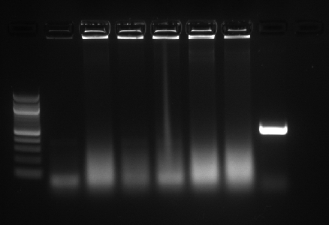
Figure 1. Gel electrophoresis Results.
This table shows the DNA fragments size which shows that the sample results are smeared. This means that there was an error with PCR most likely from contamination.

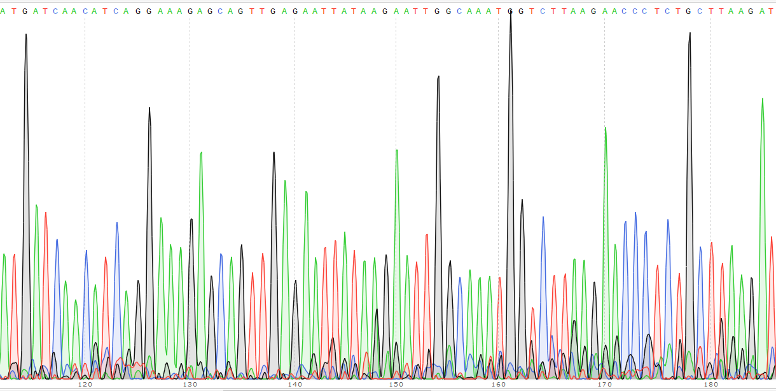
Figure 2. Sequencing Results
The sequencing results shows the affected area where the gene wds has been expressed.

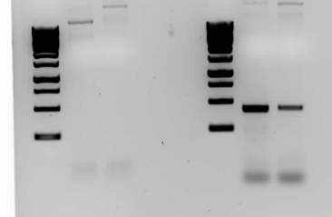
Figure 3. Colony PCR results
This table shows the DNA fragment sizes that have been properly ran without contamination.

References
Hollmann, M., Simmerl, E., Schäfer, U. et al. Mol Gen Genomics (2002) 268: 425. https://doi.org/10.1007/s00438-002-0768-0
Limsirichai, Pajit. “CRISPR-Mediated Activation of Latent HIV-1 Expression.” Molecular Therapy, Cell Press, 14 Dec. 2016, www.sciencedirect.com/science/article/pii/S1525001616309674.
“Maximizing Research Impact via Insightful Peer-Review.” Oncotarget, www.oncotarget.com/index.php?journal=oncotarget&page=article&op=view&path%5B%5D=30215
Singh, V., Gohil, N., Ramírez García, R., Braddick, D. and Fofié, C. K. (2018), Recent Advances in CRISPR-Cas9 Genome Editing Technology for Biological and Biomedical Investigations. J. Cell. Biochem., 119: 81–94. doi:10.1002/jcb.26165
Xue, H., Ji, L., Gao, A., Liu, P., He, J., & Lu, X. (2016). CRISPR-Cas9 for medical genetic screens: Applications and future perspectives. Journal of Medical Genetics, 53(2), 91.

