Identifying Microbes in Water Samples of Flowing versus Stagnant Water in Prince Edward County
Reece Theakston 11-27-17 Biology 250
Fall semester Longwood University

1
Introduction
This experiment is based off the study of aquatic biofilms, which are the formation of bacterial communities on the surface of water. These biofilms are home to an assortment of bacteria, fungi, and other microorganisms which are surrounded by an outer layer which protects them from changes in the environment and helps them with the consumption of organic matter (Lang, 2016). The structure of these biofilms can depend on the fluidity of their environment. This difference in stagnant freshwater versus flowing freshwater even in the same creek or river can have an enormous effect in the abundance and type of microbes that develop in those areas (Hunt, 1997). These variations in water movement play such a large role in microbial diversity that even in sample areas that are just a few meters away the variation in microbial diversity can be close to 50% (Besemer, 2009). These biofilms are usually harmless to the overall ecology of the rivers and creeks but sometimes they pose a threat if conditions are right and they culture, it can lead to a negative impact like large scale deaths in fish within a certain area (Bain, 2011). The hydrodynamics of where the microbial samples were taken can determine how those microbes might look and function. Microbes in stagnant water are more circular in shape and larger in size from the stillness of stagnant water, while microbes in flowing water are more elongated and smaller in size due to the constant flow of moving water (Stoodley, 1999).
The variable being tested in this experiment is the difference in abundance and number of microbes in stagnant freshwater versus flowing freshwater and the water quality over various areas in Buffalo Creek behind lancer park. The hypothesis of this experiment states that if water is sampled from stagnant water and flowing water then the samples from the stagnant water would have the most abundance and diversity of microbes. 2

Methods
Environmental Sample Collection
Two 50ml conical tubes and six LB agar plates were collected, three were for flowing and three for stagnant. Next, the two tubes were taken to two different areas on Buffalo creek, one area that had constant flowing water and one area that held stagnant water. The first conical tube “site A”, was filled with a sample of the surface water from the area with flowing water, while the second conical tube “site B” was filled with a sample of surface water from the area with stagnant water.

Bacterial Culture
Then 900μl of sterile LB broth was pipetted into each tube. Next, 100μl of the flowing water sample was added to the tube labeled 10^1 and was vortexed which resulted in a 1:10 dilution. After that 100μl of the 1:10 dilution was added to the second tube labeled 10^2 and was vortexed resulting in a 1:100 dilution. Next 100μl of each tube was pipetted onto the agar plate that correlated with the labels on the tubes, i.e. tube flowing 10^1 was pipetted onto agar plate flowing 10^1. After a 100μl sample was pipetted onto an agar plate it was then spread on the agar gel using a sterile spreader. The plates were then incubated at 25 degrees Celsius for 18-24 hours. After the incubation process the plates were examined and the data consisting of color, form, shape, size, and elevation of the colonies that formed on the plates was recorded.

3
PCR & 16s rRNA DNA sequencing
Plate 10^0 from “flowing” was observed and a bacterial colony that was separated from other colonies by at least 1cm was selected. Next the selected colony was observed through microscope at 4X magnification and the color and edges of the colony were observed. These steps were then repeated for plate 10^0 from “stagnant”. After the plates were examined a 1.5mL tube, which was labeled with group number and site location, (7-A). Once the tube was labeled a sterile tooth pick was used to pick up the selected colony from plate 10^0 “flowing” by gently sliding over the surface of the agar gel without touching any other colonies and was then smeared onto the inside of the tube. The tooth pick was then disposed of in a waste beaker. After the colony was transferred to the tube, 30μl of sterile water was pipetted into the tube with the colony and was then vortexed in order to achieve a solution that looked cloudy. These steps were repeated for the colony selected from agar plate “stagnant” 10^0. After two tubes containing 30μl of a cloudy, bacterial- water solution were collected, the tubes were centrifuged for 1-2 seconds. Next tubes of primer mix, Master mix w/ standard buffer, and nuclease- free water were collected and then all tubes were put in an ice box. Then, 12.5µl of the nuclease-free water was pipetted into the PCR (7-A) tube, followed by the addition of 25µl of the Master mix and then 2.5µl of the primer mix was added via pipette. After the nuclease-free water, Master mix, and primer mix, were added the reactions were gently pipetted up and down. After everything was mixed 10µl of the cell suspension (colony and water mixture) was pipetted into the PCR tube (7-A). The same steps were repeated for PCR tube (7-B). After both PCR tubes are filled with the required materials the tubes were placed into a PCR machine and were put through thermocycling.
4

PCR Purification
Two 1.5mL tubes were collected and labeled, (7-A) and (7-B). Then 250µl of Binding buffer was pipetted into each tube. Next 50µl of the PCR reaction samples were added to the matching tubes and then the mixtures were pipetted up and down to mix. Then, the mixtures were added to a labeled spin filter column and spun for one minute at 13,000 rpm. After the mixtures were spun, the flow through was discarded into a waste beaker. Once the flow from both mixtures was discarded, 200µl of DNA Was Buffer was added to each spin filter column which were spun again at 13,000 rpm for one minute. Next, the spin filter columns were transferred to clean 1.5mL. Once the spin filter columns were placed in the tubes, 20µl of sterile water was added. Next, 2µl of flow through from each tube was put on the nanodrop which measured the DNA concentration (ng/µl) and the 260/280 values.

Restriction Enzyme Digestion
Then the DNA samples were sent along with primer sequences to EurofinsGenomics who then sent back DNA sequences. After that the “cleaned” PCR products and a tube of MspI mixed with tango buffer were collected along with two tubes. Then 5μl of PCR product and 10μl of MspI mix were added to each tube, the tubes were then pipetted up and down with a pipette that was set to 10μl. Finally, the samples were incubated at 37 degrees Celsius for 45 minutes.
5

Analysis of PCR products and MspI digestion
First the electrophoresis chamber was filled, and the gel was covered with 275mL of 1X TAE buffer. Next 10μL of each sample was loaded into separate wells in the gel chamber. After that the power was turned on and the gel ran at 120 V for 30 minutes. Finally, the size of the purified PCR product before MspI digestion and the sizes of the fragments produced after MspI digestion were determined using a ladder image that was provided by the instructor.

BLAST Analysis
First SnapGene Viewer 3.3.3 was installed onto a laptop and opened. Next the sequencing results (.ab1 file) and electrophoresis results (.tif file) were downloaded. Then the .ab1 file was opened in SnapGene Viewer, which allowed for the chromatogram of the sequence to be observed. The “show quality data” option was checked which added gray bars under each peak which showed if the data was accurate, “high quality” or “low quality”. Then an area of the sequence which contained “high quality” bases was selected and pasted onto a Microsoft Word document. Next the MspI enzyme sequence was searched for on SnapGene Viewer and the cleavage sites were recorded. After that the website http://nc2.neb.com/NEBcutter2/index.php was used to analyze the MspI digestion patterns. The 16s rRNA DNA sequence was submitted into the website, the linear, custom digest, MspI, and fragments options were used when submitting the sequence which showed the sizes of the MspI-digested fragments. The bands were then compared with the bands of the gel to see if the bands matched the ones in the NEB cutter. The list of MspI fragment sizes, top five blast hits, 6 screenshot of alignment of the top hit, and FASTA sequence of the top hit were added to the Microsoft Word document. 6

Results
In this experiment, water samples of different water fluidity were taken from two sites in Buffalo Creek to determine which fluidity, flowing or stagnant, would have the most microbial diversity and abundance. The samples were first put onto agar plates which grew colonies to determine which site had the most diversity (color) and abundance (quantity of colonies). Observations of the cultured agar plates revealed that flowing sample had the most abundance of bacteria on the agar plates with 425cell/mL as seen in figure 1. The stagnant sample had the most color diversity due to it having more evenly distributed bacterial colors as seen in Figure 2.
Once the cultured agar plates were observed, a single colony from the flowing sample, plate 10^0 and stagnant sample 10^0 were selected for sequencing to determine what species of microbes were in Buffalo Creek. After the samples were put through PCR and DNA sequencing the results were put through gel electrophoresis to determine the fragments in the DNA. These fragments were used to compare the fragments of the top BLAST hit, Figure 3. The sequence results were also run through Snag Gene Viewer and BLAST analysis. The flowing sample was properly sequenced with very little bases while was shown to have very many unknown bases, this meant that the sample was contaminated with different DNA. The BLAST analysis showed that flowing had a top BLAST hit of Bacillus mycoides with a 99% DNA likeness.

7
8
Discussion
This experiment was conducted in order to determine the difference in microbial life in Buffalo Creek. Two different sites were chosen to test, one stagnant and one flowing to see which water fluidity contained the most diverse and abundant microbes. It was hypothesized that the stagnant water would contain the highest level of microbial diversity, this hypothesis was not supported due to the lack of information for the stagnant water sample.
Once the experiment was finished the stagnant DNA sample was unreadable on snap gene viewer, meaning that the sample was contaminated either by a researcher’s DNA or another microbial colony came into contact with the sample. The flowing site was correctly sequenced and received a full BLAST analysis with Bacillus mycoides with a 99% identity match to the sample microbe. Also, when comparing the Cell/mL count of the two samples in Figure 1., the flowing sample had the highest Cell/mL count with 426.66 Cell/mL while the stagnant sample had an average of 253.33 Cell/mL. The results showed that the flowing water had the greatest microbial diversity based on the 68 colonies compared to the 16 colonies on the stagnant agar plate. The agar plates and the DNA sequencing showed that the flowing water site in Buffalo Creek had the greatest amount of microbial diversity and abundance.

These results make sense when compared with other scientific articles. The results showed that the flowing site had the most abundant and diverse microbes, this is supported by the shapes of the microbes found in each fluidity. Microbe cells found in flowing water are elongated due to the constant water movement and are able to cover a larger surface area which allows them to collect more nutrients while the stagnant microbes are just circular (Stoodley, 1999). Also, according to one study water fluidity goes hand in hand with biofilm
biomass and architecture (Besemer, 2009). Another study determined that when put under lab controlled water flow versus stagnant the microbes in the with water fluidity had greater diversity and abundance (Yawata, 2016). These studies all looked at the differences between microbes in flowing water and stagnant water, all three though used controlled environments with controlled conditions in order to culture the bacteria while agar plates were used in this experiment.
Some limitations that could have impacted this experiment are the short amount of time, human error, and possible contamination due to the large number of researchers working in the same lab. The next step for this project would be to repeat all of the steps multiple time in order to get an average for all results. This study can help the field of microbial ecology because microbes play a big part in our water ways by dealing with nutrients and pollutions that are in the water.

9

Figures
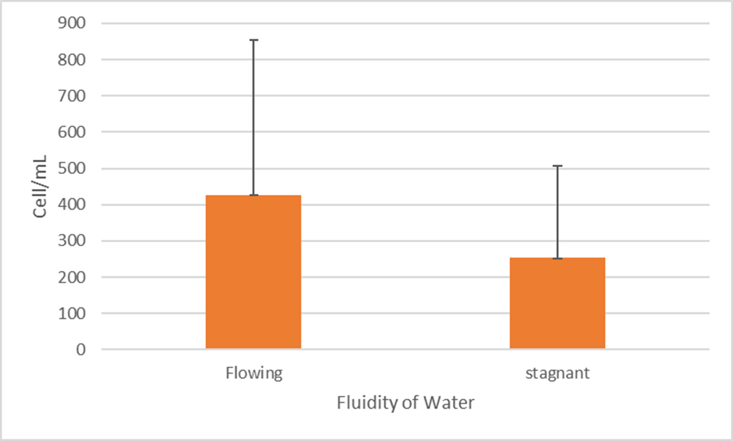
Figure 1. Abundance of Bacteria in Flowing and Stagnant Water. Site A which was the flowing water sample had the most microbial abundance due to its cell/mL count being around 425cell/mL. Site B which was the stagnant water sample had the least microbial diversity due to its cell/mL count being around 250cell/mL. This figure compares the cell/ml count between the different water fluidity samples.

10
11

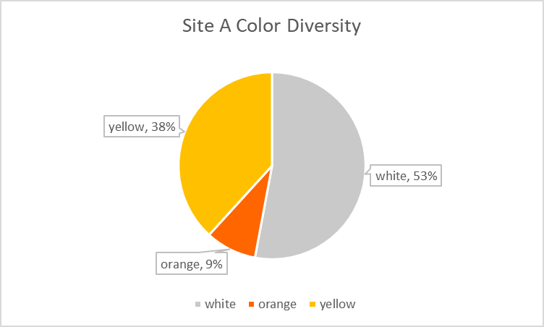 A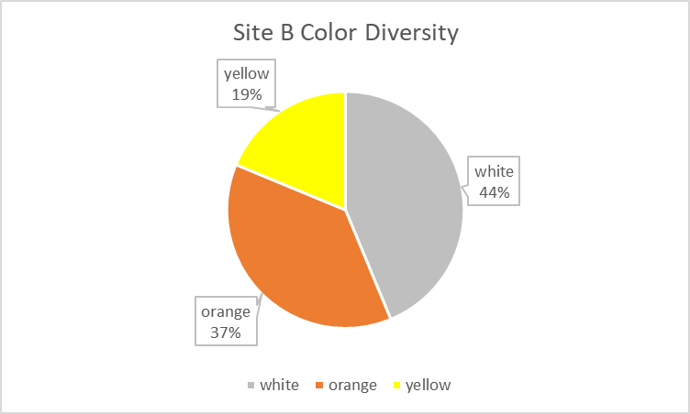 B
Figure 2. Bacterial Color Diversity Between Flowing and Stagnant Water. Figure2.B, (stagnant) had the most color diversity due to its more evenly distributed bacterial colors between white, orange, and yellow. Figure2.A, (flowing) had the least color diversity due to the bacterial color percentage being mostly between white and yellow and very few being orange. The color percentages show what percentage of the bacterial colonies were that color.

Figure 3. Differences in DNA fragment size between PCR and MspI. This figure compares the DNA fragment sizes with the ladder being far left, PCR in the middle and MspI far right. 12
Literature Cited
Bain, M B, et al. “Monitoring Microbes in the Great Lakes.” Environmental Monitoring and Assessment., U.S. National Library of Medicine, Nov. 2011, www.ncbi.nlm.nih.gov/pubmed/21336487
Besemer, Katharina, et al. “Bacterial Community Composition of Stream Biofilms in Spatially Variable-Flow Environments.” Applied and Environmental Microbiology, 22 Nov. 2009, aem.asm.org/content/75/22/7189.full.pdf+html
Hunt, Amelia & Parry, Jacqueline. (1998). The effect of substratum roughness and river flow rate on the development of a freshwater biofilm community. Biofouling. 12. 287-303. 10.1080/08927019809378361.
Lang, J M, et al. “Microbial Biofilm Community Variation in Flowing Habitats: Potential Utility as Bioindicators of Postmortem Submersion Intervals.” Microorganisms., U.S. National Library of Medicine, 4 Jan. 2016, www.ncbi.nlm.nih.gov/pubmed/27681897.
Stoodley, P, et al. “Influence of Hydrodynamics and Nutrients on Biofilm Structure.” Journal of Applied Microbiology., U.S. National Library of Medicine, Dec. 1998, www.ncbi.nlm.nih.gov/pubmed/21182689.
Yawataa, Yutaka, et al. “Yutaka Yawata.” Journal of Bacteriology, 1 Oct. 2016, jb.asm.org/content/198/19/2589.full?sid=8f826165-1be4-4d6d-855d-d218de5eaa11. 13

