Brianna Cervantes

**Human Demography Studied in Farmville, VA**

**Abstract**

Human lifespan has changed over the years because of the increase in technology and medicines. Students in Farmville, VA went to a cemetery to show how different it has changed. They took data from tombstones, from both males and females, from pre-1901, between 1901-1950, and post-1950. The experiment showed that as time went on, the average lifespan for both males and females increased over time, being especially high in the post-1950 era because of technological advancement, there being less wars occurring that kill people at an earlier age, and medicinal advancement.

**Introduction**

Throughout the millions of years that humans have been around, there have always been births and deaths, but the rate at which these occurred changed throughout the times. We can study this by using demographics, or demography, which is when you study the births, deaths, and others that help contribute to make up the human population size ( Lahr 1998; Liu 2001). When thinking back into older times, people used to die when they were younger, which is why we get grey hair younger. In older times, the general age of living was younger, and so our bodies stopped making melanin, the color protein in our hair, at an earlier age because humans weren’t living for a long time. But what’s happening now? Are people still dying young or are their lifespans being increased? Human lifespan could be increasing because of technological advancement and less wars, it could not change at all, or it could even decrease because diseases could have evolved so that we can’t tolerate them and prevent them, which kills the human population.

In a previous study done in Argentina, they found that as time went on, many of the departments, or areas they had sectioned off in this forest area, human population increased overall by “> 5.0 × 105 people,” and mainly it occurred in the urban areas (Izquierdo et. al. 2008). It is hypothesized, because of previous work and technological advancement, that as time goes on, the life span of humans would increase.

**Methods**

**Study Area:** A group of students, a part of Dr. Henk’s 251 Ecology and Evolution class, traveled to Westview Cemetery in Farmville, VA. The goal was to look at the headstones and record when people died before 1901, between 1901-1950, and post-1950, this was done with both males and females.

**Data collection:** The group was split into pairs, one of the pairs was looking at females and the other males, starting at the beginning of a row so that the different groups don’t overlap each other. The data collected was entered into an excel sheet, with the entire classes data, with spaces for birth year, death year, and sex.

**Data Analysis:** The data was then prepared to be analyzed through “R” using a t-test when comparing males to females in pre-1901, between 1901-1950, post-1950 and comparing the male pre-1901, post 1950, and female pre-1901 and post-1950. The data was analyzed for the average ages overall for the different time periods and both genders, and was also analyzed to determine survivorship curves for the different time periods.

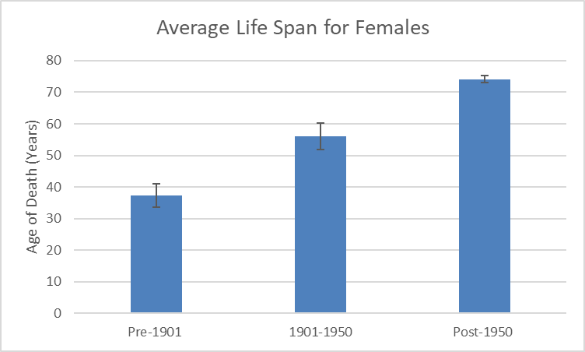**Results**

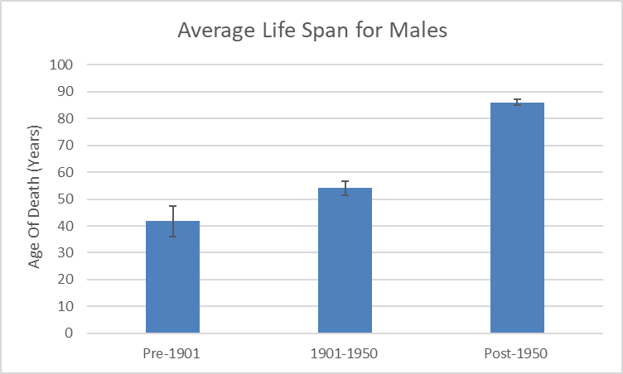 Pictured in Figure 1 is the average lifespan for a female before 1901, between 1901 and 1950, and after 1950. The average lifespan for a female before 1901 was around 37, between 1901 and 1950 it was around 56, and after 1950 it was around 74. The life span for females increased over the years, as shown. The error bars represent the deviation between the data points in that particular data set.

**Figure 1.** Average lifespan for Females before 1901, between 1901-1950, and post-1950. The average lifespan increases as the different time periods increase.

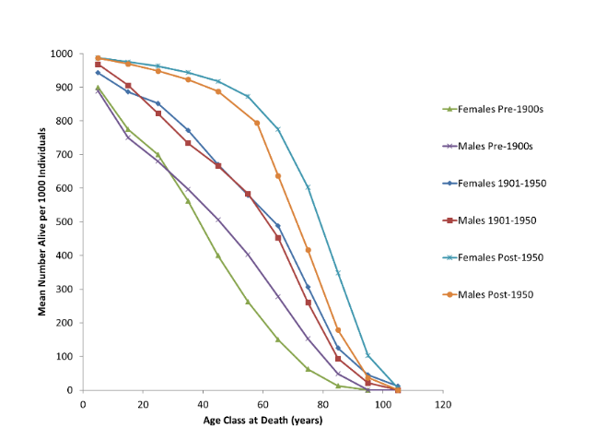 In Figure 2 (Male Average), the average life span for males throughout the time periods is displayed. Similar to females, the life span for males increases. In 1901 it was around 41 years, 1901-1950 was around 54 years, and post-1950 is around 86 years of age. The errors bars in this graph also represent the standard deviation of the data sets within the different time periods.

**Figure 2.** Average lifespan for Males before 1901, between 1901-1950, and post-1950. The average lifespan increases as the different time periods increase, same as the females.

Figure 3 shows the survivorship curves during the different time periods based on the ages of death for both genders. As shown in Figure 3, both males and females in pre 1901 have a survivorship curve that is type I, in 1901-1950, the survivorship is type II, and post-1950 the survivorship curve in type I.

**Figure 3.** Survivorship curves comparing genders in 1901, between 1901-1950, and post 1950. The survivorship curve goes from type III (pre-1901) to type I (post-1950) as the time goes on.

In Table 1, the genders were compared throughout the time periods between the two and themselves. The t-value and p-value are listed to show the significance of the different data sets and to show whether they are different enough between the two.

**Table 1.** T-values and p-values are displayed, as well as the significant difference between the data sets. The early periods have no difference between the data points but end up becoming different as time goes on.

**Discussion**

Throughout the time period, the female and male average lifespan went up as time goes on. Why this could have occurred is that during pre-1901 times, there wasn’t as much technological advances then as there are now, so they didn’t have the medicine for a common cold or the flu in order to help save people’s lives from what we think as simple diseases or sicknesses. Technological advancement has allowed for lives to be expanded because there are different medicinal, surgical, research, etc. advancements to help people live longer. Because of this technological advancement to help humans live longer, this explains why the figure 1 and figure 2 both have higher averages of life spans in the later time periods

Between 1901-1950, they were just starting to get these advancements, which is why the numbers for lifespan grew, to show a type II survivorship, but also explains why it’s not type I yet. This is because the advancements in post-1950 are way more advanced and helped people to live longer better than those between 1901-1950. Why also the survivorship may look like this at this time is because the world wars were occurring during 1901-1950 as well. This explains why 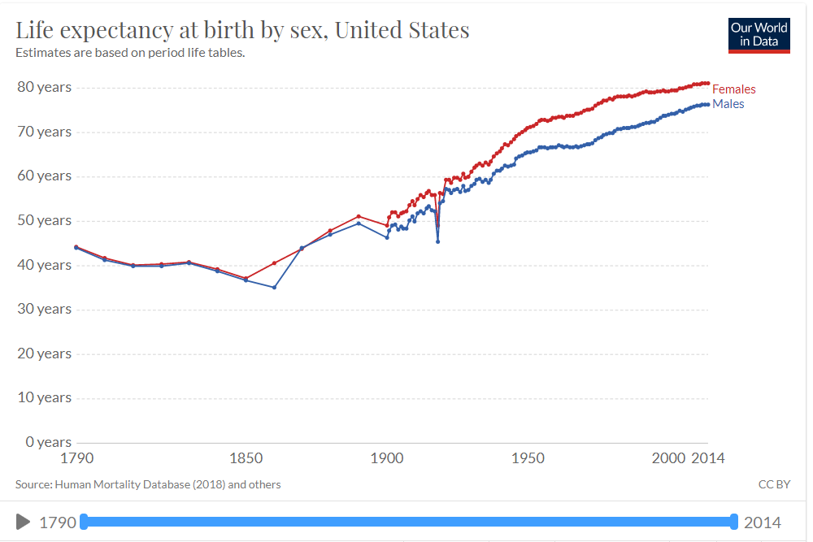women have a higher lifespan during this time. If you look at the graphic, it shows the average lifespan for males and females from 1790-2014, which shows that since around the mid 1800’s females have always had a longer lifespan than males (Ortiz et. al. 2018).

The p-values in Table 1 are also accurate as to whether there was a difference between the genders during the different time periods and comparing the genders to themselves pre-1901 and post-1950. In the pre-1901 and 1901-1950 when comparing males and females, the p-value was not less than 0.05, which is the standard number to determine whether the data points are statistically significant, but they were 0.3727 for pre-1901 and 0.6843 for between 1901-1950, meaning that the data points were not statistically significantly different. This data is also proven by looks at the survivorship curves in Figure 3 because they don’t look that much different between the data points. When comparing males to females post-1950, the p-value was 1.76e-12, which is significantly lower than 0.05, which means that is significantly different. This is also supported by Figure 3 when looking at the survivorship curve because the lines for the males and females are consistently separated as time goes on.

When comparing males from pre-1901 and post-1950, the p-value was 1.50e-10, which is lower that 0.05 and statistically significant different, the same goes for when comparing females pre-1901 and post-1950, that p-value is 1.76e-12 is also lower than 0.05, meaning that the data is significantly different. This is true for both because with these technological advancements that were mentioned earlier, people seem to be healthier at older ages. This means that the natural deterioration of the human body would be occurring later because the body is healthier at an older age. These technological advancements are helping tremendously to help prolong the human life (Vaupel 2010). What is also occurring is that there is less war in the post-1950’s, which means that less people are dying at young ages and living longer just based on not having to go to war.

Based on the data collected and analyzed, it is apparent that as time goes the average lifespan for both males and females increases. Some things that we still don’t know is around what time specifically the average age started to change, as if due to what. We also don’t know if this experiment is the same worldwide and whether this trend is common among all places within the world. In order to answer these unknowns, more extensive research on specific years will need to be done and collecting average death days around the world to determine what kind of trends different parts of the world endure.

**Acknowledgements**

I’d like to thank Longwood University for giving students this opportunity to do research in Farmville and I’d also like to thank Dr. Henk for providing us with the materials and resources in order to do this experiment and teach us the importance of collecting data and doing research.

**References**

Lahr, M. M., & Foley, R. A. (1998). Towards a theory of modern human origins: Geography, demography, and diversity in recent human evolution. *American Journal of Physical Anthropology*, *107*(S27), 137–176.

Liu, J. (2001). Integrating ecology with human demography, behavior, and socioeconomics: Needs and approaches. *Ecological Modelling*, *140*(1-2), 1–8.

Izquierdo, A. E., C. D. De Angelo, and T. M. Aide. 2008. Thirty years of human demography and land-use change in the Atlantic Forest of Misiones, Argentina: an evaluation of the forest transition model. *Ecology and Society*.

Ortiz-Ospina, Esteban, and Diana Beltekian. “Why Do Women Live Longer than Men?” *Our World in Data*, 14 Aug. 2018, ourworldindata.org/why-do-women-live-longer-than-men.

Vaupel, J. W. (2010). Biodemography of human ageing. *Nature*, *464*(7288), 536–542.