Name: Jacob Carney
Bi-Weekly Report Dates: 2/25-3/02 and 3/09 – 3/16
Steps Week 5 total: 90,486 High Day: Monday 2/29 (20,526) Low Day: Tuesday 3/01 (8,153)
Steps Week 6 total: 70,751 High Day: Monday 3/14 (19,545) Low Day: Friday 3/11 (2,093)
Weekly Overview
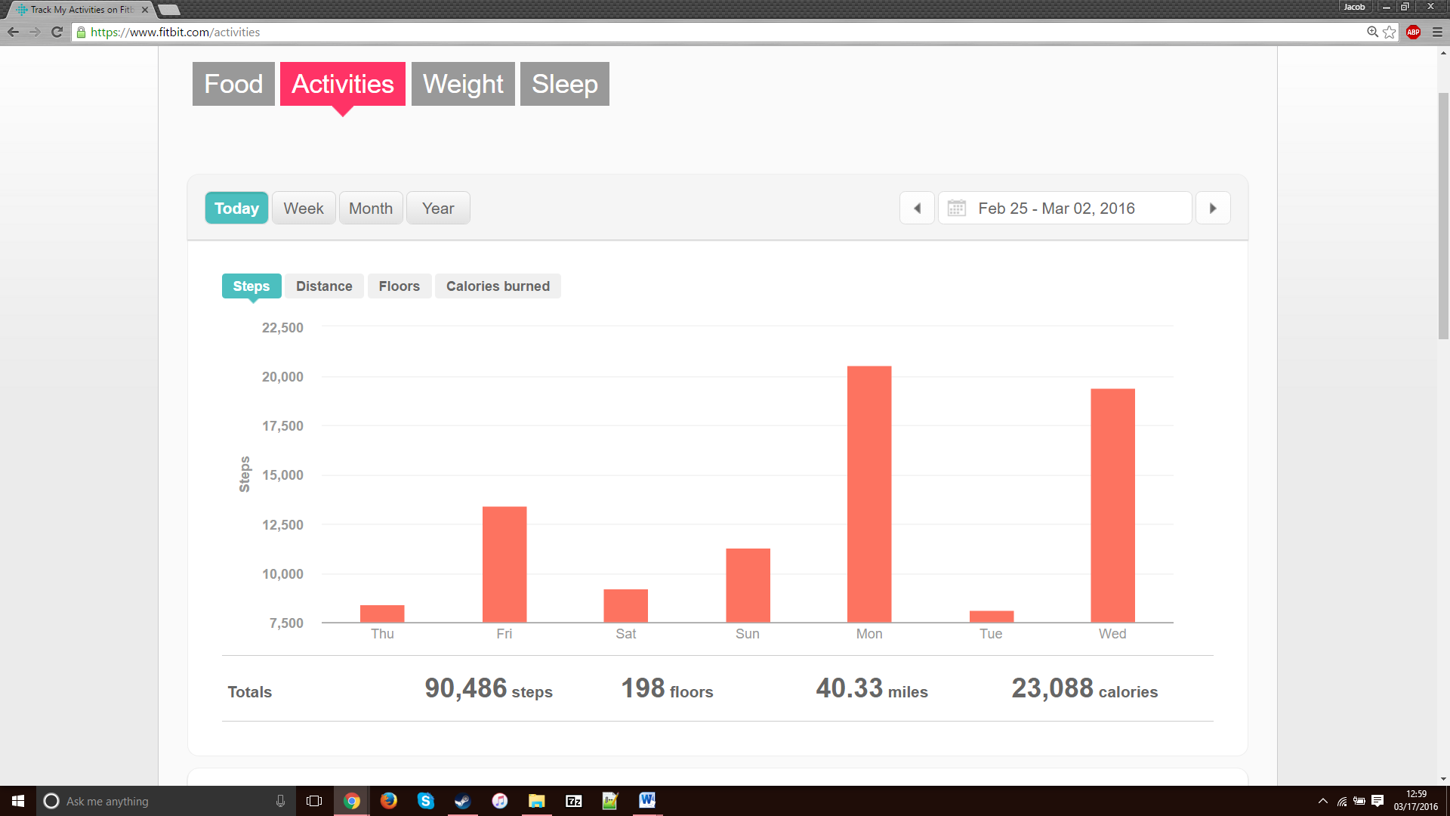

High Day
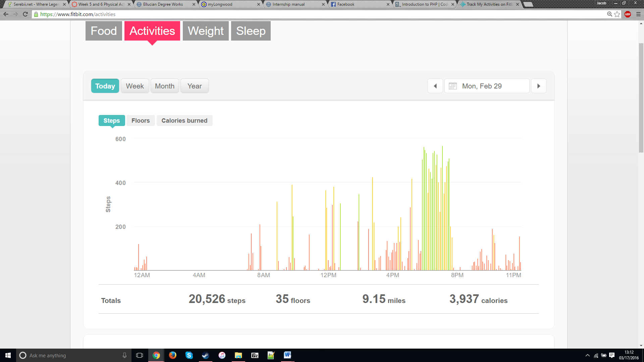
Low Day
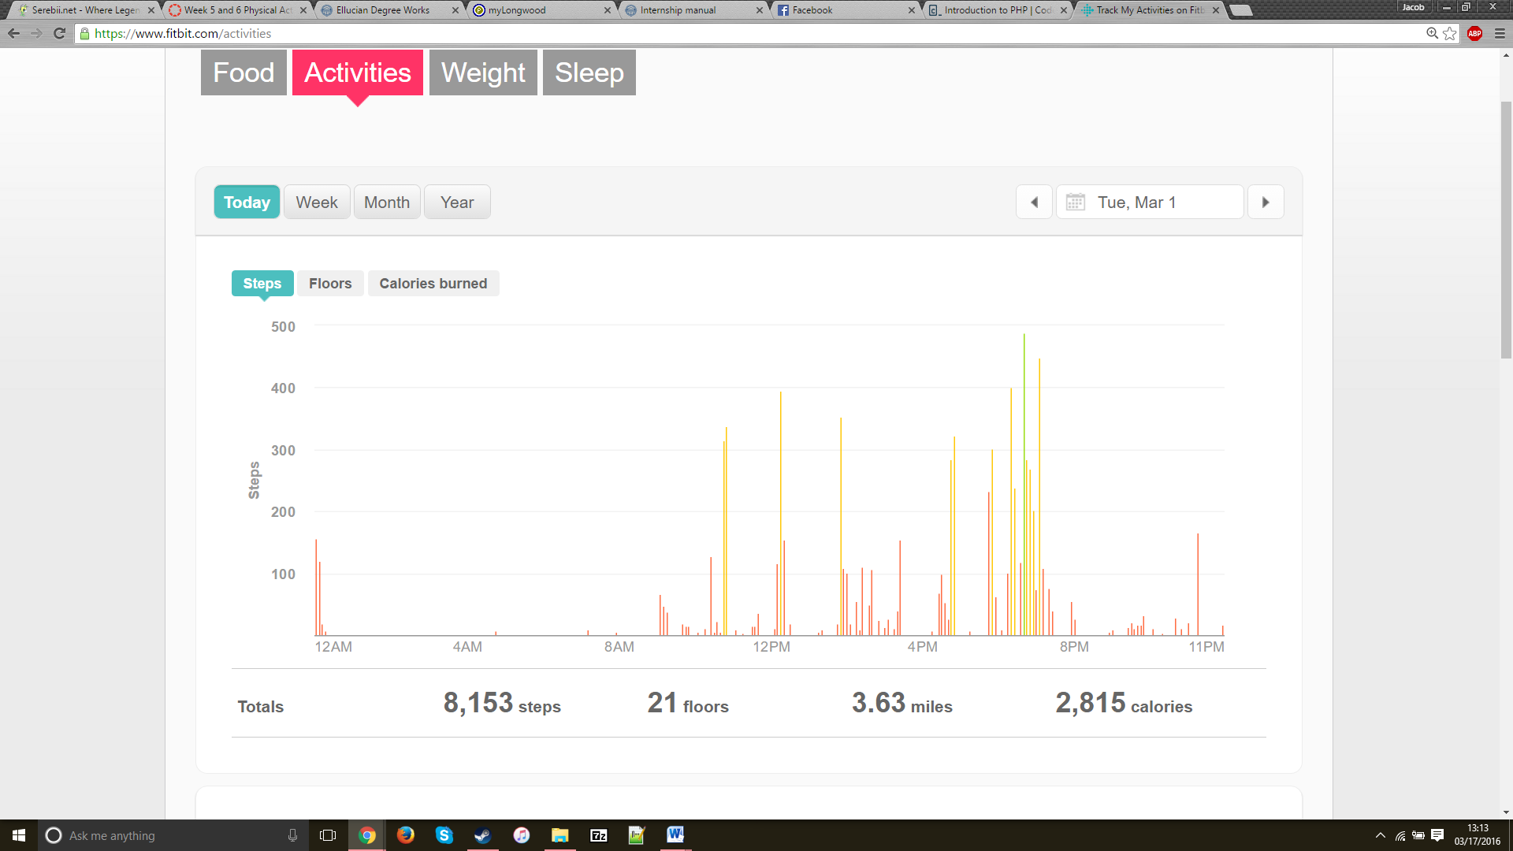
Reflection for Low and High Activity Days (Week 5)
-I had over 8,000 steps every day and I just happened to not walk as much on Tuesday.
-A lot of my steps came from Monday and Wednesday. I’ve started walking parts of High Bridge with friends when I can.

Weekly Overview
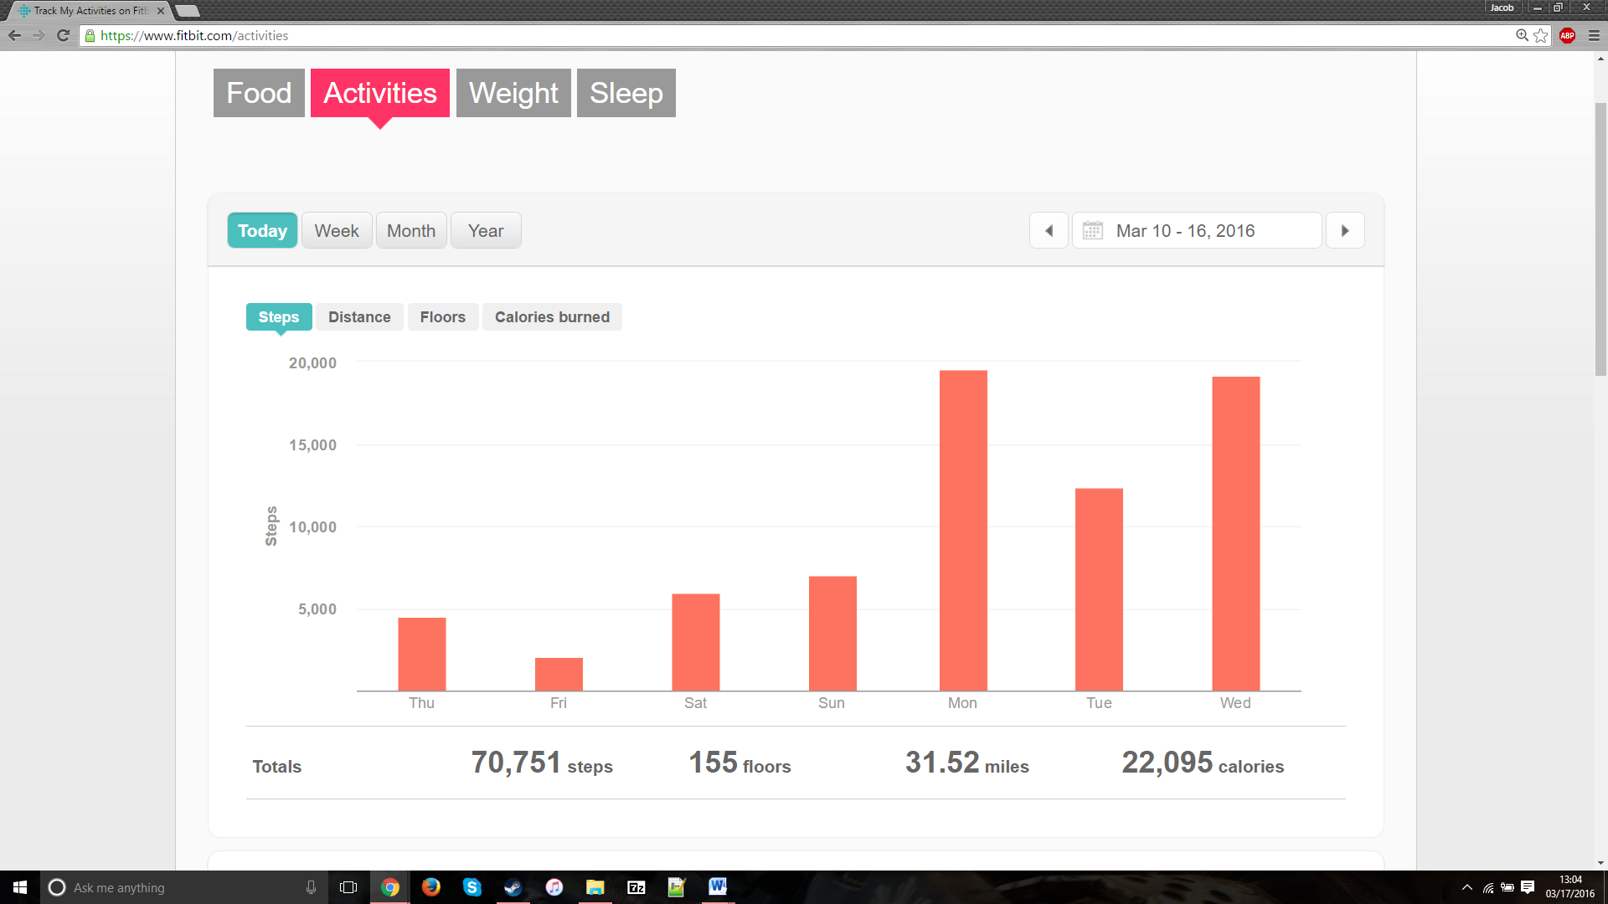
High Day
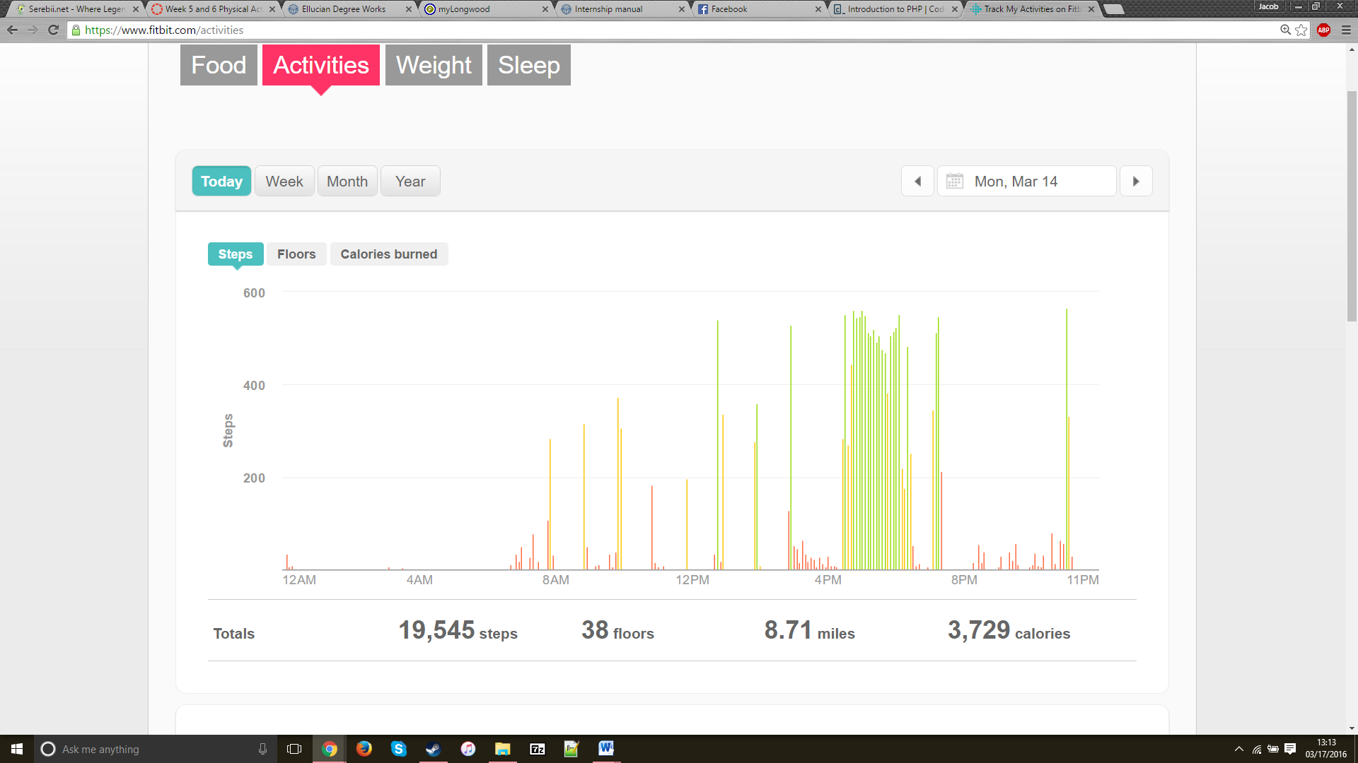

Low Day
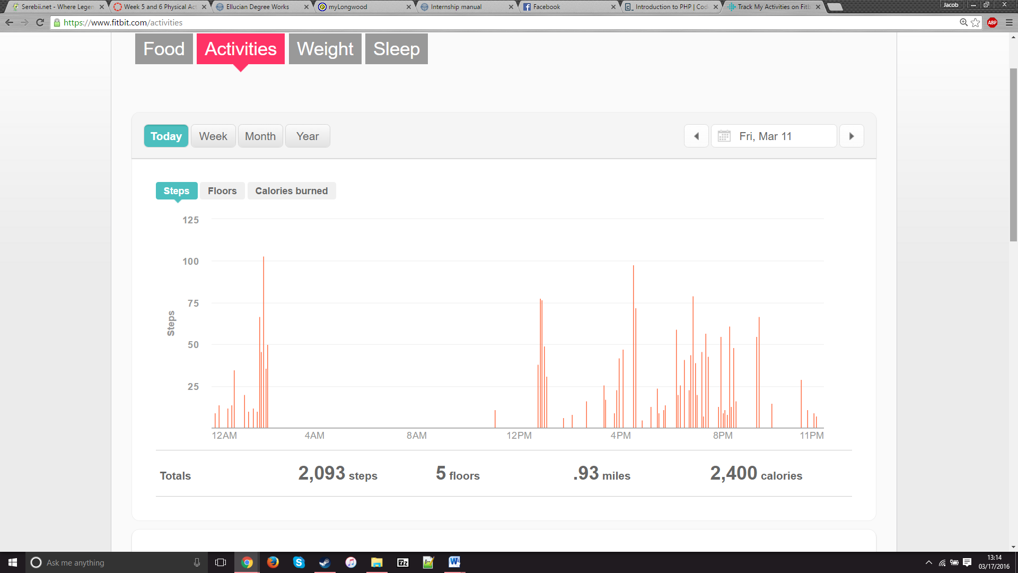
Reflection for Low and High Activity Days (Week 6)
-My week happened to start at the end of Spring Break and I wasn’t quite concerned with steps until I realized that my week had started.
-The weather has started to become nicer and I’ve been out walking more and more on High Bridge because of the weather.

Environmental Barriers
Low Light, Unpaved Path, Overcast Weather (possibility of rain), The Rotundas, Missing Sidewalks, Pedestrian Crosswalk Stoplights
