Observation 2 Essay- Katherine Buchholz

My group today explored Squirrel Hill North and Regent Square. We did not have enough time to really go into Point Breeze. We did go on its border though because we walked on the border of Frick Park. At first, we went to the University of Pittsburgh area that we already knew to get to the start of our walk to Squirrel Hill. When we did this, we got a little turned around because we started walking more into the University of Pittsburgh campus. When we realized this, we asked for directions to Squirrel Hill from a college student who I’m pretty sure was on their way to class. She told us to go the other way, so we did. We ended up going down the sidewalk right next to the Schenley Bridge that led to the museum we went to and then on to Forbes Avenue. 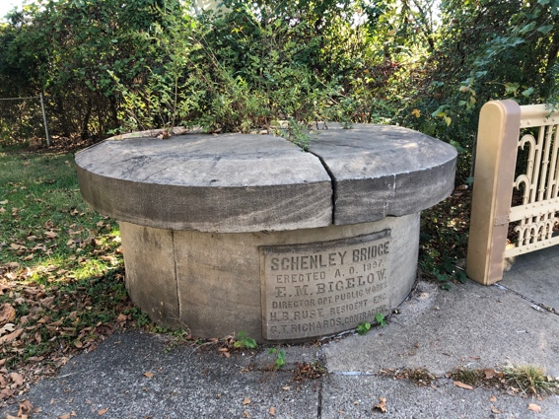There we walked up and were right in Carnegie Mellon University’s campus. It reminded me of Longwood with all the green lawns they had in front of their buildings. It appeared they were trying to make the campus more friendly, so that people would want to stay in these areas and do their homework or just talk with friends.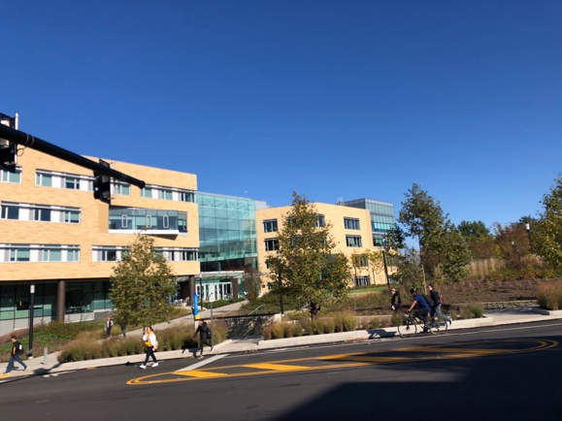 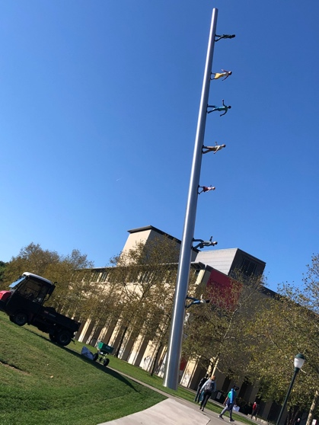There was also a little bit of art on the campus, which Longwood doesn’t have. The art at Longwood is basically the Joan of Arc statues. Also, I noticed that there was a new hall being built for the Carnegie Mellon campus. This shows me that they are starting to need more buildings because it is very likely that more people are deciding to study there. Longwood is also getting new buildings like the new music building, but those will take longer to build than the one I saw for Carnegie Mellon. Another thing I noticed about the Carnegie Mellon campus was that their Greek life has their letters on display on the outsides of their buildings. Longwood doesn’t do this and the sororities can’t do this sort of thing, which is why there is Stubbs. This also showed me that they have pride in their Greek life because they show it off this way. A last thing was how modern the Carnegie Mellon campus is compared to what I saw of the University of Pittsburgh. There are buildings that are mostly glass as opposed to places like the Cathedral of Learning. The Mellon campus is more modern architecture and I think that entices more people to go there because younger generations like that sort of architecture.
We continued walking down Forbes Avenue for the whole way until we hit Squirrel Hill. Even then, we continued walking along Forbes and the straight path we were on until we got to Regent Square. While walking through the residential area of Squirrel Hill, we noticed that many of the houses were really nice. They seemed like they would be a little pricey compared to housing in other areas we have gone to in our other groups. Some of them had driveways, others had two car garages or a garage, and others just looked really nice because of the architecture of the building. 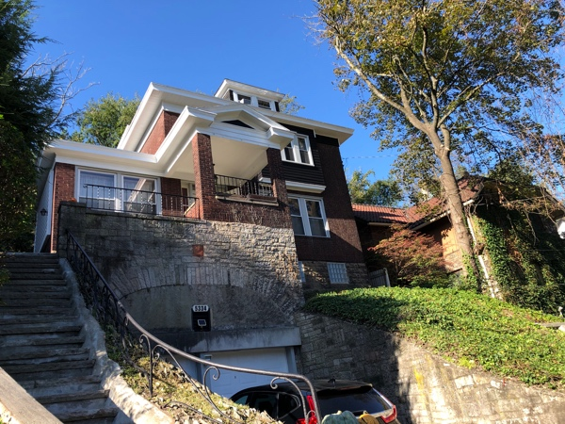 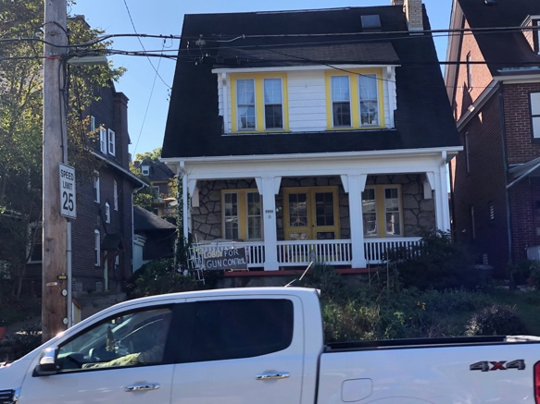 Even the Jewish temple we stumbled across had a home with these sort of features attached to it. We tried to go into the temple, but it wasn’t open because today is a Jewish holiday.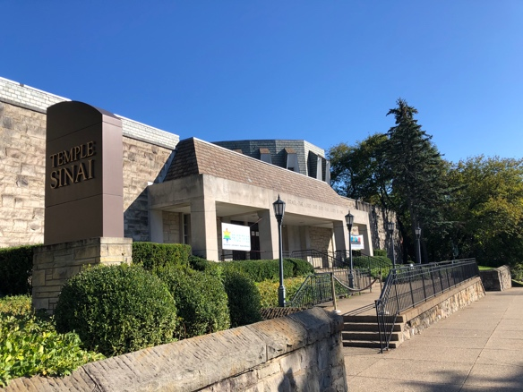 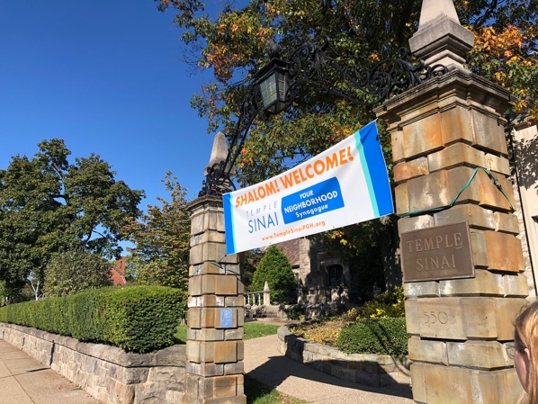 We figured this out when we tried to talk to someone in the Jewish Community Center when we got to the business district of Squirrel Hill, and that wasn’t open either.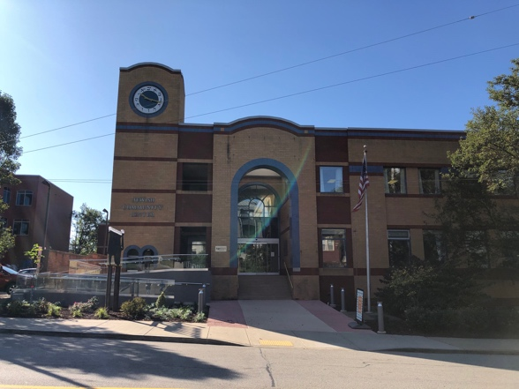 I feel like it would have been very cool to talk to someone that is a part of the Jewish community in Pittsburgh because of the whole shooting that happened recently and just to know how they felt about the area. I guess I will just have to imagine what they would have said. Another thing I noticed was that some of these really nice houses were now condos and townhouses so that more people could live in the area and maybe even a college or graduate student could buy one and live in the area. It would be cool to know who thought of doing this to some of the houses because I think it is a cool idea. A last thing I noticed about the whole residential part of Squirrel Hill and the sense of community and pride was the blue, green, and orange signs welcoming immigrants everywhere and saying they would be safe in this community they were invited into.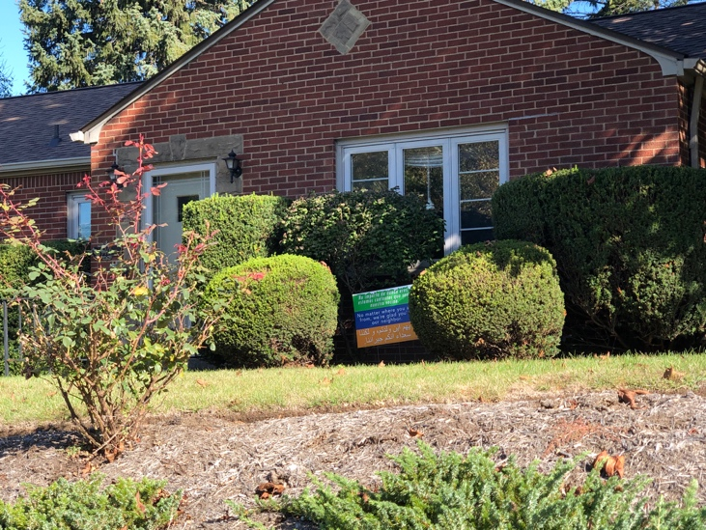 These signs are definitely newer to the area, but I feel like they are showcasing how welcoming the people of the community are. I have seen these signs back in Arlington too, so that was a connection to back home that I saw here. It is cool to know how welcoming many people are and how people stand up for what they believe in here too.
The Squirrel Hill business district on Murray and Forbes that we walked through quickly was interesting too. I noticed that a lot of it was food from other cultures like Asian cultures. An example of that would be the ramen place I noticed. Not a lot of it was stores except for a Rite Aid. The rest of the buildings were businesses.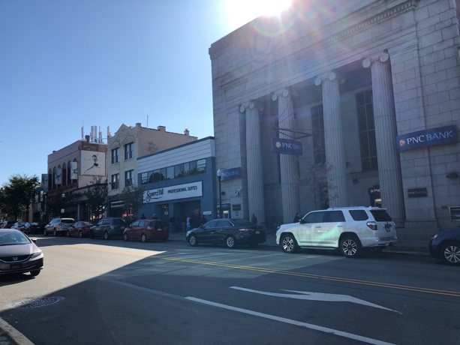 I liked the feel of the area because there was quite a lot of activity there compared to all of the walking we did before getting there. There really weren’t many people there while we were walking from place to place. The only other place we went into in was the Carnegie Library at Squirrel Hill. We talked to the security guard that was there. She was a native! She told us that she thinks that Pittsburgh is safe enough and so is Squirrel Hill and the borough she lives in. She also told us that the Squirrel Hill area was, in her opinion, not necessarily where many students were going to be. She mentioned that this library is mostly used by kids and their families as opposed to university students. We asked if she would live in Squirrel Hill and she said she would, though it is a pricey area. She talked about how Pittsburgh is made up of so many communities, like we have been hearing from others. She also talked about how the businesses in Squirrel Hill have grown over the years to make it go from a ghost town to a striving place. I thought that this conversation showed the whole community aspect and growth of Pittsburgh that we have been talking about. After we left the library, we encountered a guy trying to get someone to pay for him to eat somewhere. We told him we couldn’t help and then we went on our way. That encounter made me a little uncomfortable because I just don’t like being approached by people in that way, even if they end up being harmless. My brain sort of goes into this defensive mode, but I would say that this was the only time I ever didn’t feel completely safe. There was even more evidence of how big the Jewish community is for Squirrel Hill as we were heading out of the business district. Squirrel Hill was a cool place to explore, even if we only hit the surface of it.
The next place we went was on a road that had sidewalk only on the side we were on, right near Frick Park. 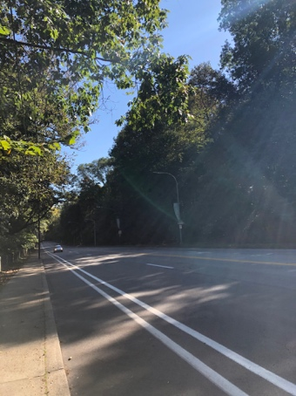 We decided not to go through the park because it is so big and we didn’t want to get too lost in it. The road was very nice and peaceful. There were two cemeteries next to each other before we started our walk through Frick Park to Regent Square. The Smithfield cemetery was the first one and it seemed like it was for people in the community or maybe even a church compared to the other one.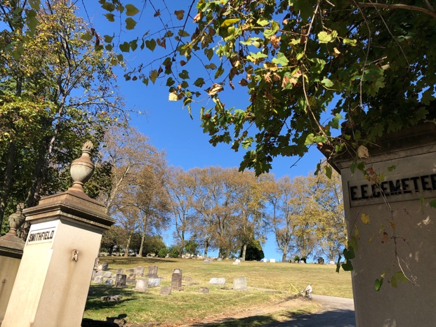 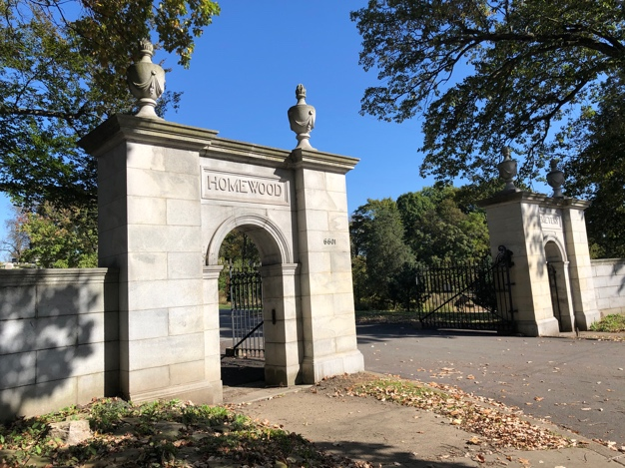 The other cemetery was the Homewood cemetery which had mausoleums in. To me this means that the family was either important or has enough money to get a specific burial place for their relatives. We didn’t really see anyone in either of the cemeteries, so we didn’t go into them. Also, I just didn’t want to disturb anyone if they were grieving in there. When we finally crossed the bridge to get to Regent Square, the whole tree line dropped quite a bit. I find it interesting because that shows how far down the area below us was compared to where we were. We walked through the residential area and it seemed pretty nice like Squirrel Hill. 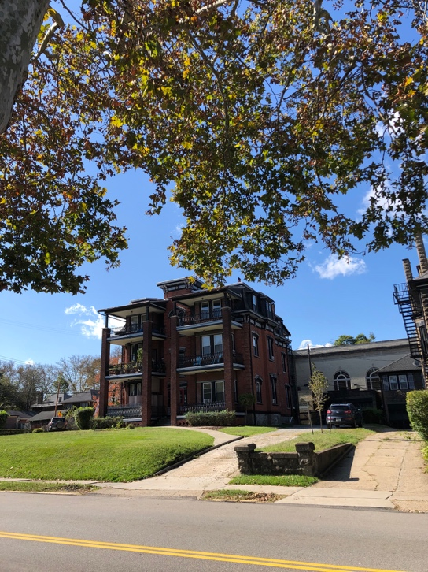 When we got to their business district, it wasn’t that big at all. In fact I’m pretty sure the area was smaller than the downtown of Farmville. I liked the quaint, small-town vibes though.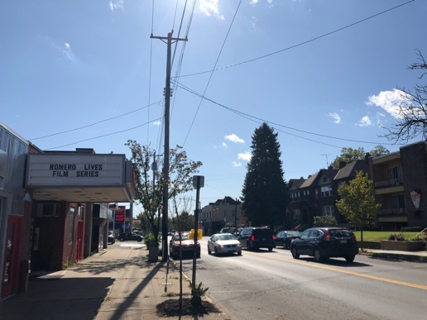 I think I get why Carnegie Mellon students liked it so much. They see it as a get away from their busy lives in the center of the city. There really were not that many stores or places to eat in the area. Also, I noticed that a lot of the stuff was closed because it is a Monday, and they aren’t open then normally. Some of that could have been from Columbus Day too though. The only place that was really busy after a little bit was D’s Six Pack and Dogs, which is where my group ate lunch. At first, there weren’t many people there, but then around 1 in the afternoon there were lots more people. I feel like these areas aren’t places that tourists normally seek out, so people just don’t know about them that much. If tourists have no purpose in going to Squirrel Hill or Regent Square, they won’t go to these places. I wonder how well these places do overall.
The last thing we did before taking the bus back was go into an antique store and talk to the person working there. We asked him many different questions and he was honest about them all. He even critiqued the places he knew, which is not something anyone else has done. Everyone else has just shown us the positives of Pittsburgh. He told us that he is from New Jersey, but he has been in Pittsburgh for a while and lives in Shadyside. He has noticed how many cultures there are and he told us how he noticed that Squirrel Hill has recently been becoming more Asian centered and not as Jewish. He told us that he thinks that Pittsburgh is a pretty safe place. He also talked to us about how most of his business comes on the weekends from people in the area who are from out of town. I asked him if he liked going to sports games and he replied that he doesn’t really care for sports. He did complain though about how because Pittsburgh is so sports-oriented, if it is game day and the game is in Pittsburgh, he doesn’t get lots of business. He then answered Danyelle’s question about education and told us that there are lots of charter schools around. Another thing I asked him was if he uses public transportation and he told us that he drives to work. He had so much more to say, but this is just some of the highlights of the conversation we had with him.
I feel like all of what I have talked about has encapsulated the words of mighty, beautiful, and welcoming that Pittsburgh uses to describe itself on the website they have for the city. The might comes from standing together throughout all the communities that make up Pittsburgh. The beauty comes from many different things like the parks, buildings, and even the rivers that flow through it. The welcoming aspect comes from how people were happy and willing to talk to us about anything we asked them, like the security guard and the antiques shop guy. All of this also shows me culture, communities, diversity, and even art. Art comes from the graffiti we saw today that was very pretty and the graffiti that I saw throughout the trip. All of the graffiti is a form of artistic expression of how people see Pittsburgh. 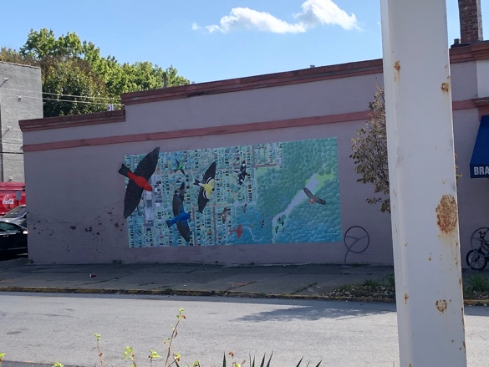 This whole trip has helped me develop a greater sense of what Pittsburgh is all about. I have had so much fun doing it all, even while being somewhat tired the whole time from all the exercise and activity we did each day.

