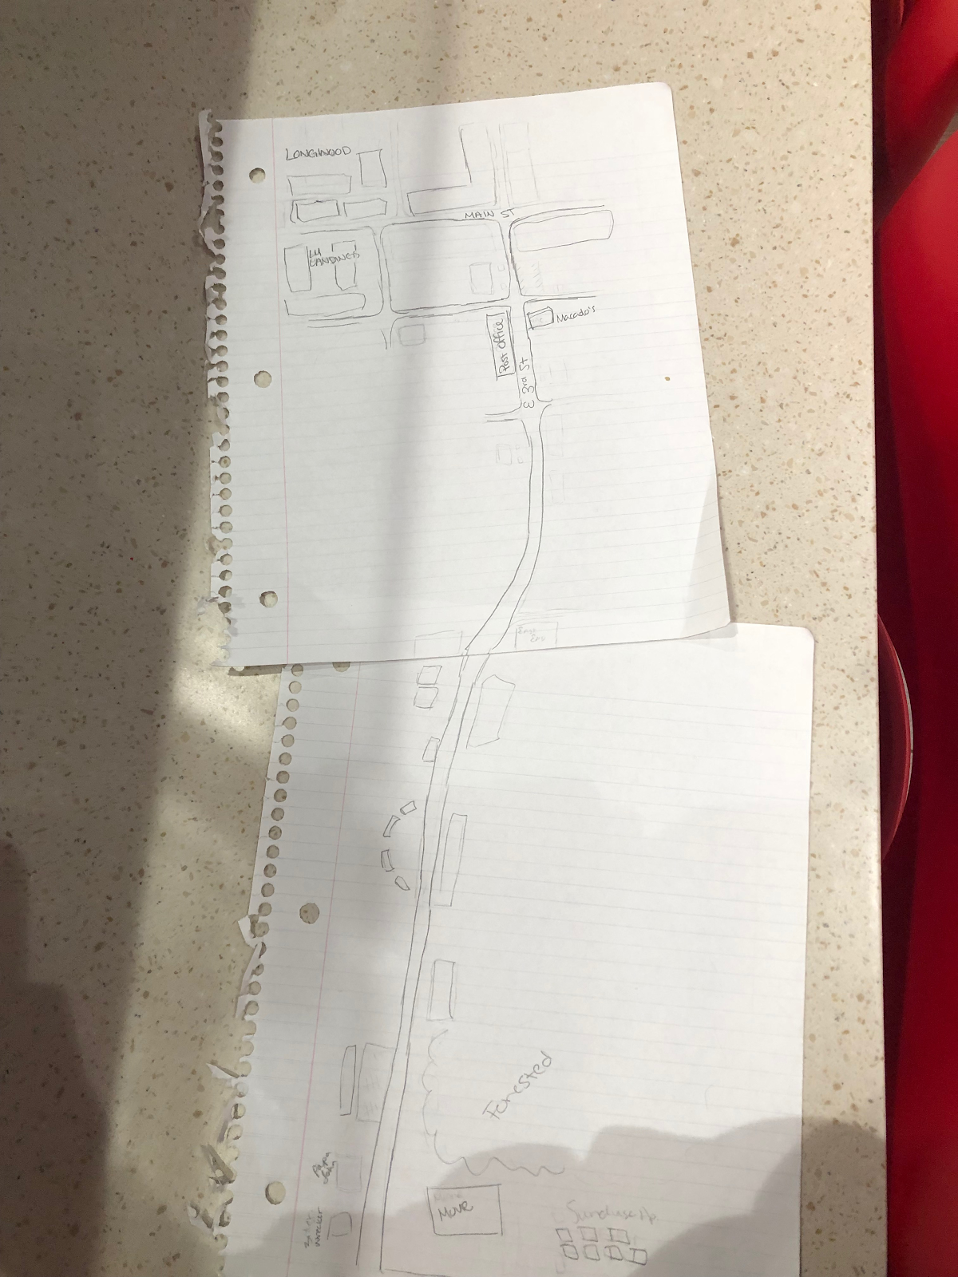
Sunchase is a decent sized apartment complex, and ideal for students or young adults. They provide many resources, including internet and printing. The Sunchase area is typically pretty busy, however with the school year at an end, there weren’t many people there. There was a single couple by the pool, but a lot of cars where gone, and there was no one utilizing the basketball courts that we had passed. Also, there was a person walking their dog by the basketball courts.
East Third St is lined with business after business. Many of these buildings, though, seemed to be vacant, for sale, or for rent. We did not pass anyone while we were walking back to town, however once in town we met two other people. There was little green space in between the businesses. The traffic flow was decent, but there was a scarce amount of people walking around. There weren’t a lot of animals in passing, aside from some birds or squirrels. The entire street is one giant hill, and from Sunchase to downtown, it’s a consistent downhill slope. While completing this assignment, it was very sunny and warm. The people we talked to were Haley, Sally, and Scott.
Haley is a worker at the Sunchase Apartments in town. She is a graduate of Longwood University who studied biology; however she works a secretary-type desk job. She had many good things to say about Sunchase itself; it’s a good place for students because there is 24/7 internet, free printing, and it’s not too expensive for a college student to afford. However, regarding Farmville itself, Haley did not have as many good things to say. She did like the sense of community that encompasses the town as well as that it is easy to get places however, being such a small town, there are not many opportunities for growth here. She used herself as an example, telling us “I am a Biology major and there are no opportunities for me here.”
When we approached Sally, she initially was reluctant to talk to us. We introduced ourselves as Longwood students who were considering living in town after we graduated. She immediately looked concerned and said that we “are too young to be stuck in a small town.” Sally is from Buckingham and was in town to do some shopping. When we further asked about why she felt that a small town would not be a good fit for us, and she elaborated by saying Farmville is small and that there aren’t too many activities to do. She mentioned it is also hard to get a good job, saying “Unless you know somebody in a business, there’s not a lot of opportunities or chances to get into one.”
Scott is a local who has lived in Farmville for about 25 years. He works as a construction worker and is also an agent in financial services. As someone who has seen this town for a while, we decided to ask if he thought this town had good opportunities for recent graduates, and he had quite a bit to say about this. “The biggest opportunity that this town has to offer someone is Longwood University. Not so much for employment, but if you want a decent education, and a less expensive one, then Longwood is a good opportunity. However, at some point you’d outgrow Longwood, and in turn Farmville. So I guess Longwood, and Farmville, are good starting points, but they aren’t the best for a destination for your whole journey.”
Reflection:
What I have learned from this is that Farmville is very different after student’s leave for the summer. This made it harder for us to find people to talk to, especially since we did this activity the day after the students that were still here took their last exam. Also, because we did this activity mid-day on a weekday, it was harder to find people around town. Most people are working at this time or have somewhere to be. All the people my pack talked to seemed to say that Farmville was too small of a place for us to stay in, and that Longwood was one of the only good things about Farmville. Otherwise, they thought that we wouldn’t be able to find jobs easily, and we would not have many activities to do. We only managed to find this one perspective, but if there were more people then we might have been able to find people with opposite opinions.

