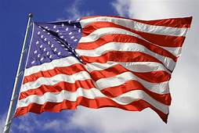
“

7 Ways that Studying US History 1877 to Modern Times History Shapes the Way You Think About American Treatment of Minority Groups.
By: Emma Bryant
History 222-50
May 4, 2020

- Native Americans were one of the first minority groups to be discriminated against in the United States.
Native Americans and the West (January 27, 2020)
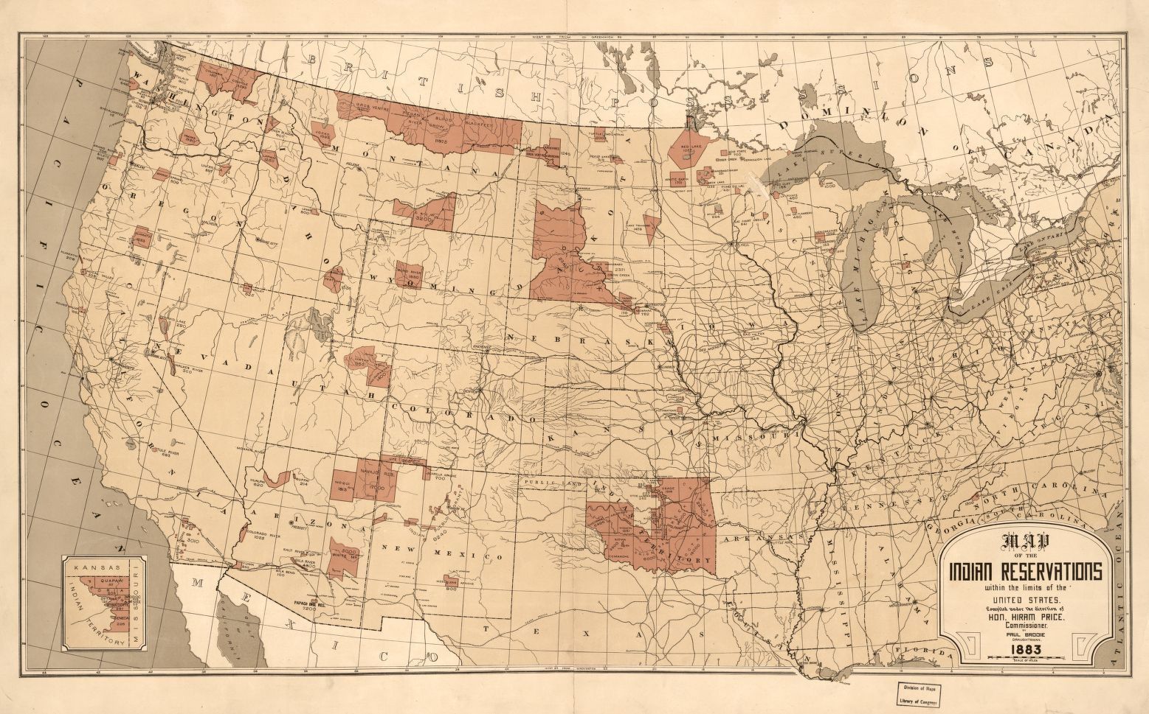
Brodie , Paul Thomas, and Hiram Price . “Map Showing Indian Reservations with the Limits of the United States : 1883.” Library of Congress, 1883, www.loc.gov/item/2009579475.
The image above illustrates Native American reservations located across the United States mostly in the Midwest and West coast. Originally, they inhabited many parts of the East Coast as well as in the central United States, but they were forced to locate to small reservations because of American Settlers.
Many Americans, at this time, believed that it was their divine right to move out west to settle and continue building their family in this young country. This idea however, forced Native Americans off their land and onto small confined reservations. This resulted in them losing over eighty-six million acres of land because of Americans’ actions (Crash Course #24, Westward Expansion). The Government was able to obtain this land by using military force as well by exchanging land for other goods. Many native Americans tried to defend themselves from the American army but unfortunately, it only delayed the process by a little bit. Americans believed that the ways of the Native Americans were very savage, so they forced Native American children to attend boarding schools where they were taught how to live like an American, as well as convert them to Christianity (Native Americans and the West, Jan. 27, 2020). Americans also began killing the buffalo that Native Americans greatly relied on. Americans saw this as a way to make profit which very negatively affected their food and supply source (W. Skeleton Glenn, The Buffalo Destroyed, 1876-1877). Collectively, Americans succeeded in stripping Native Americans of their culture by taking away their land, forcing them to assimilate, and by taking away their most important supply and food source.
- African Americans have faced racial discrimination throughout American history.
The New South & Lynching (January 22, 2020)
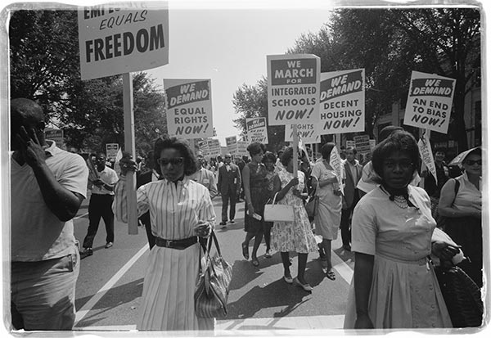BailingOutBenji, /. “Why Protest?” Bailing out Benji, 7 Sept. 2015, peopleforanimals2011.wordpress.com/2015/09/07/why-protest/.
The image above shows African Americans protesting segregated schools as well as fighting for equal rights. This group has been fighting for equal rights since the abolishment of slavery yet, they continue to fight for equal treatment today.
Though slavery has been abolished with the creation of the thirteenth amendment, African Americans have been fighting equal rights since then. This fight includes for things like the right to vote and desegregated schools after the formation of Jim Crow laws post-civil war. Those in the Civil Rights Movement use many different styles to protest the inequalities that they were facing daily. They participated in things such as peaceful and unpeaceful marches, freedom rides, as well as other organized demonstrations (The Civil Rights Movement, 2010). After African Americans achieved the ability to attend schools with white children, some school districts went to great lengths from preventing that from happening. For example, Prince Edward County in Virginia changed their schools to private schools, allowing only white students to attend. This resulted in African American children not attending school for several years until the schools were made public again (60 Years Since Brown v. Board of Education, March 12, 2014). This time also was very violent. Advocacy groups began using other forms of protest to get their points across. These protests were much more forceful which opposed Martin Luther King Jr.’s idea of passive protests (Carmichael and Hamilton, Black Power, 1967). Americans used different strategies to keep African Americans segregated from whites as well as to keep them from having the right to vote.
- After a surplus of immigration from China, Chinese Americans became a target for racial discrimination.
Immigration (January 29, 2020)
.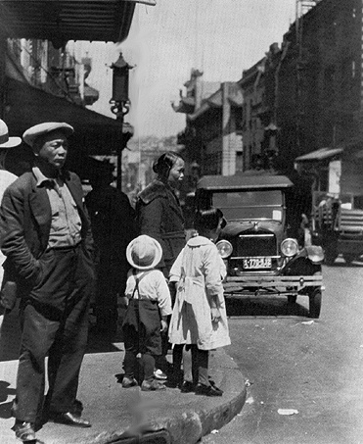 Genthe , Arnold. “The Glittering Ghetto Revisited .” FoundSF, 1920, www.foundsf.org/index.php?title=The_Glittering_Ghetto_Revisited
The image above is a photograph of a Chinese ghetto in the 1920s. Chinese immigrants generally lived in similar locations in big cities because of the community feel as well as to stay connected with their culture even in a foreign country. These small villages were extremely poor neighborhoods as well.
Many male Chinese immigrants were recruited to work on the railroad system as well as to work in mines on the West coast. Most came to the United States for economic opportunity to support their family back home in China (Crash Course #25, Growth, Cities, and Immigration). There became a large number of Chinese immigrants who came over to the United States creating a sense of uncertainty in Americans. Americans felt that there were too many Chinese immigrants working in the United States and stealing jobs that should be given to an American. The Federal Government then banned Chinese immigration to the United States for ten years and later denied citizenship to the Chinese in 1882 however, this ban was not extended to white European immigrants. (Immigration, Jan. 29, 2020). Not only were Chinese immigrants discriminated against by the government, but they were socially segregated as well for their “lack of understanding” of the social standards in the United States (Laura Belmante, On the evils of Chinese Immigrants, 1878). Many immigrants from China knew that they were being discriminated against, but they often felt powerless to do anything about it. These peoples were also hired for exceedingly small wages, so they often lived in poor conditions and made very little (Lee Chew, The Life of a Chinese Immigrant, 1903).
- Japanese Americans were discriminated against after the bombing of Pearl Harbor by the Japanese.
World War 11 (February 19, 2020)
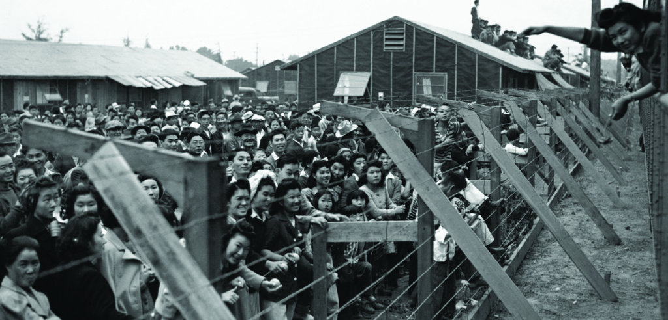
“Forced Internment of Japanese Americans.” Equal Justice Initiative, 11 Nov. 2019, eji.org/news/history-racial-injustice-forced-internment-of-japanese-americans/.
The image above shows a Japanese Internment camp that is highly overpopulated after the bombing of the naval base, Pearl Harbor. It shows how poorly the United States ran the camp and how poorly Japanese Americans were being treated.
After the bombing of Pearl Harbor, the United States declared war on Japan. This resulted in the rise of fear in Japanese Americans. Many Americans became suspicious that the Japanese Americans were spies for Japan and that they could not be trusted (Crash Course #35, World War 11 pt. 1). As a result of this, President FDR issued an executive order, ordering Japanese Americans into Internment camps. They were then forced out of their homes to live in extremely poor living conditions. The camps were very militaristic, and families were given extraordinarily little privacy because of the close approximation to other people. There was little access to medical supplies and care as well, but they made it their home as much as physically possible (World War 11, February 19, 2020). Even with Japanese Americans in these camps, propaganda was made against them. These posters and images told Americans to stand up against them to fight for the country they loved so dearly. This sense of nationalism only created discrimination amongst minority groups (Avenge December 7)
- As Feminism began to rise, more conservative ideals began to oppose the progressive women.
Women’s Suffrage (February 12, 2020)
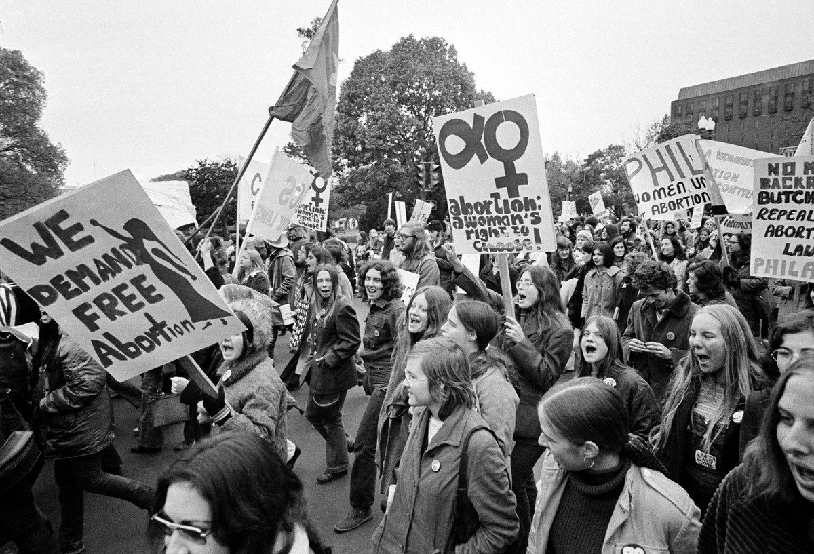 Pripas, Sarah. “Coat Hangers and Knitting Needles: A Brief History of Self-Induced Abortion.” Nursing Clio, 10 Mar. 2016, nursingclio.org/2016/03/10/coat-hangers-and-knitting-needles-a-brief-history-of-self-induced-abortion/.
The image above shows women at a women’s reproductive rights march. A march like this is made possible because of the 19th Amendment giving women the right to vote. This amendment allowed for women to partake in other social movements and other political agendas.
Women have been seen as less than men for centuries and there are some nations still today that recognize this idea as fact. They had fought for almost 100 years to gain the right to vote before this right was awarded to them. Groups like the Women’s Temperance Union and the National Women’s Organization were created to push for Women’s suffrage as well as reproductive rights. At this time, women were also pushing for birth control and contraceptives to have the ability to limit the number of children they had (Crash Course #31, Women’s Suffrage). Women believed they should have this right to vote because it would balance out the vote with men. There were many different tactics that women went about with their protests for the right to vote. The women in the organization NAWSA were a more conservative organization that pushed for women’s suffrage. Their means of protest were very passive and moderate. The national Women’s party on the other hand, was more radical and militant. A famous member of theirs was Alex Paul who led a hunger strike after being unfairly imprisoned for a protest (Women’s Suffrage, Feb. 12, 2020). There were, however, many women who believed that they should not get the right to vote. They believed that voting would only continue to add to the burden they carried along with all their other responsibilities they have. Simply put, these women believed that men should have the sole responsibility to vote (The Remonstrance, 1909). The nineteenth amendment giving women the right to vote was eventually passed into law however, many reproductive and other social justice rights issues came about.
- American soldiers were harassed for their involvement in Vietnam by other Americans.
Vietnam (March 30, 2020)
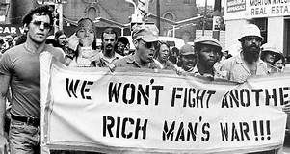
Cox, Savannah. “The Heart And Soul Of The Anti-Vietnam War Movement, In 39 Wrenching Photos.” All That's Interesting, All That's Interesting, 14 Jan. 2019, allthatsinteresting.com/vietnam-war-protests.
The image above is of an anti-Vietnam war protest. Many Americans were against the war resulting in the harassment of many Vietnam War veterans.
The U.S got involved in the Vietnam war because of their fear that the nation would fall to Communism. Many Americans, especially college students and Vietnam veterans, were very against the United States’ involvement in the war which ultimately led to the anti-war movement. This movement protested by participating in demonstrations and burning of draft cards to show their dissatisfaction with the war. Many men and women involved in the feminist movement also became a part of the anti-war movement (Vietnam, March 30, 2020). The antiwar movement focused greatly on the ethics and morality of the tactics used by soldiers on the battleground. In the film, The Craters, veterans search out to find craters where American and Australian soldiers put many dead Vietnamese soldiers as an immoral form of burial. This is an example of different ways that American soldiers, unfortunately, were not completely ethical in war tactics during their time in Vietnam resulting in heated controversy (The Craters). Because of this controversy, many soldiers were forced to suppress the emotions and experiences they encountered in Vietnam to avoid harassment. In the article A Veteran Remembers his Bitter Homecoming, a soldier recalls how he was treated when he returned home from war. He recalls being called a murderer even though he was drafted and had to go to war by law (A Veteran Remembers his Bitter Homecoming, 1981). Most soldiers had no choice but to go Vietnam, yet they were treated like murderers and killers for their part. As a result of this, many soldiers suffered from Post Traumatic Stress Disorder with no way to find support.
- Muslims became a target after the events of September 11, 2001.
9/11 and the war on terror (April 15, 2020)
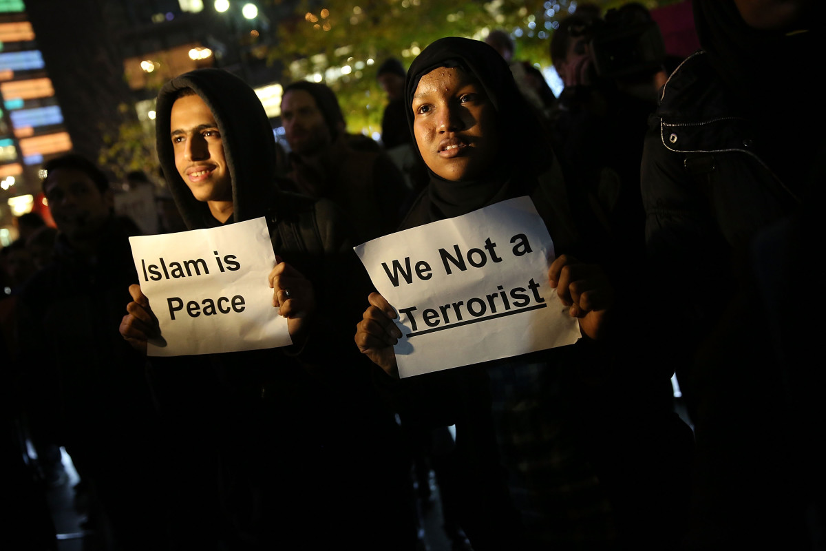
Keller, Jared. “Our Double Standard on Religious Violence.” Pacific Standard, 11 Dec. 2015, psmag.com/news/americas-depressing-double-standard-on-religious-violence.
The image above shows Muslim individuals protesting discrimination they have faced after the events of 9/11. Muslims began to be the center of many racial hatred because the terrorist organization responsible for the events have Muslim affiliation.
After the tragedies of 9/11, many Muslims were targeted and seen as dangerous threats because of the responsible party’s religious affiliation. U.S. Government officials and civilians decided to do whatever means possible to ensure safety and freedom in the United States. This idea put the U.S. in a constant state of war with fear of terrorism at home and abroad (Getting Here from There, 2011). As a result of this, the U.S. made it their mission, under the Patriot Act to ensure freedom in the United States. The U.S. began to get involved in more foreign affairs to combat terrorism even if the country did not house any terrorist organizations (Lafeber, Michael Jordan and the New Capitalism: American on top of its game, 486). The U.S. used different tactics at home to combat terrorism. The biggest example of this was the Government’s ability to spy or wiretap on suspected terrorists. As a result of this, five thousand people from the middle east were questioned and twelve hundred were held but given no reason as to why they were being held. Americans began to fear those from the middle east and other Muslims because of the association with 9/11. Muslims are also usually questioned and searched at airports because of the stigma that surrounds them. The Federal government’s use of unwarranted wiretapping was unethical and a way to discriminate against Muslims (Crash Course #43, Terrorism, War, and Bush). The Muslim faith puts a strong emphasis on harmony so to assume that all Muslims are terrorist is just incorrect and do not deserve to be treated in such a hateful way by many Americans.

