A Statistical Analysis of Math 171 and Math 301 Students’
Responses to a Longwood University Survey in Spring of 2020
Claire Briggs
Math 171, Spring 2020, Dr. Steven Hoehner

Introduction:
In this project I analyzed a random sample from a voluntary survey given to 349 Longwood University students enrolled in Math 171 and Math 301 during the spring 2019 semester. I observed the presidential approval rate and the body mass index of the students included in the simple random sample and computed both boxplots and histograms in order to provide a visual element to the data that was collected from the survey. The results of the survey can be viewed in the Appendix section.
Using the data collected in the survey, I analyzed the question of whether there is a difference in body mass index between male and female students that participated in the voluntary survey. I conducted a hypothesis test using the data from the random sample and constructed a 95% confidence interval, as well as a two sample t-test in order to analyze whether or not there is a difference in the body mass index between male and female students who voluntarily participated in the survey.
Data Collection:
It is often impractical to study an entire population, so we use samples in order to study the nature of entire populations more conveniently. The population involved in this study includes all students enrolled in Math 171 or Math 301 in the spring semester of 2019 who voluntarily chose to participate in taking surveys. The categorical variables in this study include students’ sex, official class, presidential approval. The quantitative variables in this study include the students’ body mass index, which is also considered to be a continuous variable.
In order to generate the simple random samples used in my analysis, I took the female students’ identification numbers 1-219 through the use of the MATH function on a TI-84 calculator, continuing onto the PROB function, and concluding with the randIntNoRep (1, 219, 20) function to aquire the random identification numbers of 20 female students. In order to obtain the simple random sample of 20 male students, I used the students’ identification numbers 220-349 through the use of the MATH function, PROB function, and randIntNoRep (220, 349, 20). After generating the simple random samples of both the female and male students, I took the randomly generated identification numbers and put them into excel.
Because of the fact that I am observing the population of Math 171 and Math 301 students in the spring semester of 2019, and that the collection of data is simple and does not involve a cause and effect method, this is considered an observational study. With this information that this is an observational study, I can also conclude that it is acceptable to use the simple random samples that I have generated to represent the population of students enrolled in Math 171 and Math 301 that voluntarily participated in the study. The simple random sample is reasonable to use in this case to approximate the populations of all female and male Math 171 and Math 301 students for spring 2019 because the sample was drawn randomly, and the sample includes 40 individuals. This is a larger sample which makes the study more acceptable to use to represent the entire population of students.
Data Description:
-Histogram for SRS of 20 Female LU Math 171 and Math 301 Students Presidential Approval:
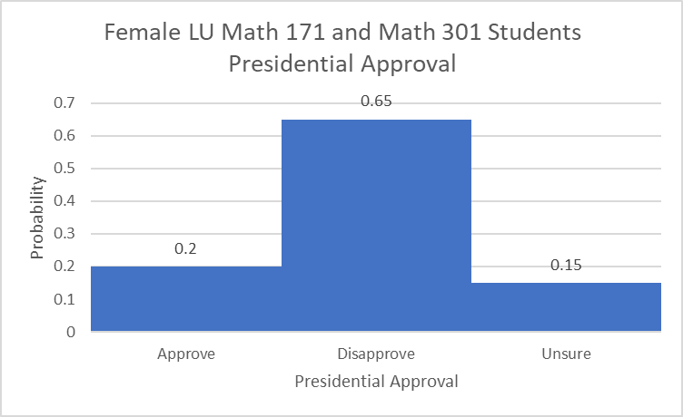Graph 1
The mode of this simple random sample is presidential disapproval. 65% of female students in this sample answered that they disapproved of the president.
-Histogram for SRS of 20 Male LU Math 171 and Math 301 Students Presidential Approval:
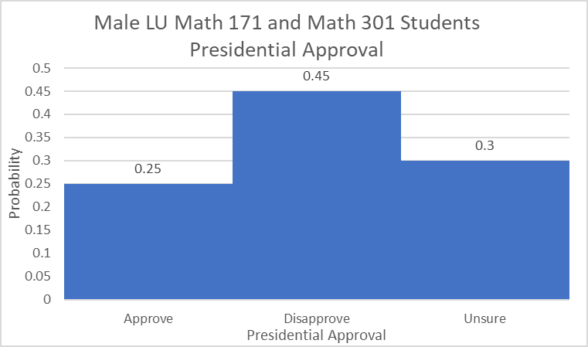Graph 2
The mode of this simple random sample is presidential disapproval. 45% of male students in this sample answered that they disapproved of the president.
Both samples show that the majority of students disapprove of the president. However, in the male sample, there were far more students that say they approve of the president or are unsure of their feelings of approval than in the female sample.
-Histogram and Boxplot for SRS of 20 Female LU Math 171 and Math 301 for BMI:
Graph 3
Graph 4
The class that occurs the most frequently in the female simple random sample is a body mass index of 23.2 to 26.45 in which 30% of females fall into this class. The mean of the female students’ body mass index is 26.59, with a distribution that is slightly skewed right.
-Histogram and Boxplot for SRS of 20 Male LU Math 171 and Math 301 for BMI:
Graph 5
Graph 6
The class that occurs the most frequently in the male simple random sample is a body mass index of 22.325 to 24.0375 in which 30% of males fall into this class. The mean of the male students’ body mass index is 24.53, with a distribution that is slightly skewed right.
The mean female body mass index is larger than that of the mean male body mass index of students enrolled in Math 171 and Math 301. The female distribution of body mass index is closer to what would be considered a typical right skewed shape while the male distribution of body mass index is more evenly distributed while still being considered a right skewed shape. Descriptive statistics for both the male and female students’ body mass index can be viewed in the Appendix Section.
For both female and male simple random samples, I computed the upper and lower fences of the data det in order to determine if there were any upper or lower outliers in the separate simple random samples. I computed the interquartile range for both random samples by taking the Q3 value and subtracting the Q1 value. Once I had the interquartile ranges, I identified outlier data by finding upper and lower fences. I found the lower fences by taking the Q1 value, subtracting by 1.5 and multiplying by the interquartile range. I found the upper fences by taking the Q3 value, adding by 1.5 and multiplying by the interquartile range.
The lower fence for the female sample of body mass index is 7.18 and the upper fence for the female sample of body mass index is 45.86. Because the minimum value for the female sample is 16.7 and the maximum value for the female sample is 42.7, there are no outliers present in the female data set. The lower fence for the male sample of body mass index is 14.78 and the upper fence for the male sample of body mass index is 34.58. Because the minimum value for the male sample is 18.9 and the maximum value for the male sample is 32.6, there are no outliers present in the male data set.
Data Analysis:
In order to accurately determine whether or not the conditions are satisfied within the simple random sample, I will have to assume that the body mass index of male and female students enrolled in Math 171 and Math 301 are normally distributed. Because the sample was fairly large and randomly generated, I can reasonably assume that that the sample is normally distributed. The sample obtained for this analysis belongs to a population of students enrolled in Math 171 or Math 301 in the spring semester of 2019 who voluntarily chose to participate in taking surveys.
I chose to let μm equal the mean body mass index of the male population and let μf equal the mean body mass index of the female population. I constructed two hypothesis tests for the samples. The first hypothesis, Ho, would be μm=μf; and the second hypothesis, Ha, would be μа≠μf. The degrees of freedom for the body mass index of the female statistics and the male statistics separately is equal to 19. To determine the test statistic and the p-value I used the 2-SampTTest on my TI-84 calculator and entered the body mass index calculations of the both the female sample and the male sample. I am using the 2-SampTTest for my random samples because I want to test my Ho hypothesis that the two populations are equal to one another. The calculated test statistic was equal to -1.218922557 and the calculated p-value was equal to 0.2319221264.
After conducting the 2-SampTTest, or the hypothesis test, I can reject the null hypothesis that I stated, that μm=μf, because there is a high probability that the stated null hypothesis does not equal the alternative hypothesis. In other words, there is a high probability that the body mass index of male Math 171 and Math 301 students at Longwood University who chose to participate in a voluntary survey does not equal the body mass index of female Math 171 and Math 301 students at Longwood University that participated in the same survey.
To construct a 95% confidence interval regarding the simple random samples that were generated, I had to use the mean and standard deviation of both the female and male samples respectively. I decided to do this work all by hand. I took the square root of the standard deviation squared, divided by the ‘n’ value of the female body mass index stats and added it to the square root of the standard deviation squared, divided by the ‘n’ value of the male body mass index stats to get the number 1.689320869. I then took 1.96, which is a number based off the fact that 95% of the area of a normal distribution is within 1.96 standard deviations of the mean and multiplied it by 1.689320869 which then equaled 3.311068903. The value of 3.311068903 could then be used to add and subtract to 2.06, which is the value I computed from the mean of the body mass index of males subtracted by the mean of the female body mass index. Using this data, I came to the conclusion that the 95% confidence interval for the difference in the two populations’ body mass index means is (-1.251- 5.371). The 95% confidence interval supports the results from my hypothesis test because the numerical values of population are not included in the confidence interval that was constructed. This conclusion supports my decision to reject my null hypothesis.
Appendix:
Female Simple Random Sample:
Identification | Sex | Class | PA | BMI
179 | Female | Sophomore | Disapprove | 31.8
111 | Female | Freshman | Unsure | 23.4
164 | Female | Senior | Disapprove | 35.8
181 | Female | Sophomore | Disapprove | 29.1
219 | Female | Senior | Disapprove | 25.9
20 | Female | Freshman | Unsure | 20.4
55 | Female | Freshman | Approve | 24.6
82 | Female | Freshman | Disapprove | 22.2
118 | Female | Junior | Disapprove | 34.6
73 | Female | Freshman | Disapprove | 32.6
87 | Female | Junior | Approve | 30
23 | Female | Junior | Unsure | 16.7
158 | Female | Freshman | Approve | 24.9
64 | Female | Freshman | Approve | 21.5
148 | Female | Sophomore | Disapprove | 19.2
38 | Female | Sophomore | Disapprove | 26.7
3 | Female | Freshman | Disapprove | 24.4
135 | Female | Junior | Disapprove | 20.4
171 | Female | Junior | Disapprove | 42.7
28 | Female | Junior | Disapprove | 24.9

Male Simple Random Sample:
Identification | Sex | Class | PA | BMI
255 | Male | Freshman | Approve | 32.6
313 | Male | Freshman | Disapprove | 30.1
304 | Male | Junior | Approve | 26.9
226 | Male | Freshman | Approve | 22.4
296 | Male | Junior | Disapprove | 22.4
230 | Male | Junior | Disapprove | 25.9
235 | Male | Junior | Unsure | 31.7
278 | Male | Senior | Unsure | 25
232 | Male | Junior | Disapprove | 18.9
248 | Male | Senior | Unsure | 22.4
241 | Male | Freshman | Disapprove | 22
314 | Male | Senior | Disapprove | 27.4
345 | Male | Freshman | Disapprove | 21.2
318 | Male | Junior | Unsure | 22.8
251 | Male | Freshman | Unsure | 23.3
221 | Male | Sophomore | Approve | 23.5
273 | Male | Freshman | Unsure | 19.6
264 | Male | Freshman | Disapprove | 24.4
346 | Male | Sophomore | Approve | 19.6
341 | Male | Sophomore | Disapprove | 28.5

-Descriptive Statistics for Female BMI:
Mean: 26.59
Standard Deviation: 6.44
Five Number Summary: (16.7, 21.68, 24.9, 31.35, 42.7)
IQR: 9.67
-Descriptive Statistics for Male BMI:
Mean: 24.53
Standard Deviation: 3.95
Five Number Summary: (18.9, 22.2, 23.4, 27.15, 32.6)
IQR: 4.95

Graph 1 – Female LU Math 171 and Math 301 Students Presidential Approval
Graph 2 – Male LU Math 171 and Math 301 Students Presidential Approval

Graph 3 – Female LU Math 171 and Math 301 for BMI

Graph 4 – Female LU Math 171 and Math 301 for BMI

Graph 5 – Male LU Math 171 and Math 301 for BMI

Graph 6 – Male LU Math 171 and Math 301 for BMI

