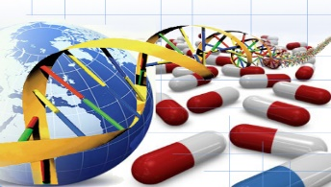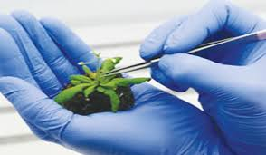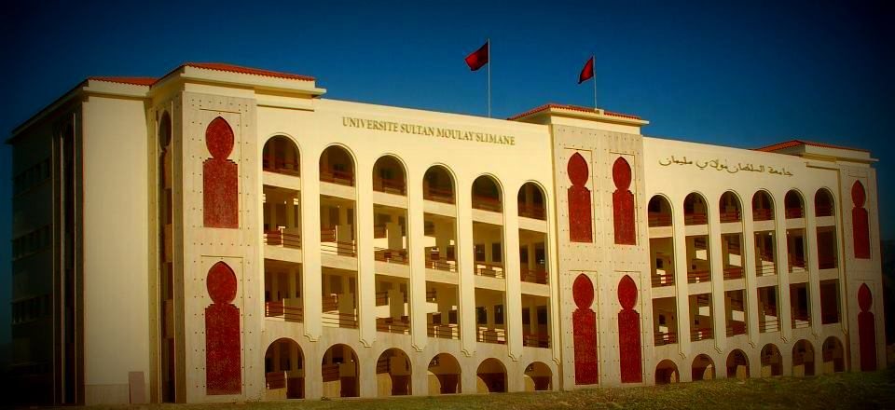

The University of Sultan Moulay Slimane, and the Polydisciplinary Faculty, in collaboration with the United States Embassy in Morocco, organize the 1ST International Conference on:



For more information and to submit your abstract, visit the conference website: blogs.longwood.edu/biotechnology2017



For questions contact us at: [biotechfpusms2017@gmail.com](mailto:biotech2017fpusms@gmail.com) Tel: (+212) 620 354 436 or 661 231 711 Fax: (+212) 523424597

December 18 and 19, 2017

at

The Polydisciplinary Faculty, Beni-Mellal, Morocco

* Amorette Barber, PhD - USA
* Noureddine Hamamouch, PhD - Morocco
* Cristina Silva Pereira, PhD – Portugal
* Francisco Canovas, PhD - Portugal
* Klaus Ammann, PhD - Switzerland

Keynote Speakrs

* Agricultural biotechnology
* medical and pharmaceutical biotechnology
* microbial and environmental biotechnology

Conference Tracks

Biotechnology: Perspective beyond 2017