Final Project
Alaina Bierman
U.S. History 1877 to Modern Times (HIST 222 - Honors)
“7 Ways that Studying US History 1877 to Modern Times History Shapes the Way You Think About The Oppression of Minorities in the US”

Looking at the cycle of abuse and racism that surrounded Chinese workers is a clear example of the oppression of Non-White Immigrants and Americans in the United States
Topic: Immigration 02/01/19
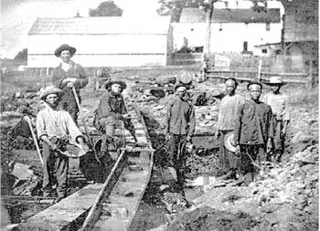
“Chinese Immigrant Laborers” can be found at Chinese Laborers on 4/28/19

In this picture, Chinese immigrants work on a railroad. In the mid 1850’s, many Chinese people immigrated to the United States for better opportunities and more freedoms. However, from the moment they got to the U.S, they were persecuted, stereotyped, and treated negatively. Due to their inability to speak proper English and their non-white culture and heritage, they were often viewed as “lesser people.” Chinese immigrants were also paid very little for their work, turning them into a cheap labor source (Unfinished Nation: The Age of the City, 2014). This led to many White Americans holding the prejudice belief that Chinese people sought to steal the jobs of, “good, hardworking, Christian men” trying to provide for their families, because they were often being hired over White Americans.
Chinese immigrants were being paid very poorly, and often could only find work doing very dangerous jobs, such as working on railroads, where there was a high death and injury rate. However, despite their ability to work tirelessly and do their job well, they were still resented by their white coworkers for their “willingness” to work low wages, not understanding or simply not caring that they were taking the low wages out of necessity (Belmonte, pgs. 476-477). Chinese immigrants formed their own communities where they were able to retain their culture and be amongst one another, but White Americans saw this as an unwillingness to gain citizenship. Rather, they thought they were simply sending the money they earned back to their families in China and stealing American jobs, all the while refusing to work for their citizenship or nativize in any way. Americans wanted the Chinese to leave and when they became demoralized and wanted to do so, Americans grew angry and blamed them for not adopting an “American” way of life (Chew, pg. 6). The hatred for Chinese people became so great that in 1882, The Chinese Exclusion Act was passed, which was created to severely limit the amount of Chinese people who could immigrate to the United States. Chinese immigrants were given horrible work opportunities, and then treated as pests by those around them for accepting those opportunities. This cycle of hatred, manipulation, and abuse led to the oppression of Chinese immigrants for decades after.

---------

From the moment European settlers invaded and colonized America, the Native Americans already inhabiting the land were brutally murdered and those that survived were forced to change their way of life and lose their culture
Topic: Native Americans and the West 01/29/19
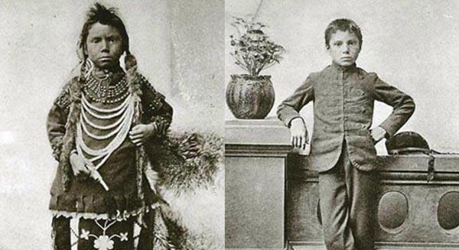
“Before and After Photo of Native American Child After Being Sent to a Boarding School” can be found in the video Unspoken Truths About Boarding Schools on 4/28/19
This photo, when the history behind it is shared, is an especially chilling one. Native Americans have been persecuted since Europeans first made contact with them in 1492. Native Americans greeted Europeans with open arms, traded with them, and aided in any assistance they needed. They believed that the Europeans were partners of sorts, more people to trade with and form alliances with. However, the “friendship” turned foul shortly after the groups came into contact with one another. Spanish Europeans quickly began to brutalize, abuse, rape, and murdered Native Americans. They stole their resources and colonized their land by force, enslaving the native people as they went and murdering those who tried to stage uprisings. (Crash Course #24: Westward Expansion) Native Americans were almost completely wiped out by the time the thirteen colonies became the United States of America.
From there, the abuse and racism Native Americans were subjected to became more subtle, but barely so. Native Americans were forced onto small reservations with limited resources and left to their own demise. The land they were given wasn’t prime land by any means, but land with limited resources and bad soil for farming. The government then began to say that it was their job to “kill the Indian, save the man.” (Immigration cont., 02/01/19) This meant that they tried to “purify” the Native American people by stealing their culture from them and forcing them to act “white.” The picture above is a before and after of a young child after being sent to a boarding school created by the United States government to destroy the culture of Native Americans. Children were often sent to the schools by force where they were made to only speak English, not speak of family, culture, or tribes, were separated from people in their tribes, were given very strict rules and were punished severely for disobeying them, and were given “American, modern-European” clothes to wear. (Belmonte, pgs. 430-431) Native Americans have had their cultures destroyed, their heritage practically erased, and their people murdered. Native Americans have been oppressed since Europeans first came into contact with them, and they have only just started expressing their culture again.

---------

Looking at the treatment of Native Peoples such as Filipinos and Puerto Ricans after their countries were given to the United States of America for imperial rule
Topic: Imperialism and World War 2 02/06/19
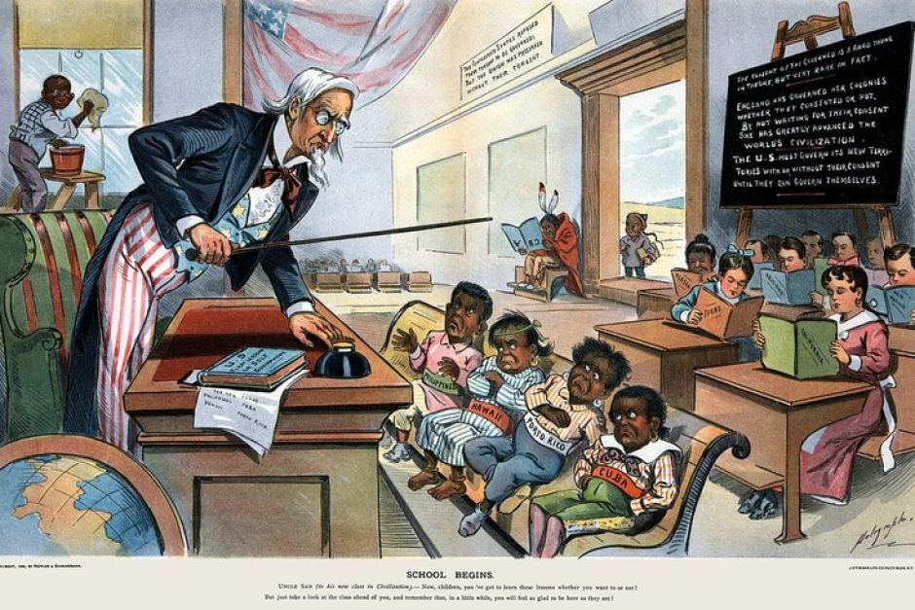
“Uncle Sam Teaches the “Savage Islanders” to Conform to Western Ways of Life” can be found at Imperialism Cartoon on 4/28/19

Imperialism is a country extending their power and military force to other countries. They set up military bases, normally get very much involved in that country's politics, and use the country's’ resources for economic gain. (Crash Course #28: American Imperialism) America has been imperializing areas (primarily smaller island countries with troubled pasts such as Cuba, Puerto Rico, and the Philippines) for decades. While The United States took away their political freedoms, they also treated them as “savages” who needed America’s help to learn how to be civil. The United States believed that since they were spreading democracy, what they were doing was actually a service to the countries they were colonizing. Propaganda created during this time purposely made native people look like brutes with very low intelligence. The cartoons were especially popular because they helped to ease any guilt that Americans had about colonizing and essentially taking over these countries, because the cartoons, like the one shown above, made them believe that they were actually saving the natives, and that they were unable to take care of themselves. The cartoons also did an excellent job of making it seem like if The United States didn’t colonize these countries, some other European country would, and they would be much worse. (Hunt, pgs. 7, 20, 22, 23) The cartoon above is a clear example of how Natives were belittled and mocked for being different from Western peoples. Racism was rampant, and these countries were being passed from one white country to the next, with very little thought being put into the treatment of Native people. (Kramer, pgs 107-116)

---------

African Americans are undisputedly one of the worst treated groups of people living in America. From slavery to segregation to police brutality, African Americans are oppressed at every turn
Topic: The New South and Lynching 01/06/19
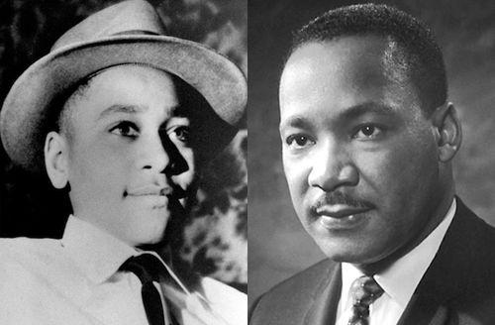

Emmett Till killing case reopened over 'new information:’ Federal prosecutors reopen their investigation into the brutal 1955 slaying in Mississippi. By Fedschun can be found at Emmett Till on 4/28/19

Africans in America have a history filled with sadness, turmoil, pain, and fear. Slavery is one of the darkest parts of America’s history, there's no doubt. Millions were kidnapped and had their lives torn apart. Women were raped, mothers watched their children helplessly as they were sold, and African Americans were forced to work on plantations day in and day out with no hope for change. (A Brief History of America) In 1865 the Civil War freed African Americans from physical chains, but they were still ensnared by oppression. Emmett Till, the child pictured above, is just one of thousands of African Americans who were lynched for crimes they were accused of committing. (Wells, 55) However, they hardly ever actually went to trial. Instead, they were kidnapped from their cells at night and murdered by angry mobs. In the case of Emmett Till, there was never even an arrest made. He was accused of whistling at a white woman in a store, was subsequently kidnapped by her family, beaten badly, and murdered. He was 14 years old, and now decades later, the woman he supposedly harassed has come out to say it never happened. Although slavery was over, African Americans were still being treated as second class citizens and being segregated and racially profiled. (Episode 4: America Divided) Throughout history, as soon as African Americans have beaten one obstacle, another pops up, proving they may be one of the most oppressed minorities in America, if not the most oppressed. Even today in modern America, the shootings of unarmed black teens cover the news, with justice being served not nearly enough.

---------

Hispanic people entering the country either for job opportunities or to become citizens were treated with distrust and disdain, and had to fight for their rights with other minority groups during the Civil Rights Movement of 60’s
Topic: Social Movements of the late 20th century 03/22/19
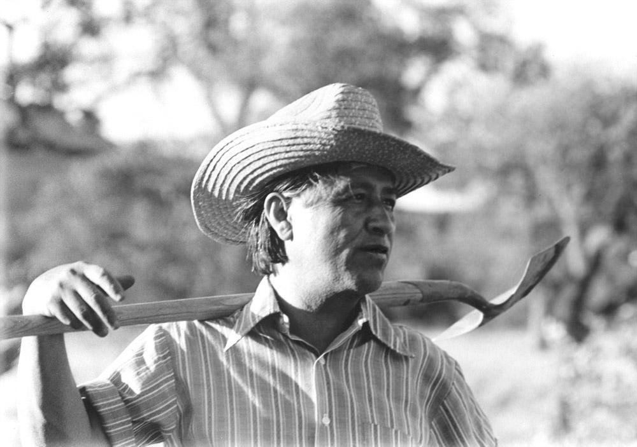
César Chávez at work in the community garden at La Paz in Keene, California by Cathy Murphy accessed at Cesar Chavez on 4/28/19
Across America, minority groups of any kind were being treated with disrespect and were seeing a lack of freedoms, despite being in “The Land of the Free.” Hispanic people immigrating to the United States or already living there were treated no differently than the other minorities in the country. Hispanic people were often forced to work very low paying jobs such as fruit pickers in order to make any sort of money. César Chávez, pictured above, was an advocate for Hispanics in his community. (Drake, pgs 162-163) Chávez was especially active in the farming community. He understood that Hispanics weren’t being given a fair piece of the pie and sought to change that in any way he could. He worked in terrible conditions at times, even out of his garage with no air conditioning. (Huerta, 42-43) Beyond just discrimination in the workforce however, Hispanics, particularly Mexican-Americans, were receiving very similar treatment to African Americans. (Crash Course #40: The 1960s in America) Hispanics faced police brutality, segregation, and overall repression. Much like African Americans, they fought back in similar fashion, with activists like Chávez leading the charge. (Social Movements of the Late 20th Century, 03/20/19) While their civil rights movement was somewhat successful, Hispanics still face discrimination in it’s ugliest form today. Some would even argue that given the opinions of certain government officials, it’s become popular and socially acceptable to mock Hispanics, sending us back in time as if the civil rights movement never occurred.

---------

For centuries, homosexuals were forced to hide their true selves from the world, in fear of being outed and having their world’s turned upside down. The United States was not kind to those who identified as being gay, often putting them in mental hospitals or sending them to conversion camps, causing many to live in constant fear
Topic: Feminism and Women’s Movements 03/29/19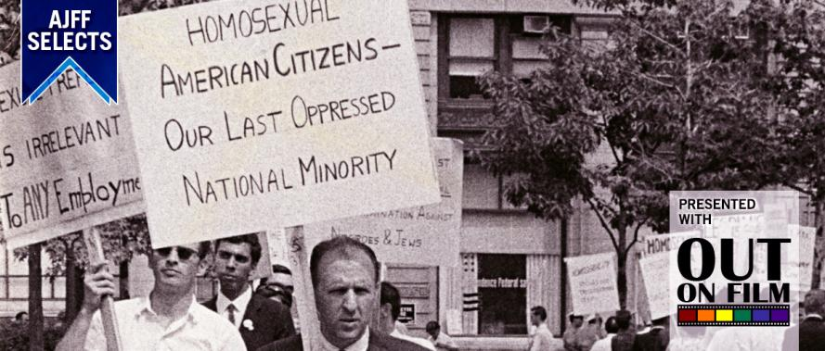A man protesting the sudden purging of homosexuals being pushed from government jobs during the Lavender Scare can be found at Lavender Scare on 4/28/19
Homosexuals, especially lesbian woman, have long been a persecuted group in The United States. The picture above was taken during the Lavender Scare of the 1950’s. During The Cold War, many sought to out homosexuals from any sort of government job. Their reasoning was that communists could more easily blackmail homosexuals into turning on their countries. (The Cold War 03/11/19) Being outed as a homosexual was the end of their career for many, and the end of relationships with family members and friends as well. The United States during this time was not only very much Anglo-Saxon, but the government during this time was conservative. Soon after this was the Lavender movement. The Lavender movement was a group of lesbians in the feminist community who weren’t being treated fairly. Even in freedom movements like the Women’s Rights Movement of the 60’s, it was possible for homosexuals and lesbians to face some kind of persecution. (She’s Beautiful When She’s Angry) Throughout this time period, homosexuals struggled to find their own voice and movement. Often, theirs was pushed to the side for being something that many didn’t want to deal with. The community was becoming depressed after being oppressed by those in a position to help them. More so, they were often being sent to psychiatrists, doctors, and mental hospitals. “Rather than deal with a sick society, the shrinks deal with individual members of that society.” (Chicago Gay Liberation Front*, pgs. 144-147) The homosexual community was having their sexuality and love oppressed by those who didn’t understand them, which led to depression and other mental disorders in the community. Lies were also spread about homosexuals, particularly in the 50’s and 60’s, labeling them as pedophiles who wanted to have sex with your children. (The Cold War, 03/11/19) This hatred and homophobia, while it has diminished somewhat as the world and country modernizes, has had a lasting impact on the community, and they still feel it today in certain political and social climates.
*No author for this document, just the actual organization is listed

---------

The Irish, Russians, Italians, and Eastern Germans were all subjected to racism following their immigration to the United States during the late 1800’s and early-mid 1900’s, and looking at the way Americas Anglo-Saxon society viewed them and the opportunities available for them shows the oppression even of white people who didn’t fit the image of the “Perfect American”
Topic: Immigration 02/01/19 and The Cold War 3/11/19
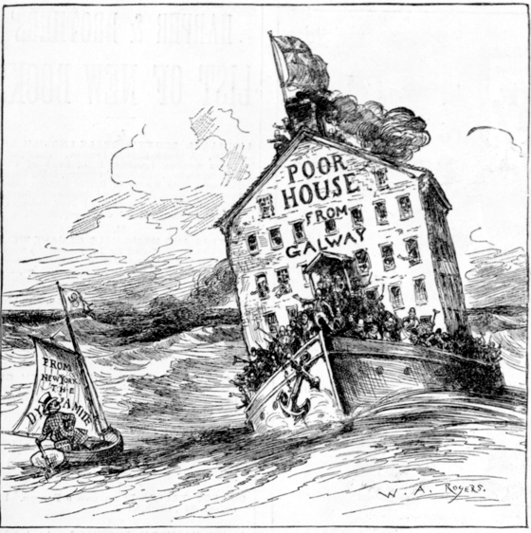
Immigrants Wanted...Or Not by David Burns can be found at Irish Poor House
The picture above depicts an Irish community sailing to the United States to immigrate. The boat is teeming with people, and it seems a very ominous warning to the native born people of the United States. Despite the color of their skin, there were certain groups, especially the Russians and Irish, that were unwelcomed in the United States. Their willingness to work for low wages took jobs from native born American men, they were often very poor, they had thick accents, had different religions (particularly the Irish, who were made up of a majority of Catholics,) and they congregated together. (Crash Course #25: Growth, Cities, and Immigration) These European immigrants often worked very similar jobs as the Chinese and Asian immigrants. They built railroads, worked in coal mines, and took very low paying factory jobs. The women were often domestic workers or servants. While the United States desperately needed these immigrants to boost their economy and work the dangerous jobs others were less inclined to, the native born Americans still turned their noses at them and didn’t view them as, “real Americans.” (Immigration 1/30/19) Political unrest also negatively affected the way people viewed these immigrants, particularly Russian immigrants. During the Cold War, people wanted Russians, who they believed were communists, out of their country or arrested and in jail. There was such a panic that the Red Scare saw people turning on eachother and fearing for their freedoms, and the group that took a good portion of the abuse were Russian Americans and Russian immigrants. (The Cold War 3/11/19) Communism was something many were afraid of, because they believed the spread of communism would aid in the forceful removal of their freedoms. This reasoning led to the United States getting involved in foreign affairs for the reasoning of aiding countries in their fight to become democracies. (Porter, 1979) Through these different periods of time in the 1800’s and 1900’s different Eastern and Northern European have been subjected to racism as a way for native born Americans to blame them for the issues they were facing, and because although it was very slight, they differed from these native born Americans, so they were made to suffer greatly.

Conclusion:
The United States of America has, unfortunately, seen countless different groups of minorities discriminated against in countless ways. This being said, I hope my generalizations above aren’t seen as a lack of knowledge or offensive to anyone in those groups. Rather, I’d hope they realize that each minority has a vast and complicated history, and I only have about two paragraphs to try and give them justice. Furthermore, I’d like to take a moment to explain my reasoning for picking Eastern and Northern Europeans over Muslims. While this was a hard choice, I did it to highlight the way this white minority suffered different than the colored minorities, and sexual minority listed above. While their oppression was real and valid, it wasn’t on the same level as the other groups I wrote about. This is because despite their differences, they were still all white. (With the exception of Italians, who some thought were white and others thought were brown.) They were discriminated against and faced hardships, but they didn’t have to fear for their lives the way African Americans did. They didn’t have their cultures obliterated and their children taken from them the way Native Americans did. And they didn’t have an entire country hate them so greatly that they created an act to keep them out, like the Chinese did. Oppression in any form is terrible, but by reading this article, it is my hope that one can see the differing levels of oppression, and how the white minority received a less threatening and invasive form of oppression that didn’t last nearly as long as the oppression of other minorities in the article. For almost every other minority in that article, they still face oppression today. But Italians, Germans, and the Irish have been completely accepted into American culture. Russians have been almost entirely accepted with the exception of some political persecution. While white minorities differed from native Americans, the underlying theme that set them apart and made it easier for them to assimilate was their skin color. Racism is one of the biggest underlying problems in the United States, and has been since its creation.

