Wooly Worm Lab Report
Nicole R. Barclay
BIOL 251
October 23, 2019

ABSTRACT
Some organisms use camouflage to prevent being eaten by predators, which through natural selection allows this favorable trait to persist because it increases fitness. In this study, we conducted a two-part experiment investigating the effect of predation on natural selection by simulating birds collecting different colored wooly worms from a grassy area on Longwood University’s Wheeler Lawn both with and without a secondary consumer of a fox. In both parts, we found that brown and green worms were consumed statistically less than bright colored worms within the grassy environment. The addition of a third trophic level decreased the total amount of worms collected, but the frequency of the collected wooly worms across the different colors remained generally consistent. Predation was the selection pressure acting on the wooly worm population in this study, leading to the survival and reproduction of those with favorable traits.
INTRODUCTION
Natural selection is the theory that certain traits are more beneficial to organisms in a certain environment, consequently increasing their ability to survive and reproduce compared to alternate versions of that trait. Those with more favorable traits might be less likely to be caught by a predator, like the peppered moth for example. During industrialization in the United States, melanic peppered moth Biston betularia was believed to be favored over pale peppered moths due to the soot on the bark of trees allowing them to camouflage better (Cook et al. 2012). Today, the bark is no longer covered in soot, so the pale peppered moths have become more favorable in that environment due to the change in conditions (Cook et al. 2012). Phenotypic variation is very important within a species because it allows favorable traits to survive, organisms to have increased fitness, and consequently allowing populations to adapt and evolve. Phenotypic variation provides the necessary variety in alleles for traits, enabling natural selection. In this experiment, we investigated the relationship between natural selection and predation by using simulated birds feeding on different colored worms in a grassy area. The null hypothesis was that wooly worms of different colors will be collected both with and without a secondary consumer. The alternate hypothesis was that wooly worms of different colors will be collected unequally both with and without a secondary consumer. We predicted that green and brown wooly worms would be collected less than brighter colors due to likely camouflage with the grassy environment.
METHODS
On August 28, 2019, a bright and sunny afternoon, 50 pipe cleaners of each of the following colors were randomly spread across one section of Wheeler Lawn at Longwood University to represent a total of 350 different colored wooly worms: red, yellow, orange, white, blue green and brown. For the first part of this experiment, fourteen students randomly picked a starting point on the lawn and had one minute to pick up as many worms as they could, representing predacious birds. To simulate the amount of time it takes for the bird to eat the worm, students could only pick up one worm at a time, place it in a paper bag, and record the color of the worm before picking up another worm. The experiment was then repeated for part two with one student representing a fox that preyed on the predacious birds who had a 10 second head start. The fox touched a prey (who then left the experiment) and waited two seconds before consuming another bird to simulate the time it takes for the fox to eat the bird. A Chi-square test was then performed after each part of the experiment with the collected data in order to determine if the wooly worms were randomly selected.

RESULTS
In the first part of the experiment, there was a significant difference in the number of wooly worms collected amongst the different colors (X²=29.61, DF=6, P=0.05) Bright colored worms such as blue and white were collected more often than green or brown (Figure 1). When adding a secondary consumer in the second part of the experiment, there was also a significant difference in the number of wooly worms collected amongst the different colors (X²=36.74, DF=6, P=0.05) (Table 2). The total number of wooly worms collected decreased in part two of the experiment from 160 to 133, but the frequencies of each color worm were very similar (Figure 1).
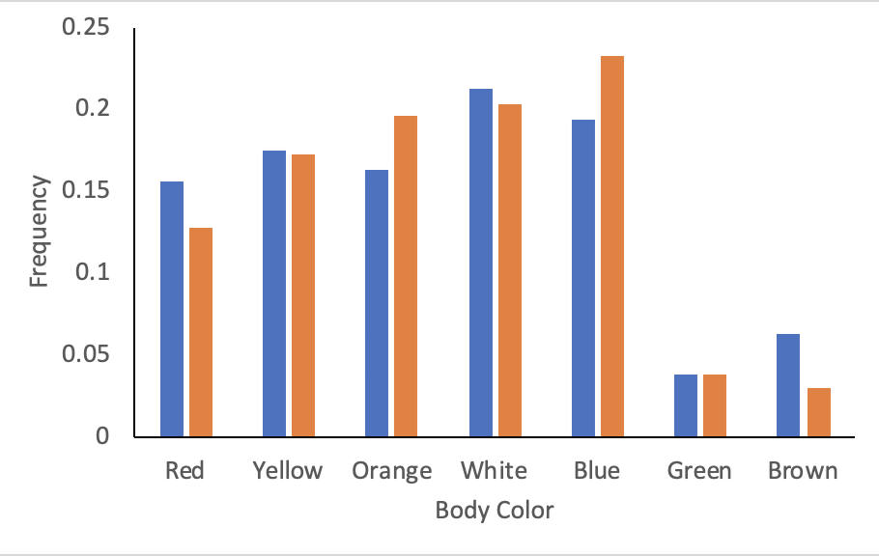
Figure 1. The Effect of Body Color on Frequency of Consumption of Wooly Worms. Predatory birds collected different colored wooly worms for one minute without a secondary consumer (blue) and with a secondary consumer (orange). After the data were collected, the frequency of each color was calculated and is illustrated above to be very similar both with and without a third trophic level.

DISCUSSION
Natural selection in combination with predation allows for favorable traits to persist throughout generations of a population, increasing an organism’s ability to both survive and reproduce. In this experiment, predation was the positive selection pressure present on the green and brown wooly worms. This selection pressure was more successful for this population in comparison to the negative selection pressure on the brightly colored wooly worms, particularly the blue and white worms. Much like the favorable green and brown wooly worms, Pacific leaping blenny are also selected because of their body coloration within their habitat in order to reduce predation and increase their ability to survive and reproduce (Morgans and Ord 2013). Adding a third trophic level decreased the total amount of worms collected due to the lower amount of predatory birds. Although the total amount of worms changed, the statistically significant difference in worms collected amongst the different colors remained constant.
Changing conditions in the environment or hierarchy can significantly impact populations. For example, if only a primary consumer was present, the wooly worm population as a whole would decrease faster than if a secondary consumer was present. If the environment were to change and perhaps become covered in snow during the winter, there would likely be a positive selection pressure on the lighter colored worms, such as white. In addition to acting on physical traits, natural selection can also act on physiological traits as demonstrated by Strobbe et al. This study analyzed the escape speed of the damselfly Enallagma vesperum from dragonfly predators in which faster swimming speeds were selected (Strobbe et al. 2010).
Possible sources of error during this experiment include uneven distribution of the different colored worms and human error in collecting the worms and timing. This study demonstrates how predation plays a significant role in allowing favorable traits that influence survival to persist over generations by eliminating those with the less favorable traits. In the future, we could conduct this experiment with real organisms and in different environments or under varying weather conditions to identify which worms would survive better in a warmer climate for example.
REFERENCES
Cook LM, Grant BS, Saccheri IJ, Mallet J. 2012. Selective bird predation on the peppered moth:
the last experiment of Michael Majerus. Biology Letters. 8(4):609-612.
Strobbe F, McPeek MA, De Block M, Stoks R. 2010. Survival selection imposed by predation on
a physiological trait underlying escape speed. Functional ecology. 24(6):1306-1312.
Morgans CL, Ord TJ. 2013. Natural selection in novel environments: predation selects for
background matching in the body colour of a land fish. 86(6):1241-1249.

