The Morphological, Biochemical, and Genetic Characterization of Yeast Growth on Berries
Nicole R. Barclay
Longwood University

Abstract
Strawberries, blueberries and raspberries were acquired from a local grocery store and refrigerated for 6 days before they were crushed using a mortar and pestle, then diluted with distilled water in order to isolate yeast which was plated on Yeast Extract, Peptone, Dextrose (YPD) + Streptomycin + Penicillin-G. The isolated yeast strains were then used for multiple assays including a Polymerase Chain Reaction (PCR) to obtain DNA sequence in a follow up reaction. Other assays allowed for the characterization of yeast according to morphological, biochemical and genetic properties.

The Morphological, Biochemical, and Genetic
Characterization of Yeast Growth on Berries
Yeast strains are found in several diverse environments, such as soil, water or even insects. One of the most significant and recent applications of the isolation of yeast strains is its usage in the creation of bio fuels, which reduces the amount of non-renewable fossil fuels used (Tikka, Osuru, Alturi, et. al. 2013) and plays an enormous role in sustainable energy. Yeast is also commonly found in environments rich in sugar or higher in acidity, like fruits for example. The characterization of yeast is also extremely important in ensuring quality and safe fruit products sold to consumers (Lacombe, Niemira, Gurtler, et. al. 2015). The processing of such fruits aims to eliminate yeast and mold to avoid foodborne illnesses and infections (Sy, McWatters, Beuchat 2005). One study focused on fruit salads and juices provided at grocery stores in the Washington, D.C. area and discovered that the predominant micro-organisms found were yeasts (Tournas, Heeres, Burgess 2006).
Following the finding that yeast strains are commonly found in environments rich in sugar the samples for this project were taken from organic strawberries, blueberries, and raspberries collected from a local grocery store. In a similar study, yeast was extracted from samples of fruits following refrigeration (Ragaert, Devlieghere, Loos, et. al. 2006). A Polymerase Chain Reaction (PCR) is commonly used in order to create numerous copies of selected portions of deoxyribonucleic acid (DNA) derived from samples. The polymerase chain reaction (PCR) significantly contributes to the identification of yeast strains through analysis of the sequences of DNA produced. This technique has been used in similar environments, such as bananas and plantains (Nakato, Mahuku, Coutinho 2018), allowing for the analysis of targeted regions of DNA, which is subsequently amplified by primers.
This project is focused on analyzing what kinds of yeast strains can be extracted from organic strawberries, blueberries, and raspberries found in a local grocery store. If yeast is to be extracted and isolated from these organic fruits, then the yeast strains found on each will be similar with a small amount of biochemical or morphological differences distinguishing them due to the similar environments.
Methods and Materials
Sample Collection, Dilution and Plating of Yeast
Strawberries, blueberries and raspberries were acquired from a local grocery store and refrigerated for 6 days before they were each crushed into a stock solution using a mortar and pestle. In a sterile 50 ml conical tube, 5 ml of the strawberry stock solution was diluted with 45 ml of distilled water, which was labelled as the 10⁰ dilution. The same procedure was repeated for both the blueberries and raspberries. The pH of each 10⁰ dilution was then measured using pH test strips and recorded. For each of these types of fruit, three sterile tubes were labelled “10¹,” “10²” and “10³.” In each one of these tubes, 900 µL of sterile water was added. Using a micropipette, 100 µL of the prepared “10⁰” dilutions were transferred to the “10¹” dilutions and mixed by vortexing. 100 µL of the “10¹” dilutions were transferred to the “10²” dilutions and mixed by vortexing. 100 µL of the “10²” dilutions were transferred to the “10³” dilutions and mixed by vortexing. On twelve separate agar plates containing Yeast Extract, Peptone, Dextrose (YPD) + Streptomycin + Penicillin-G, 100 µL of each dilution were pipetted in the middle and then spread across the plate using sterile cell spreaders. They were then incubated at room temperature (23˚C) for three days.

Counting Yeast Cells and Morphology
On each of the plates, the number of colonies was counted and recorded. The number of Colony Forming Units (CFU) per ml was then determined by the following calculation: number of colonies x dilution factor x 10.
A dissecting microscope was then used to view the plates and record observations about the morphology of these colonies. Colonies identified as having clean edges were then isolated using the technique of a streak plate. Each new agar plate was divided in two halves and labelled “A” and “B”. Those halves were then divided into thirds and labelled “1,” “2” and “3.” Using a sterile inoculating loop, a single colony was streaked first into section 1 of “A”, then into section 2 and finally into section 3. The same procedure was done for another colony onto the “B” half and repeated as many times as necessary onto agar plates. All plates were incubated at room temperature (23˚C) until colonies had formed.
Colony PCR and Gel Electrophoresis
First, 30 µl of water was added to a microcentrifuge tube to begin preparing a DNA template. A sterile toothpick was then used to select a colony for DNA extraction and then swirled in the microcentrifuge tube with water for 20 seconds in order to suspend yeast cells. The DNA template, IST4 primer, IST5 primer, 2X Master Mix and water were held in an ice bucket in preparation for the PCR reaction. The following reagents were pipetted to a 200 µl PCR tube and mixed by pipetting: 10 µl of the DNA template, 10 µl of the IST4 primer, 10 µl of the IST5 primer, 20 µl of water and 50 µl of the 2X Master Mix. If bubbles were present following pipetting, the PCR tube was placed into a centrifuge for 15 seconds. The PCR tube was then placed into the Thermal Cycling Device, where the “thermal profile” included a 30 second pre-heat at 95˚C, 30 repeat cycles of 30 seconds at 95˚C, 60 seconds at 55˚C and 60 seconds at 68˚C, and then 5 minutes at 72˚C. The PCR tube was then finally stored at 4˚C overnight. This procedure was performed twice in order to have a PCR reaction for 2 separate colonies.
In each of two sterile tubes, a loading buffer was prepared containing 2 µl of 6X loading buffer and 5 µl of water, which 4 µl of PCR sample was the pipetted into as well and mixed 2 to 3 times. Each of the two solutions were then loaded into two wells of a 1% agarose gel covered by about 3 mm of 1X TAE buffer. In another well, a DNA Molecular Weight Marker (DNA Ladder) was loaded to compare size. The lid and electrical leads were placed onto the electrophoresis chamber and ran at 120 V for 30 minutes. The gel was then analyzed using a visualizer.
Amplicon Purification and DNA Quantification
For each PCR reaction, 450 µl of binding buffer and 90 µl of the PCR sample were added to a 1.5 mL tube and pipetted up and down, then transferred to a spin filter column and centrifuged for 1 minute at 13,000 rpm. The liquid that passed through the filter was discarded. 200 uL DNA wash buffer was then added to each column and again placed in the centrifuge for 1 minute at 13,000 rpm and the passed liquid was discarded, then was once more repeated. The spin filter columns were then placed in a sterile 1.7 ml microcentrifuge tube and 30 uL of elution buffer was added to the center of the filter without directly touching it, then the column sat for 1 minute. The two samples were then placed in the centrifuge for 1 minute at 13,000 rpm and the resulting solution was placed on the nanodrop to measure the DNA concentration of the purified product.
Biochemical Assays
The first biochemical assay performed was a temperature sensitive assay where a portion of three different isolated yeast colonies of were each transferred as a single-colony streak onto a YPD + antibiotics plate. One plate was incubated at room temperature (23˚C), one at 30˚C and one at 37˚C. This assay was repeated once again for another set of yeast colonies derived from a different sample.
The second biochemical assay performed was a salt resistance assay where two yeast isolate colonies were plated as a single-colony streak onto YPD plates supplemented with 0.5M NaCl and 1.5M NaCl. The plates were then incubated at room temperature (23˚C). This assay was repeated for another set of yeast colonies derived from a different sample.
The third biochemical assay performed was an amylase assay where a portion of a yeast isolate colony was transferred as a single-colony streak onto an agar plate containing YPD + 1% (w/v) soluble starch, and then incubated at room temperature (23˚C). After being incubated for three days, iodine was added to test for the presence of amylase. This assay was repeated for a colony of a different sample.
DNA Sequencing
The DNA samples previously extracted were sent to a company called EurofinsGenomics along with a sequencing primer, where they in return send the DNA sequence. The primer used for this DNA sequencing was the IST4 primer, which has a sequence as follows: 5’ TCCTCCGCTTATTGATATGC 3’.
Bioinformatics Analysis
The sequenced deoxyribonucleic acid (DNA) was then entered into the Basic Local Alignment Search Tool (BLAST) provided by the National Center for Biotechnology Information in order to identify the most similar strains of yeast listed in the database and further analyze the nucleotide sequence.

Results
The strawberries, blueberries and raspberries were collected from the organic produce section found at the Walmart located in Farmville, VA on February 9th, 2019, which was six days before the experiment started (as shown in Figure 1). Following the diluting of each type of berry, the pH of each 10³ dilutions was measured (as shown in Table 1), where the raspberry dilution was slightly more acidic than the strawberry and blueberry dilutions.
The four dilutions of strawberries, blueberries and raspberries were all plated in order to isolate yeast strains. The abundance of yeast on these plates was then observed. The strawberry 10⁰ dilution showed the growth of large, round, filamentous colonies, while the 10² dilution showed one round and flat colony (as shown in Figure 2). The blueberry 10⁰ dilution showed a few small, round and raised colonies, the 10¹ dilution showed 1 small, round and raised colony, while the 10² and 10³ dilutions showed no growth (as shown in Figure 2). The raspberry 10⁰ dilution showed numerous filamentous colonies, the 10¹ dilution showed one filamentous colony, and the 10² and 10³ dilutions showed no growth (as shown in Figure 2). The morphological properties of the colony growth are described in Table 3.
Polymerase Chain Reaction (PCR) #9 and #10 were derived from the two different colonies of the 10⁰ blueberry dilution (as shown in Figures 3 and 4). In order, the following solutions were placed in wells of the gel: marker, reaction #9, reaction #10, and the positive control (as shown in Figure 6). This allowed for the DNA fragment lengths to be quantitatively measured, showing slightly longer fragments in reaction #10 compared to reaction #9, both of which were above 500 base pairs. After the DNA purification, the nanodrop was able to measure the nucleic acid concentration of samples from reactions #9 and #10 (as shown in Table 2), which revealed a much higher concentration in reaction #10 compared to reaction #9.
The yeast colonies selected in Figure 3 was plated out as shown in Figure 4 in order to be used in the three different assays for identification purposes. The results of reaction #10 (as shown in Figure 5) revealed that the selected yeast strain grew best under the conditions of room temperature and a lower NaCl concentration.
The two reactions were sent with a primer to be sequenced and the results are shown for reaction #9 (as shown in Figure 7) and reaction #10 (as shown in Figure 8). The sequence from reaction #9 was entered into the Basic Local Alignment Search Tool provided by the National Center for Biotechnology Information in order to find similar nucleic information. The closest genetic match to the sequence was the ribosomal RNA gene found in an uncultured Hanseniaspora clone (as shown in Figure 10). The next four closest matches are shown in Figure 9.
Discussion
In this experiment, the isolated yeast was most similar to a yeast strain found in the stool of gorillas, indicating it was derived from what the animal had consumed and digested. The ability to morphologically and biochemically characterize yeast strains isolated from fruit is significant in ensuring successful food processing, as well as consumer safety (Lacombe, Niemira, Gurtler, et. al. 2015). The purpose of processing produce is to eliminate yeast and harmful bacteria in order to prevent the spread of illnesses (Sy, McWatters, Beuchat 2005). With such characterization, the genetic identification of microorganisms growing on produce could contribute to the health and well-being of consumers to avoid ingestion of harmful food. After concluding that the predominant microorganisms found on fruit found in grocery stores in Washington, D.C., isolating and characterizing those yeast strains is clearly the first step in ensuring adequate processing (Tournas, Heeres, Burgess 2006).
The first step in going about isolating and characterizing yeast strains from produce would most likely include a Polymerase Chain Reaction (PCR) in order to target specific regions of DNA and amplify those using primers, which allows for the genetic analysis of the contributing region of deoxyribonucleic acid (Nakato, Mahuku, Coutinho 2018). One study investigated the effects of different storage methods on yeast and mold growth in strawberries and found that gaseous chlorine dioxide in perforated clamshell packaging significantly reduced the amount of these microorganisms, showing the contributions of identifying and characterizing yeast strains (Chiabrando, Giuggioli, Maghenzani, et. al. 2017).
In this experiment, the number of polymerase chain reactions and sequencing analyses were limited due to constrained time and supplies. Had there been more, the comparison of yeast strains from similar samples would have been improved, rather than analyzing the best suited colonies. To expand upon this study, more information could be gathered and concluded from sequencing all collected samples.

References
- Chiabrando, V., Giuggioli, N., Maghenzani, M., Peano, C., Giacalone, G. 2017. Improving storability of strawberries with gaseous chlorine dioxide in perforated clamshell packaging. Polish Journal of Food and Nutrition Sciences. 68: 141-148.
- Lacombe, A., Niemira, B., Gurtler, J., Fan, X., Sites, J., Boyd, G., Chen, H. 2015. Atmospheric cold plasma inactivation of aerobic microorganisms on blueberries and effects on quality attributes. International Journal of Food Microbiology. 46: 479-484.
- Nakato, V., Mahuku, G., Coutinho, T. 2018. Xanthomonas campestris pv. Musacearum: a major constraint to banana, plantain and enset production in central and east Africa over the past decade. Molecular Plant Pathology. 19(3): 525-536.
- Ragaert, P., Develieghere, F., Loos, S., et. al. 2006. Role of yeast proliferation in the quality degradation of strawberries during refridgerated storage. International Journal of Food Microbiology. 108: 42-50.
- Tikka, Chiranjeevi, Osuru Hari, Atluri Navya, et. al. 2013. Isolation and characterization of ethanol tolerant yeast strains. Bioinformation 9: 8.
- Tournas, V.H., Katsoudas, Eugenia. 2005. Mould and yeast flora in fresh berries, grapes and citrus fruits. International Journal of Food Microbiology. 105: 11-17.
- Tournas, V.H., Heeres, J., Burgess, L. 2006. Moulds and yeasts in fruit salads and fruit juices. International Journal of Food Microbiology. 23: 684-688.
- Sy, K., McWatters, K., Beuchat, L. 2005. Efficacy of gaseous chlorine dioxide as a sanitizer for killing Salmonella, yeasts, and molds on blueberries, strawberries, and raspberries. Journal of Food Protection. 68: 1165-1175.

Figures, Tables and Graphs
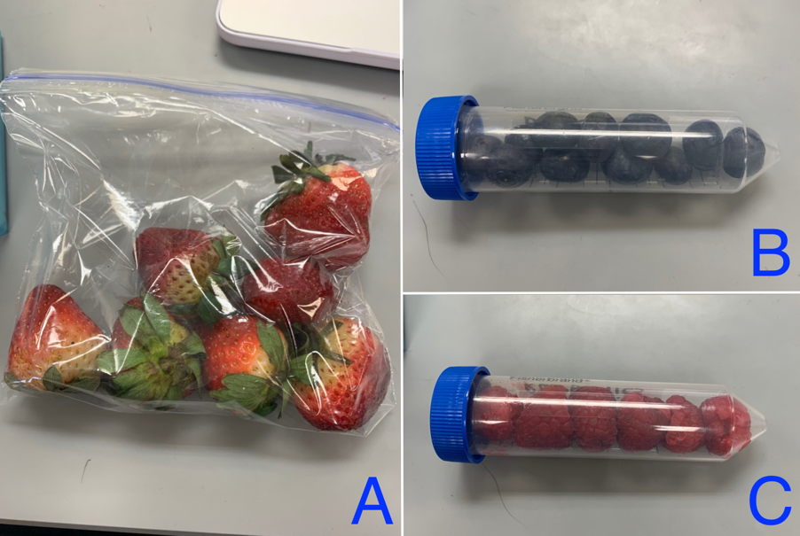
Figure 1. Sample Collection. Organic strawberries, blueberries and raspberries were collected from the Walmart located in Farmville, VA on February 19th, 2019 and refrigerated for six days before the start of the experiment. Section A shows the collected strawberries, section B shows the collected blueberries and section C shows the collected raspberries.
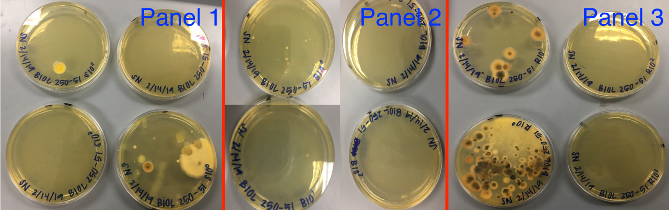
Figure 2. Dilution plates. Six days following sample collection, the strawberries (Panel 1), blueberries (Panel 2), and raspberries (Panel 3) were crushed using a mortar and pestle and used as the original, or 10⁰ dilution. These were then diluted 3 times with sterile water, creating the 10¹, 10² and 10³ dilutions. The dilutions were then plated on agar plates containing Yeast Extract, Peptone, Dextrose (YPD) + Streptomycin + Penicillin-G and incubated at room temperature for three days.
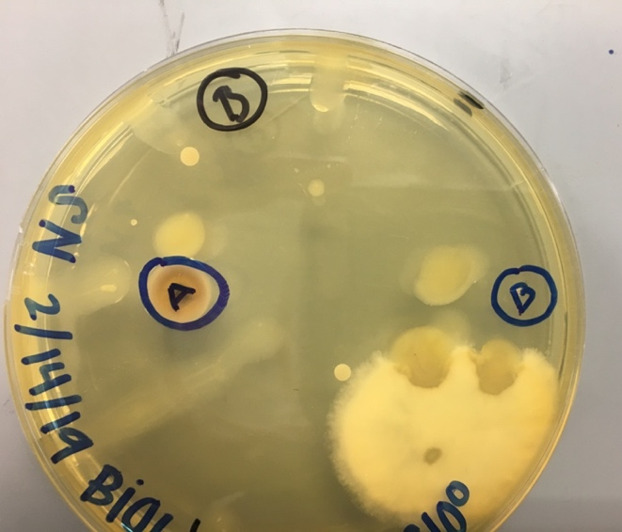
Figure 3. Colony selection. Colonies from the blueberry 10⁰ dilution were selected in order to be isolated later. There are two colonies circled for “B” due to the small size of those single colonies.
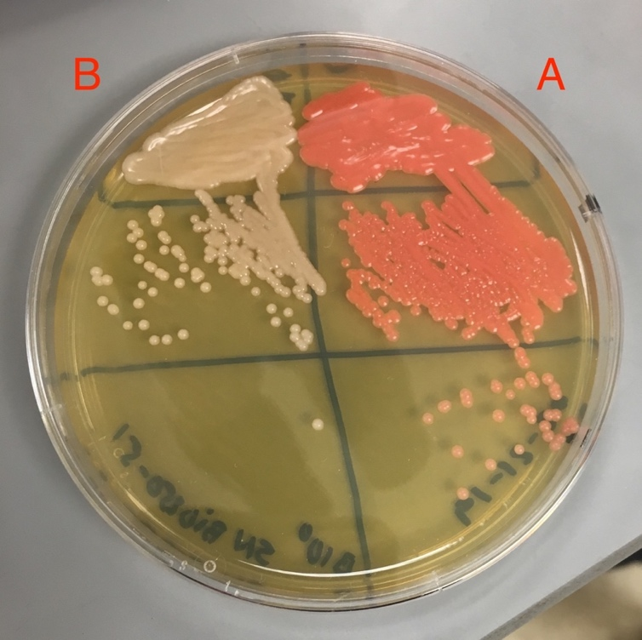
Figure 4. Selected colony isolation. The colonies selected in the previous figure (Figure 5) were plated on an agar plate containing Yeast Extract, Peptone, Dextrose (YPD) + Streptomycin + Penicillin-G and incubated at room temperature for three days. The colony labelled “A” in Figure 5 was plated on side A and the colonies labelled “B” in Figure 5 were plated on side B.
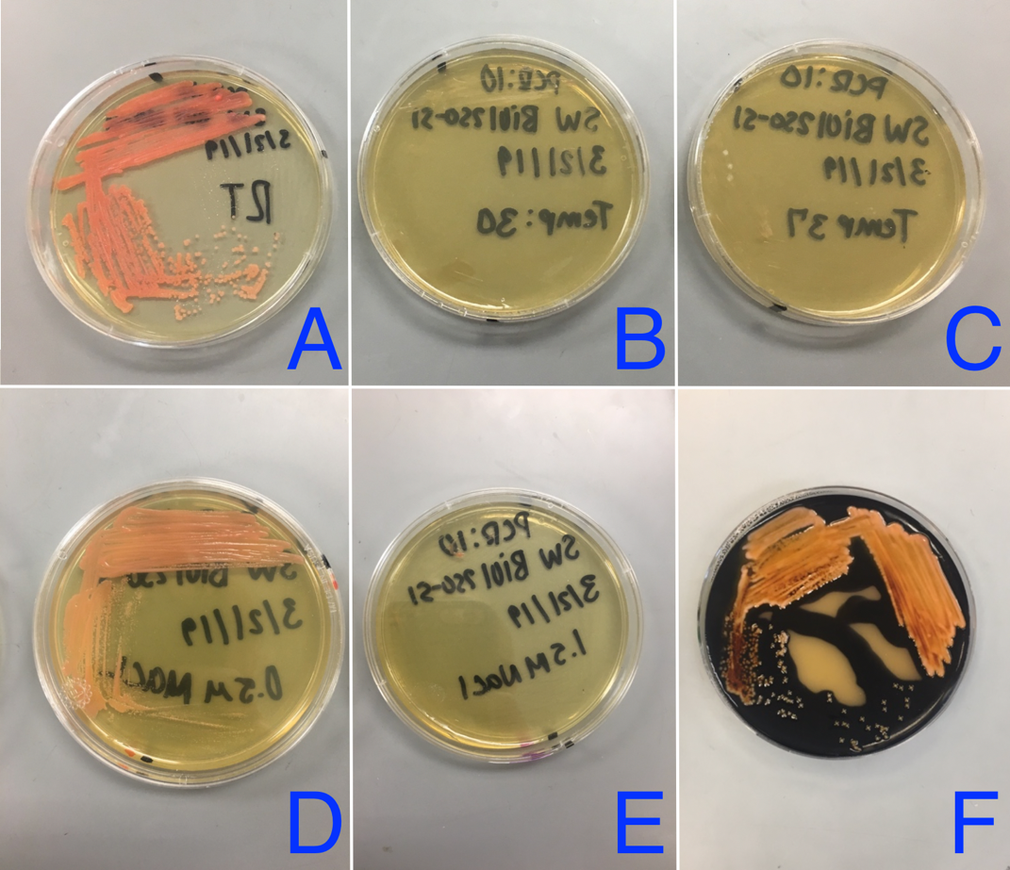
Figure 5. Biochemical assay plates. Single colonies grown on side A in Figure 6 were sampled for further biochemical testing. Section A shows the plated sample incubated at room temperature (23˚C), section B shows the plated sample incubated at 30˚C and section C shows the plated sample incubated at 37˚C, all of which were plated on agar containing Yeast Extract, Peptone, Dextrose (YPD) + Streptomycin + Penicillin-G for three days. Section D shows the sample plated onto a YPD plate supplemented with 0.5M NaCl and incubated for three days at room temperature. Section E shows the sample plated onto a YPD plate supplemented with 1.5M NaCl and incubated at room temperature. Section F shows the sample plated onto an agar plate containing YPD + 1% (w/v) soluble starch and incubated at room temperature for three days.
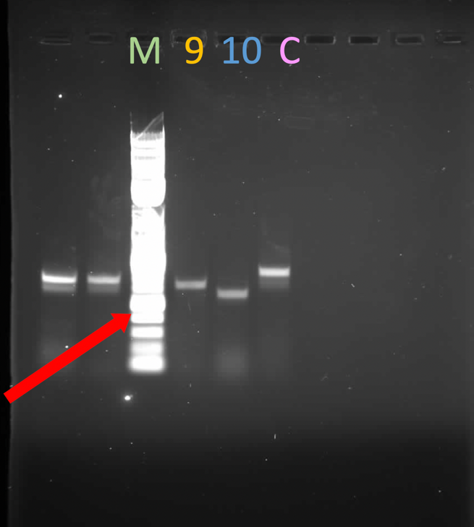
Figure 6. Gel electrophoresis. A gel electrophoresis was run with Quick-Load® 2-Log DNA Ladder (0.1-10.0 kb) in the well labelled “M,” PCR #9 in the well labelled “9,” PCR #10 in the well labelled “10,” and a positive control in the well labelled “C” in order to identify the fragment lengths of the deoxyribonucleic acid (DNA). The red arrow points to the the marker representing 500 base pairs.
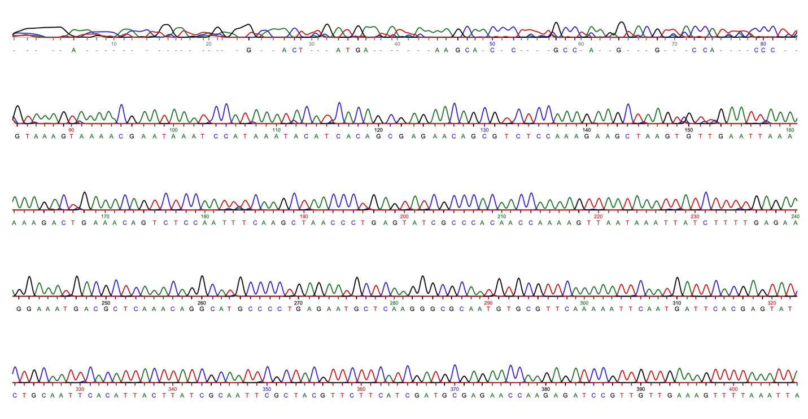
Figure 7. Reaction #9 sequence. The Polymerase Chain Reaction (PCR) #9 previously performed and the IST4 primer was sent to a company called EurofinsGenomics to have the nucleic acids sequenced. The IST4 primer has the following sequence: 5’ TCCTCCGCTTATTGATATGC 3’. “A” stands for adenine, “T” stands for thymine, “G” stands for guanine, “C” stands for cytosine and the dashes represent an inconclusive base pair.
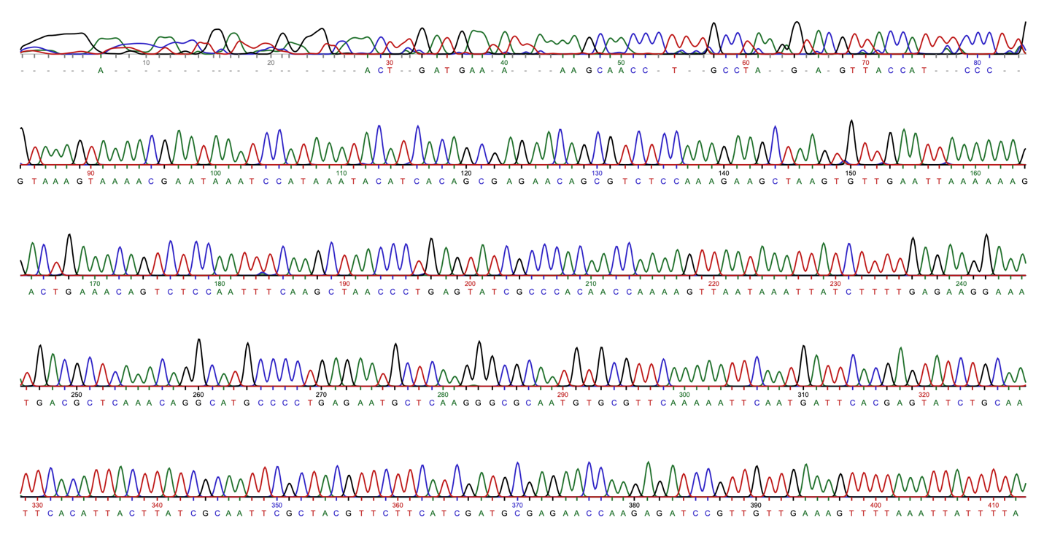
Figure 8. Reaction #10 sequence. The Polymerase Chain Reaction (PCR) #10 previously performed and the IST4 primer was sent to a company called EurofinsGenomics to have the nucleic acids sequenced. The IST4 primer has the following sequence: 5’ TCCTCCGCTTATTGATATGC 3’. “A” stands for adenine, “T” stands for thymine, “G” stands for guanine, “C” stands for cytosine and the dashes represent an inconclusive base pair.
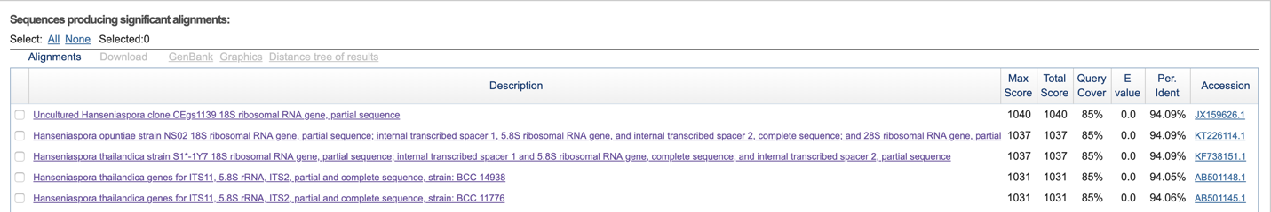
Figure 9. BLAST Analysis Results. The sequence shown in Figure 9 was entered into the Basic Local Alignment Search Tool provided by the National Center for Biotechnology Information and the five most genetically similar results were given.
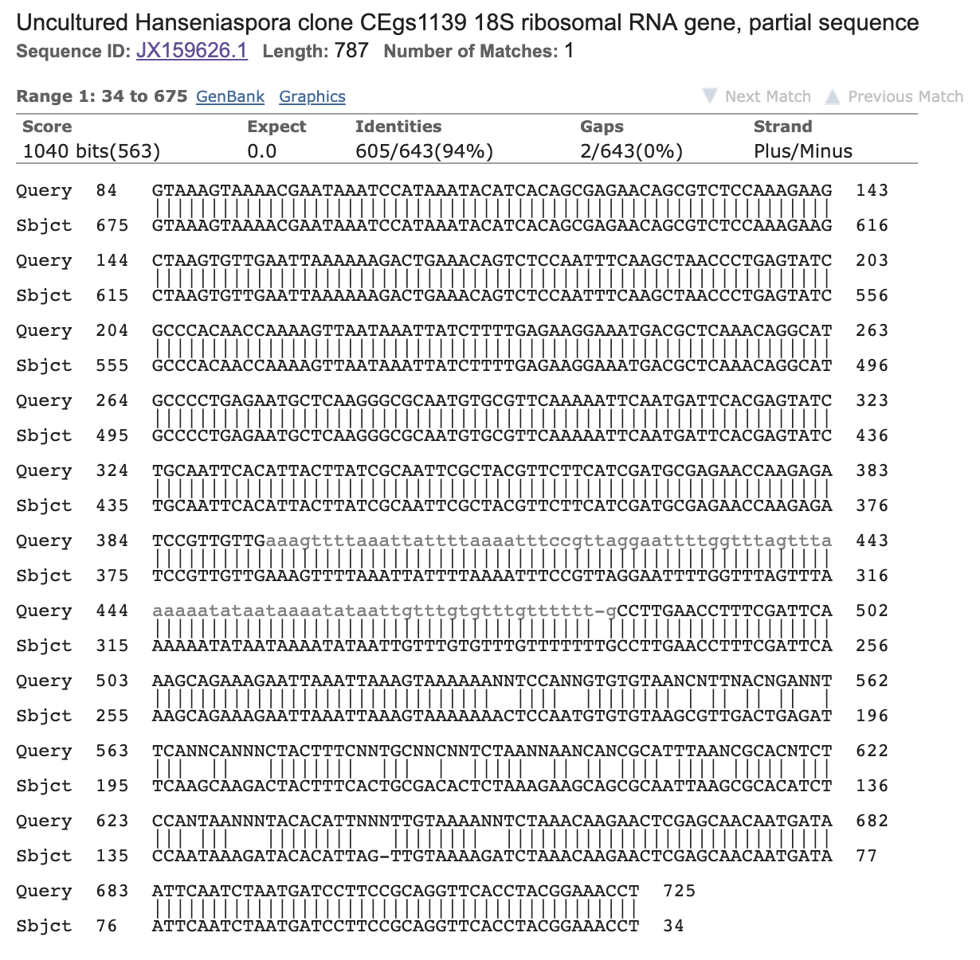
Figure 10. Alignment analysis. The sequence shown in Figure 9 was analyzed using alignment of the DNA from the most similar result from the BLAST analysis, which was a partial sequence of an “Uncultured Hanseniaspora clone CEgs1139 18S ribosomal RNA gene.”
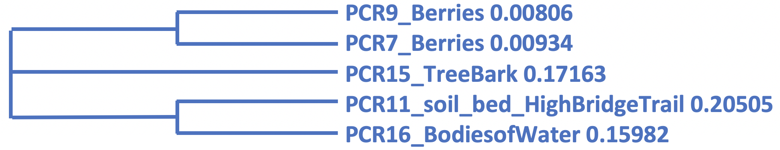
Figure 11. Phylogenetic Tree. Using a multiple sequence alignment, the Polymerase Chain Reaction (PCR) #9 was compared to other collected samples as labeled.
Table 1. pH of collected samples. The pH was measured for each original, or 10⁰, dilution for strawberries, blueberries and raspberries.
Sample | Strawberries | Blueberries | Raspberries
pH | 5 | 5 | 3

Table 2. Nanodrop data. Polymerase Chain Reactions (PCR) #9 and #10 were purified and placed onto a nanodrop in order to measure the nucleic acid concentration.
Sample Number | Nucleic Acid Concentration (ng/µl) | 260/280
9 | 60 | 2.32
10 | 169.6 | 1.87

Table 3. Yeast morphology on YPD + Antibiotics plates. The morphology of yeast found on each of the YPD + antibiotics plates following dilutions was analyzed and then recorded according to shape, elevation and color.
 | Characteristic | 10⁰ Dilution | 10¹ Dilution | 10² Dilution | 10³ Dilution
Strawberries | Shape | Circular and irregular | Circular | Circular | N/A
 | Elevation | Flat, raised, convex | Raised | Raised | N/A
 | Color | White, brown and cream | Cream | White | N/A
Blueberries | Shape | Circular | Circular | N/A | N/A
 | Elevation | Pulvinate | Pulvinate | N/A | N/A
 | Color | Non-pigmented | White and pink | N/A | N/A
Raspberries | Shape | Circular | Filamentous | N/A | N/A
 | Elevation | Pulvinate, convex and raised | Pulvinate and convex | N/A | N/A
 | Color | Non-pigmented and pigmented | Dull, white, black, green | N/A | N/A

Table 4. Biochemical Assays. The results of each biochemical assay were recorded, where “++” indicates growth and “+++” indicated abundant growth. For the amylase assay, the presence of amylase was tested.
Biochemical Assay | Result
Room Temperature (23˚C) | +++
30˚C | No Growth
37˚C | No Growth
0.5 M NaCl | +++
1.5 M NaCl | No Growth
Amylase | Negative

