Entertainment or Endangered? Protecting the Chimpanzee Population.
Have you seen the television show “The Hathaways”? It was a show in the 1960’s where a couple had three chimpanzee children. This was most likely not the first television show to feature chimpanzees and it most definitely is not the last. There have been countless features of these animals in entertainment for comedic values while they are placed in human-like situations. In reality, this species is listed as endangered by the IUCN Red List. Does the use of chimpanzees in entertainment change the way viewers perceive their endangered status and view conservation efforts?
A study performed at Duke University asks the same question, “How does the use of commercials and videos of chimpanzees influence the way the public views the conservation status of chimpanzees in the wild and their suitability as pets?”. There were two experiments performed to test two different hypotheses; the familiarity and the distortion. The distortion hypothesis predicted that viewers shown baseline of conservation commercials will have more knowledge and donate more to a conservation effort, while the entertainment chimpanzee commercials will have a negative impact. The familiarity hypothesis predicted that being exposed to both the conservation and the entertainment chimpanzee commercials, viewers will be more understanding of the conservation needs of chimpanzee and will be positively affected by both of the commercials.
This was tested by doing a controlled experiment where participants were told the focus of the study was about marketing. They were shown commercials about different soda companies and either a public service announcement (PSA) for chimpanzee conservation, a video of chimpanzees in the wild, or an entertainment commercial. Then the participants answered a survey and were given the opportunity to donate to a conservation organization. After each experiment, the familiarity hypothesis was not supported. This is a graph indicating which group is donating to a conservation organization. This shows in experiment one, only the group shown a PSA would donate, and then in experiment two that a majority of those donating are those shown a PSA.
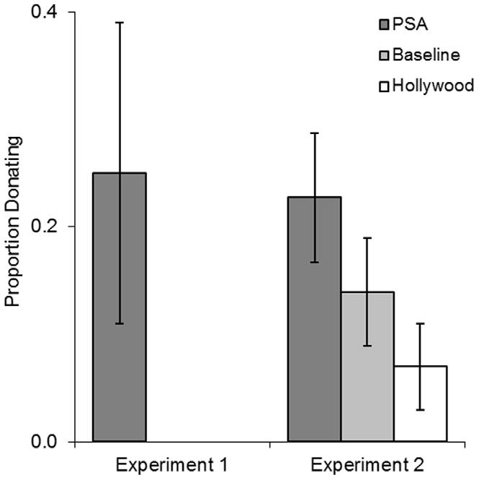

These experiments strongly support the distortion hypothesis and indicate that the familiarity hypothesis, or in other words, and exposure to chimpanzees in the media, create a false perception of chimpanzees.
There is a vast amount of misinformation spread throughout the entertainment industry. It might not be spread with malicious intent, but it impacts the conservation efforts of groups such as the Bushmeat Crisis Task Force and the African Wildlife Foundation which were the options for either experiment one and two, respectively. When shown chimpanzees in their natural environment there a small amount more understanding, but when shown a PSA there is even greater understanding of the need for conservation.
Careful marketing and messages are necessary in any form of the entertainment industry and especially in the conservation efforts. Marketing and messages that display endangered animals as pets are shown to distort the need for conservation. Careful messaging such as a Public Service Announcement will led to greater understanding and possibility for greater recovery of the chimpanzees.

Schroepfer, K. K, Rosati., A. G., Chartrand T., Hare, B. (2011) Use of ‘‘Entertainment’’ Chimpanzees in Commercials Distorts Public Perception Regarding Their Conservation Status. PLoS ONE, 6(10): e26048. doi:10.1371/journal.pone.0026048

