Biodegradable Materials Experiment
Taylor Ford, Mohamed Moussi, Walton Baines, & Taylor Harris
Longwood University

INTRODUCTION
Human waste has become a world-wide epidemic. Many of the products we as humans use, are made of plastic. The average decomposition rate of plastic is upwards of 1000 years. Humans are slowly, but surely destroying this planet by disposing of our waste in the wrong places. As stated in Nina Golgowski’s article titled “Why Those Compostable Straws May Not Be As Green As You Think,” just because a material is labeled as “biodegradable,” does not necessarily mean it is “compostable.” If a material is biodegradable, it can be broken down using naturally occurring organisms and often turned into toxic matter that releases methane gas. In addition to being biodegradable, if a material is compostable, it will not leave behind any toxic residue. Most garbage in landfills does not break down due to the lack of oxygen and being packed so tightly underground. The author claims that labeling a material “biodegradable” could simply be a marketing strategy (Golgowski, 2018). According to Tamaki Bieri in her article titled “Biodegradable Products,” a material that is biodegradable will only degrade if it is exposed to oxygen, moisture, and sunlight. If the claimed “biodegradable” material is not exposed to these elements, it will not break down and will simply take up space in a landfill. More often than not, biodegradable materials are actually toxic for the environment. These materials release methane gas that is eventually released into the environment (Bieri, 2016). According to an article titled “Biodegradable products may be bad for the environment,” written by Science News, biodegradable materials may not be as great for the environment as everyone thinks. 31% of the methane produced at landfills is released into the environment. The level of degradation solely depends on the material and the environment it is placed in (Science News, 2011). These statements are proven within the experiment that has been held. The straws placed into the environment with exposure to moisture, sunlight, and oxygen lost the most mass. The research conducted through this experiment tested exactly what has been discussed in the literature. This research has its limitations, such has more exact measurements of the resources used and the overall duration of the experiment. The material that was used to test biodegradation were obtained from a local restaurant. This research provides information about a material that local college students use every day. Students at Longwood University could gather information about exactly how the materials they use are affecting the environment.
For this experiment, the degradation of straws, that claim to be biodegradable, was observed in various environments. An environment with just air was used as the control group. Salt water, fresh water, and wet soil were the environments used as experimental groups in this experiment. Biodegradable straws and mason jars were the main materials used for the experiment. The researchers suspect that the straws that are exposed to moisture, oxygen, and sunlight will lose the most overall mass. This is due to the production of microorganisms that eat away at the straws.

METHODS

- During the experiment there were no participants, The experiment was conducted on a non-living “subject”.
- For the materials, paper straws were acquired claiming decomposition within 4-6 weeks, and mason jars to store the paper straws that are 3 inches long and weigh a little less than a gram. Salt water, Fresh water, Dirt, and Wet dirt were also needed to conduct the experiment.
- For this experiment, the jars with just air were the control, The jars were glass and the straws were made of paper. The straws were weighed and measure being approximately 1 gram 3 inches long respectively. The independent variables in this experiment were the environments. Each environment affected the corresponding straw in different ways. The environments were Air, Fresh water, Salt water, Dirt, and Wet dirt. The dependent variable was the decomposition of the straw in the corresponding environment, and how quickly each environment would decompose the paper straws.

DISCUSSION

The results we gathered from this experiment proved that an oxygen rich, microbial environment allows the degradation of the paper straws. That is because microbes rely on oxygen to live and replicate and used the straws as a “food source”. Thus proving our hypothesis correct. However, what did surprise us is that our control group also lost .33% of its mass, we didn't think it would lose any mass.

ABSTRACT

For this experiment, the degradation of straws, that claim to be biodegradable, was observed in various environments. An environment with just air was used as the control group. Salt water, fresh water, and wet soil were the environments used as experimental groups in this experiment. Biodegradable straws and mason jars were the main materials used for the experiment. The straws were weighed before they were placed in their designated environments. These weights were used to compare to the weights of the straws at the end of the experiment. The straws were then placed in their assigned environments and kept there for about 4 weeks. At the end of 4 weeks, the straws were removed from the jars and weighed once again.

RESULTS

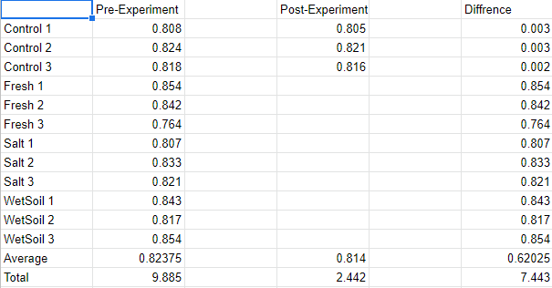

For the results, the controls came in at the lowest weight change due to the fact that they have the fewest organisms within their container. This was expected in our experiment.

The wet soil jars had the largest weight change out of all the tested environments. This was due to the large amount of microbial organisms found in the soil and the holes in the container providing oxygen. Sunlight into the jars and the water and oxygen in them provided an ample environment for said organisms to decompose the straws.

Bieri, Tamaki. “Biodegradable Products.” STANFORD Magazine, Stanford, 2016, https://stanfordmag.org/contents/biodegradable-products.
Golgowski, Nina. “Why These Compostable Straws May Not Be As Green As You Think.” HuffPost, HuffPost, 13 July 2018, https://www.huffpost.com/entry/compostable-straws-twist_n_5b460643e4b0c523e264f9a7
North Carolina State University. "Biodegradable products may be bad for the environment." ScienceDaily. ScienceDaily, 1 June 2011. <www.sciencedaily.com/releases/2011/05/110531115321.htm>.

