CASE SUMMARY SHEET
Student Name: K Age: 6 years Grade: 1st
Tutors: Casey Bainbridge Date: 9/16 to 11/4
 | Word Lists |  |  |  | Passage Reading |  |  | Reading Rate |  | Comprehension
Difficulty Level  ↓ | Sept. |  | Nov. |  |  | Sept. | Nov. | Sept. | Nov. | % questions answered correctly
Difficulty Level  ↓ | Timed  %age | Total  %age | Timed  %age | Total  %age |  | WRC  % Corr | WRC  % Corr | ORAL WPM | ORAL WPM | Sept. | Nov.
Preprimer | 20 | 25 | 35 | 55 | Readiness | 46 | 80
Primer |  |  |  |  | Preprimer
1st |  |  |  |  | Primer
2nd |  |  |  |  | 1st
3rd |  |  |  |  | 2nd
4th |  |  |  |  | 3rd
5th |  |  |  |  | 4th
6th |  |  |  |  | 5th

Sept. Spelling Assessment | Nov. Spelling Assessment
WTW Inventory: Primary Spelling Inventory  Score: 22 out of 82  Spelling Stage: Letter Name- Middle  Examples of Confusions:  Short vowels (e and i) | WTW Inventory: Primary Spelling Inventory  Score: 19 out of 40  Spelling Stage: Letter Name- Middle  Examples of Confusions:  Short vowels (e and i)(e and a)

Instructional Reading Level: ______Readiness_________

Instructional Goals:
Fluency | Word Knowledge | Reading & Writing
-Use High Frequency Words to read with greater fluency  -Reread familiar texts with automaticity  Potential Activities  -reading sentence strips  -rereading texts  -increase HFW word bank through games and practice | -Grow knowledge in HFW and sight words  -Continue working with short vowels  -After short vowels, move onto diagraphs (beginning and ending sound)  Potential Activities  -Picture sorts  -word study games  -Books and rhymes with the word feature used frequently | -Increase confidence with reading with practice and praise  -Continue writing with sentence frames, but focusing on decoding words.  -Emphasis on ensuring the sounds are in the correct order (especially medial)  -Trial with writing with technology  Potential Activities  -Practice correct letter formation (lowercase e)  -Practice using CUPS in writing  -Drawing and free-write activities  -Using a tablet or computer to practice writing
- How does this student's current level compare to others in the same grade?
  - K is reading at readiness level when he should be reading at the Primer or 1st grade level. His confidence with reading is lacking, but he should be able to look at a simple text with practiced features and attempt to decode the words.
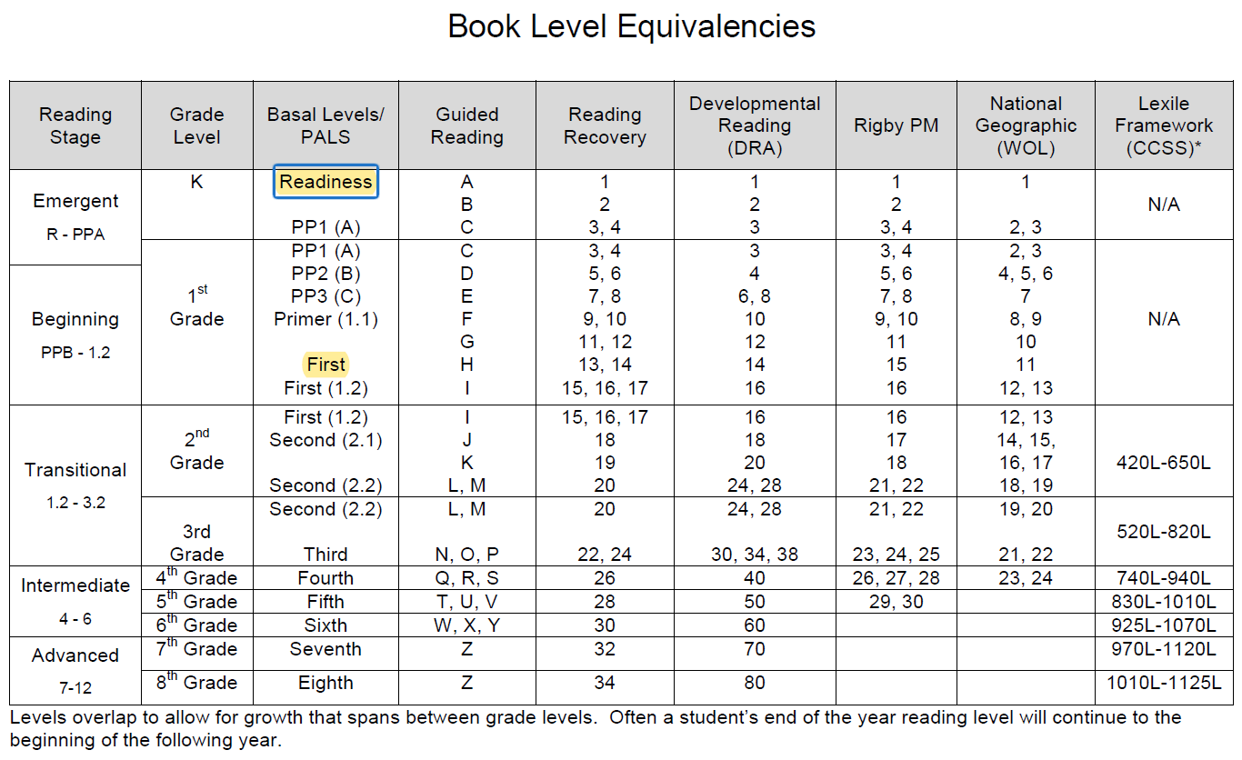
  - K is still at the early-middle latter name stage when she should be in the late letter name stage. At the mid-year of first grade, he should be making a score of 24-52 out of 52 on the spelling inventory, but he scored a 19 out of 40 as he failed to complete the assessment.
  - For word recognition in isolation, he should be scoring 19-20 words on the Preprimer list and then moving up towards the first grade words list, but he only scored a total of 11 words out of 20 on the assessment.
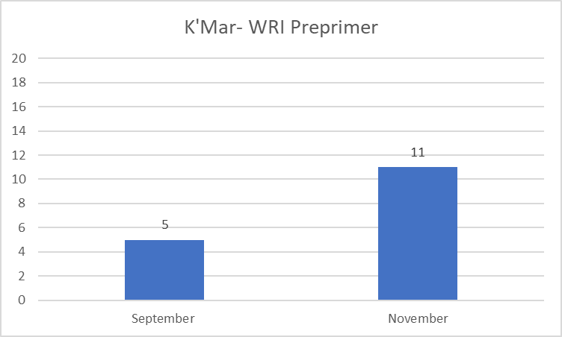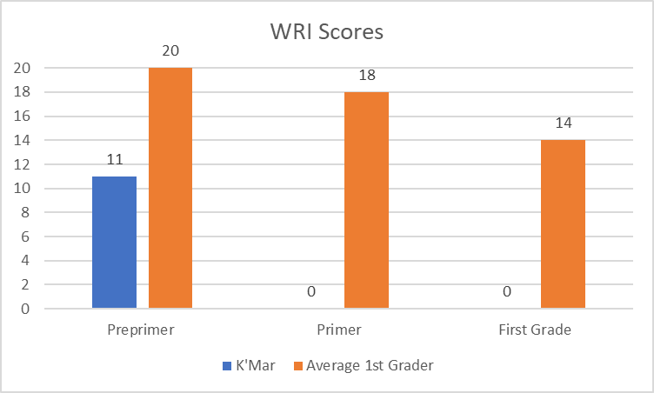
  - For letter recognition and sounds, K did well with identifying each letter and sound.
- How does your student's rate of growth compare others and/or to the rate needed to be caught up?
  - K’s growth isn’t as rapid as wanted. He will need more intensive tutoring in order to catch up with his peers. He didn’t grow in spelling stage or reading stage over my tutoring with him. His word recognition score grew, but not to where it should be for mid first grade.
  - When I first started working with K, he was very quiet and insecure with his stutter. As time went on, be began talking more with me and being more engaged with the work. After speaking with his teacher, K began talking with his peers and speaking to other teachers in the halls. At recess, he is playing with other people than just his cousin and is much more social.
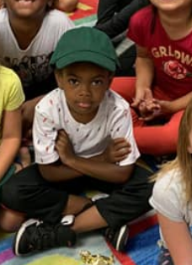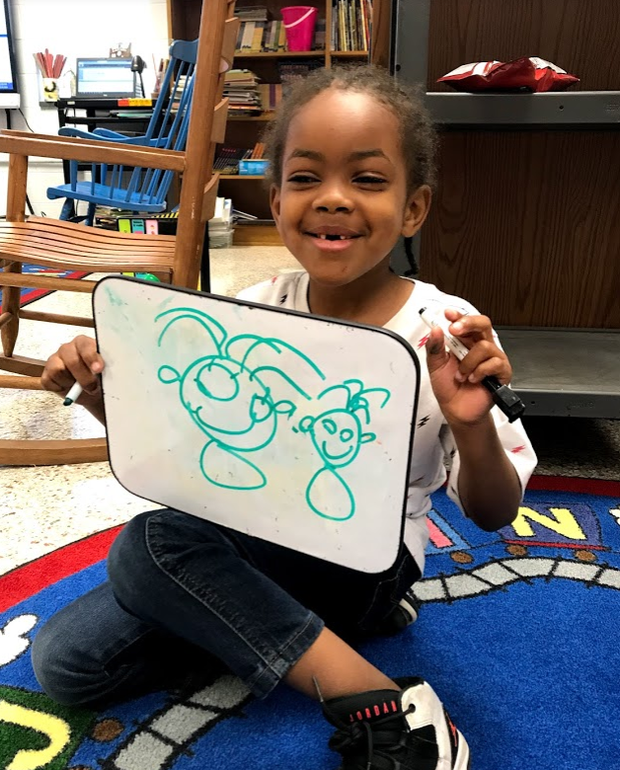
- What recommendations can you offer the committee with regard to further intervention efforts related to (1) time, (2) intensity, and (3) duration?
  - Time: K receives one-on-one support from the librarian, but I would recommend that he words with a reading specialist for 2-3 hours per week.
  - Intensity: He would benefit from one-on-one work to focus on the skills he needs. Small group lessons may be beneficial for practice as he is competitive and wants to prove himself to others.
  - Duration: Intervention should be carried out for 6 to 8 works with assessments along the way to gain data for changes when necessary.
  - I would recommend that K gets tested for dyslexia based on his scores and slow growth.

