Statistics Projects Paper
Out of the three variables offered which included political lean, political party, and religion, we decided to use political party. The different categories within political party were Democratic, Republican, Green, Libertarian, and Other. Based on these categories we were able to calculate which option each person felt most affiliated with.
The individuals in the population for our project is all students who completed the survey which gave us the results we used for this project. The survey was optional, so everyone that actually took the survey is included in the population, but not those who decided not partake in it. The individuals included in a smaller percentage of the population, the sample, includes those that chose a political party which is the variable that we decided to focus on. A population includes all of the elements from a set of data. A sample means a subgroup of the members of a population chosen for participation in the study.
The type of data that we collected is in fact qualitative. This is true because the data collected is not numerical, it is just the type of political party that each student chose. Types of qualitative data include the color of the sky and types of majors. These values cannot be measured, unlike quantitative. On the other hand, quantitative is information about quantity, which means it can be measured and written down with numbers. These values include examples such as the number of pennies in your pocket and how many people there are on a bus.
The type of sample we acquired is an observational sample. This is because we could not control what answers or questions the survey provided us. If it were to be experimental, we would have a control and testing group populations, and we would have to take a sample size from it.
We acquired a simple random sample through a graphing calculator. On the TI-84 calculator, we pressed math, to PROB, to number 8 randIntNoRep. After putting in 1 and 300 with a 50 sample size, we got fifty numbers that represent the political party chosen by a student. Later, we stored the numbers in L1 and accessed it on a table. This allowed us to calculate the frequency for each category by using the corresponding number on the excel document and on the calculator with the political party.
This sample only covers the people who have taken this survey, so it is not an accurate representation of all students at Longwood University. If all students at Longwood University were to take this survey, it could accurately measure and represent the population. The same applies to students in VA or the United States. Around the world, this survey cannot represent the population because there are different political parties and systems of government, so our categories cannot be held accountable. It can be used, however, as a representative of the population of students who took the survey.
Simple random samples can be used for several things. One can use a simple random sample to find a needed response to an issue, or calculating the leanings within a demographic area to use for general elections. In our case, we used it to measure each person’s political affiliation through a survey. You can also use a simple random sample through different sampling methods. There is cluster sampling, stratified sampling, and systematic sampling. When using these methods, you can eliminate bias and you can represent your selected population.
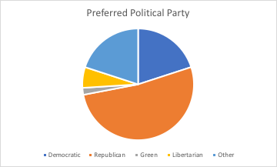

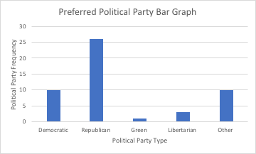

Democratic | 10
Republican | 26
Green | 1
Libertarian | 3
Other | 10

