The Grand Finale
Here we are, Blogpost #4. It seems crazy to me that I’m already finding myself writing about the final project. I’ve learned so much in this class, I’m glad that I was able to switch into this class during the first week of the semester and it’s crazy to think that the semester itself is pretty much done.
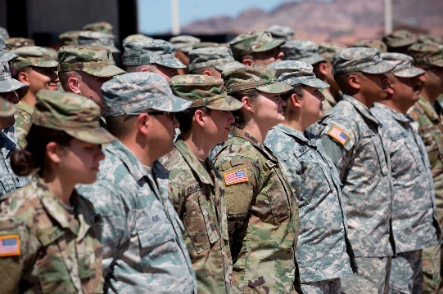
My podcast topic has shifted slightly since my last blogpost, only because of what I came to find during my research. As you may know, my project is covering the Reproductive Justice issue of Sexual Assault in the U.S. Military. I was originally thinking I would do a somewhat of a historical comparison, since the military has come a long way in how they handle these cases. That being said, the more I dove into my research the more I was finding that was talking about men. Since my last blogpost, I have shifted my focus on the effects sexual assault has on its servicemember with a focus on that male population and how sexual assault in the military mirrors our civilian society. Doing this project opened my eyes. Most of the in-class discussions and readings tended to focus on females. This is what I expected. While the Reproductive Justice Framework was creating by some pretty strong and smart women, this does not mean it is only for women. This podcast project opened my eyes (and mind) to the idea that reproductive injustices can and do effect men. While it seems obvious that Reproductive Justice clearly effects women, this does not mean men are directly excluded from this equation.
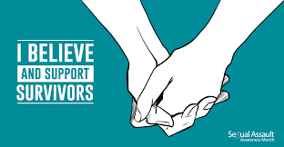
Similar to how my understanding of the Reproductive Justice Framework was furthered, this project furthered my understanding of how this problem affects my community. People always talk about how sexual assault in the Military is a serious, big problem. I agree, but to me sexual assault is a serious, big problem in general. I think it’s very sad, that the men and women who devote their lives to protecting our country are scared to speak up after they’ve been sexually assaulted. What’s even more sad to me, a member of this community, is the fact that I could know someone who has been assaulted and is silently suffering because they feel they can’t talk about it. This does not reflect weakness on their part, but instead it reflects a weakness in our society which in turn reflects a weakness in our Military. I know that even once I turn in this project and all is said and done, I will continue to follow up on this topic. Who knows, maybe it will spark some kind of volunteer opportunity or passion project for me!
To the left is a concept map regarding my learning process from this semester, specific to this course! Some of the more pivotal changes in my learning I would say include: seeing and thinking about things I learn in a class in a new way, being able to make connections between different disciplines, and becoming more comfortable with sharing my thoughts! There were so many times in this class we would learn something, specifically about a time in history, and I would think, “huh I never thought about it like that.” I began to see things I was taught, not only in this class, in a new light. I would think about the credibility of who wrote something, or the source of the subject matter, and take that into account. A lot of the topics we covered included health aspects, which I also cover in a different way in my nursing classes. I definitely plan on taking what I learned in this class into my nursing classes, clinical rotations, and eventually my career. I only feel it will make me a more well rounded nurse, and person overall. Lastly, I became more confident. I felt I could ask questions in this class without feeling like I sounded stupid. I also felt like I, just like the rest of my classmates, could always add something to conversation. We all have different backgrounds, each of them are unique and important. I will take this feeling not only into other classrooms, but also into the real world as well.
Well once again, here we are. The end of the last blogpost. 15 weeks can go by so fast, but these past 15 weeks were well spent. Thanks for keeping up with me this semester!

