Morgan Armiger
January 3, 2020
ISCI-361-JB3/JB4
Dr. Sujan Henkanaththe Gedara
Elephant Poaching Takes More Than Tusks
Loxodonta cyclotis, the African Forest Elephant, is one of two African Elephant species weighing in between three and six tons. At approximately ten feet tall, this is among the largest terrestrial species on the planet. They roam the tropical rainforests of Western Africa in close-knit herds. Although they are not considered ‘endangered’ at the moment, they are still a very much threatened and vulnerable species. For centuries, elephant tusks have been internationally traded for their tusks made of extremely valuable ivory. In the late twentieth century, however, increased elephant poaching became an issue – especially in Western Africa: the African Forest Elephant was specifically targeted. Economic value of ivory combined with political conflict and corruption have together wiped out over a million individuals of this species. Unfortunately, the continuous elimination of African Forest Elephants from their habitats and ecosystems has serious ecological, social, and economic repercussions for both humans and the elephants.
A Literal Ecological Footprint
The African Forest Elephant has seen shocking population decline over the last forty years. In a nine-year span (2006-2015), West Africa saw a decline in their Forest Elephant population as they lost over 100,000 individuals (Asmelash). Despite the mortality rate for the population declining overall – from 10% in 2011 to 4% in 2017 – there are still ecological concerns over the loss of the species. The African Forest Elephant is considered to be a keystone species; which means that its ecosystem – and all of its other inhabitants – depend heavily upon the elephant and its natural activities to sustain the surrounding organisms and abiotic factors (Lolosoli). Among many other things, elephants act as “gardeners of the forest.” Their feces act as a natural fertilizer, replenishing depleted soils for continued agricultural use, and provides breeding ground for dung beetles and food for other animals like birds and baboons that search for undigested seeds and nuts. Their daily routes throughout their habitat allow for clearings and openings for other species as they eat and plow down trees and plants in the forest. They often dig holes in dry riverbeds that can be used as waterholes for other organisms; Zakouma National Park in Chad (Appendix I), one of the last elephant refuges in the area, experiences seven months of a dry season in which the intense rainfall from the remainder of the year sustains the wildlife in the park. Elephants’ tracks and digging helps to also sustain the rest of the species in the community and ecosystem.
Our Actions Are Hurting the Herd
The rapid and rampant loss of the African Forest Elephant has social impacts for both the elephants and human beings. Like humans, elephants are exceptionally social organisms. They travel in herds and experience strong familial ties and relationships. Poaching and increasing habitat fragmentation has contributed to a decreased sense of unity and cohesiveness in elephant family structures. This problem also leads to a lack of genetic variance, genetic diversity, and inbreeding, which ultimately can cause issues from an ecological standpoint as it could be potentially detrimental to population health and for those surviving individuals that will go on to reproduce young. Elephant poaching does not solely affect elephants. There have been great human losses as well. The Lord’s Resistance Army (LRA) has been wreaking havoc on the villages of West Africa for over a decade. As they plunder and poach Zakouma National Park, oftentimes elephants aren’t the only ones that experience severe losses. Park rangers and villagers passionate about protecting “their” elephants have been seriously maimed and injured, and many have lost their lives trying to stop the LRA from poaching ivory.
A Tusk Is Worth More Than A Thousand Bucks
The heavy loss of the African Forest Elephant population in West Africa and at Zakouma National Park is accompanied by equally heavy economic consequences. While poachers and those rangers who fall victim to bribery by poachers make hefty profit from the poaching and trading of ivory, the surrounding villages and communities lose from others’ gains. Many of these villages are already ravaged by poverty, which perpetuates poaching incentives; however, the economies of these regions are fueled by ecotourism. People from all over the world come to the rainforests and savannas of Africa to see the majestic species that live and roam the African grasslands. With the threatened status of the Loxodonta cyclotis and the organisms that rely on them as a keystone species, ecotourism could be reaching its end in these areas. Without the elephants, and other species in their ecosystem, who will come to see the empty land? As suggested in Lolosoli’s Nikela article, “money should be used as an incentive for saving the elephants.” Without ecotourism and safari rides through the savanna, the economies of these countries will ultimately suffer in the long run.
The Future for Loxodonta cyclotis
Although mortality rates and the demand for ivory have declined and populations are slowly rising, action and conservation measures are direly needed. Current legislation is in place that bans the trade of ivory; however, there are loopholes around legality. Bribery of officials and rangers combined with a complete lack of law enforcement and the trade of ivory on the black market all still threaten elephant populations. Until strict and serious enforcement of legislation is implemented, and poverty is reduced in these countries, Loxodonta cyclotis will continue to be threatened by poachers. As Joshua Hammer from Smithsonian Magazine states in an article, “If we value human rights, we should also value animals that have the same level of sophistication that we do.” Loxodonta cyclotis is a valuable, majestic species that its ecosystem and our planet cannot afford to lose.

Appendix
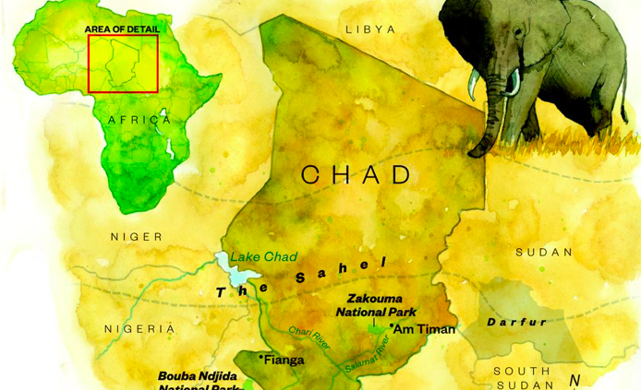
- A map of Chad, where Zakouma National Park lies.

Works Cited
“African Elephant.” WWF, World Wildlife Fund, www.worldwildlife.org/species/african-
elephant.
Asmelash, Leah, and Saeed Ahmed. “African Elephant Poaching Has Declined, but Study Warns
They Are Still Vulnerable.” CNN, Cable News Network, 6 June 2019, www.cnn.com/2019/06/06/world/elephants-poaching-decrease-trnd/index.html.
Connor, Tara. “Loxodonta Cyclotis (African Forest Elephant).” Animal Diversity Web,
animaldiversity.org/accounts/Loxodonta_cyclotis/.
“Effects of Poaching on African Elephants.” Center for Conservation Biology,
conservationbiology.uw.edu/research-programs/effects-of-poaching-on-african-elephants/.
Hammer, Joshua. “The Race to Stop Africa’s Elephant Poachers.” Smithsonian.com,
Smithsonian Institution, 1 July 14, www.smithsonianmag.com/science-nature/race-stop-africas-elephant-poachers-180951853/?page=1.
“The Human Toll of Ivory Poaching.” National Geographic,
www.nationalgeographic.com/tracking-ivory/.
“The Lesser-Known Forest Elephant Is Crucial to Its Ecosystem.” African Wildlife Foundation, 1
July 2019, www.awf.org/wildlife-conservation/forest-elephant.
Lolosoli, Chady C. “The Impact of Elephant Poaching Is Greater Than We Think.” Nikela, 5
Feb. 2019, www.nikela.org/the-impact-of-elephant-poaching-is-greater-than-we-think/.
Marsh, Jenn. “Duke Researchers Find Poaching Elephants Hurts Forest Ecosystems.” The
Chronicle, 26 Mar. 2018, www.dukechronicle.com/article/2018/03/duke-researchers-find-poaching-elephants-hurts-forest-ecosystems.

