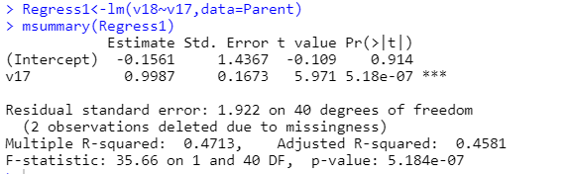

Within the Noodle Necklace activity, that relationship between the parent and child have improved and doing the activity shows that this helped improve their relationship. This table helps us understand that participants that were able to do this activity enjoyed the activity and improved the relationships. 0.09987 estimate shows this improvement. The R- Squared statistic (0.4713), shows us that percentage (47%) of the improvement of relationships with children and parents. This chart also shows that the findings is not significant (p=0.914).

