7 Ways that Studying US History 1877 to Modern Times History Shapes the Way You Think About Women

- During this time period, women were controlled by their husbands and the opinion on whether women should work was very controversial.
Week 2 – Industrialization (1/25/19)
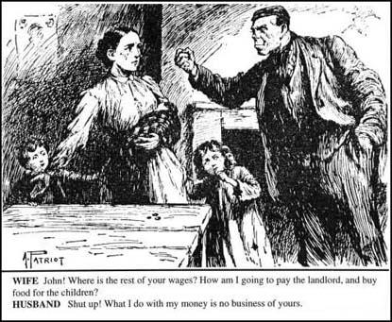

Cartoon from The Vote, a newspaper published by the Women’s Freedom League (February 1911). (https://spartacus-educational.com/Wmarriage.htm).

This picture above is describing a typical family when it comes to finances. In the early 1900’s the term “invisible women” came about to mean that women became financially dependent on her husband. Men were getting paid the family wage, meaning they were earning more money with the intent that they are providing for their family. As a result, women were getting paid less and their earnings were used as spending money. (Industrialization, Jan. 25, 2019). The picture shown above is expressing the women’s concerns with the way that her husband is spending the money. Since she doesn’t make enough money to provide food and shelter for the children, she needs his family wage, which he is spending elsewhere.

Conversely, Mary Blewett argues that the family wage is not a real thing. She states, “The family wage has always been a myth. Only a minority of men have ever been able to earn enough single-handedly to support a family. Most families depended on wives’ and children’s earnings also” (Blewett, Shall Married Women Work, 1879). Blewett is saying that everyone, including women, needs to go to work and put their earnings together in order to survive.

John Green states that “by 1890, two thirds of Americans worked for wages rather than farming or owning their own businesses” (Crash Course #23: The Industrial Economy). If two thirds of the population are working for wages, then that includes women. It is unclear as to whether or not the women’s wages went to the family wage or their own spending money, but regardless, according to the video, they were working.

As seen, there was much controversy about whether women should work and contribute to the family bills, use the money as spending money, or stay home and take care of the children.

- In the early 1900’s, immigrant women were seen as being unequal to white American women.
Week 3 –Immigration (1/30/19 & 2/1/19)
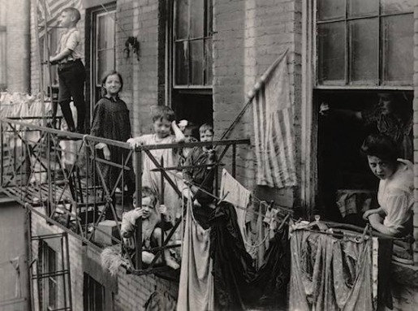

Bial, Raymond, Tenement: Immigrant Life on the Lower East Side (Houghton Mifflin Company, Boston, 2002), 11. (https://immigrants1900.weebly.com/living-conditions.html).

The picture above shows a couple of women with six kids out on a balcony. There are clothes hanging out to dry and the building looks run down. Unfortunately, this picture shows the life of many immigrant women during this time. While the ideal white woman was portrayed as a well put together lady who worked in the home, immigrant women were depicted as dirty, having lots of kids, and not being a good mom. (Immigration, Jan. 30, 2019).
Still today, immigration is a huge issue among women. The National Organization for Women says, “Immigration is a feminist issue. Women and children comprise approximately three-quarters of people migrating to the United States each year” (National Organization for Women, https://now.org/resource/immigration-as-a-feminist-issue/). The website then goes on to state, “We need an immigration process that treats women fairly and humanely, and recognizes the value of their contributions to the U.S. economy and society.” (National Organization for Women, https://now.org/resource/immigration-as-a-feminist-issue/). Here, they are saying that the women immigrating to the United States are worth something. They don’t deserve to be treated like trash because they are valuable to society and have skills to contribute. Some suggestions that the website suggests to reform the system include, “Recognize the value of the work women do by including professions where women predominate, and protect women in asserting their labor and civil rights” (National Organization for Women, https://now.org/resource/immigration-as-a-feminist-issue/). This example, having women work, proves that they are a key part to society and should be treated as such.

John Green’s Crash Course video describes tenements, the buildings that many immigrant women lived in after arriving to the United States. These buildings were unequal to the houses of white American women as they were dark, unsanitary, and crowded. Many women worked from home, taking in peace work, especially in the garment industry. John Green then goes on to explain how the cities were segregated between the rich white people and the poor immigrants because transportation allowed the rich to move away from the cities. (Crash Course #25: Growth, Cities, and Immigration).

- Women in the early 1900’s wanted a change of life in order to be treated better.
Week 4 – Social Reform (2/4/19 & 2/8/19)
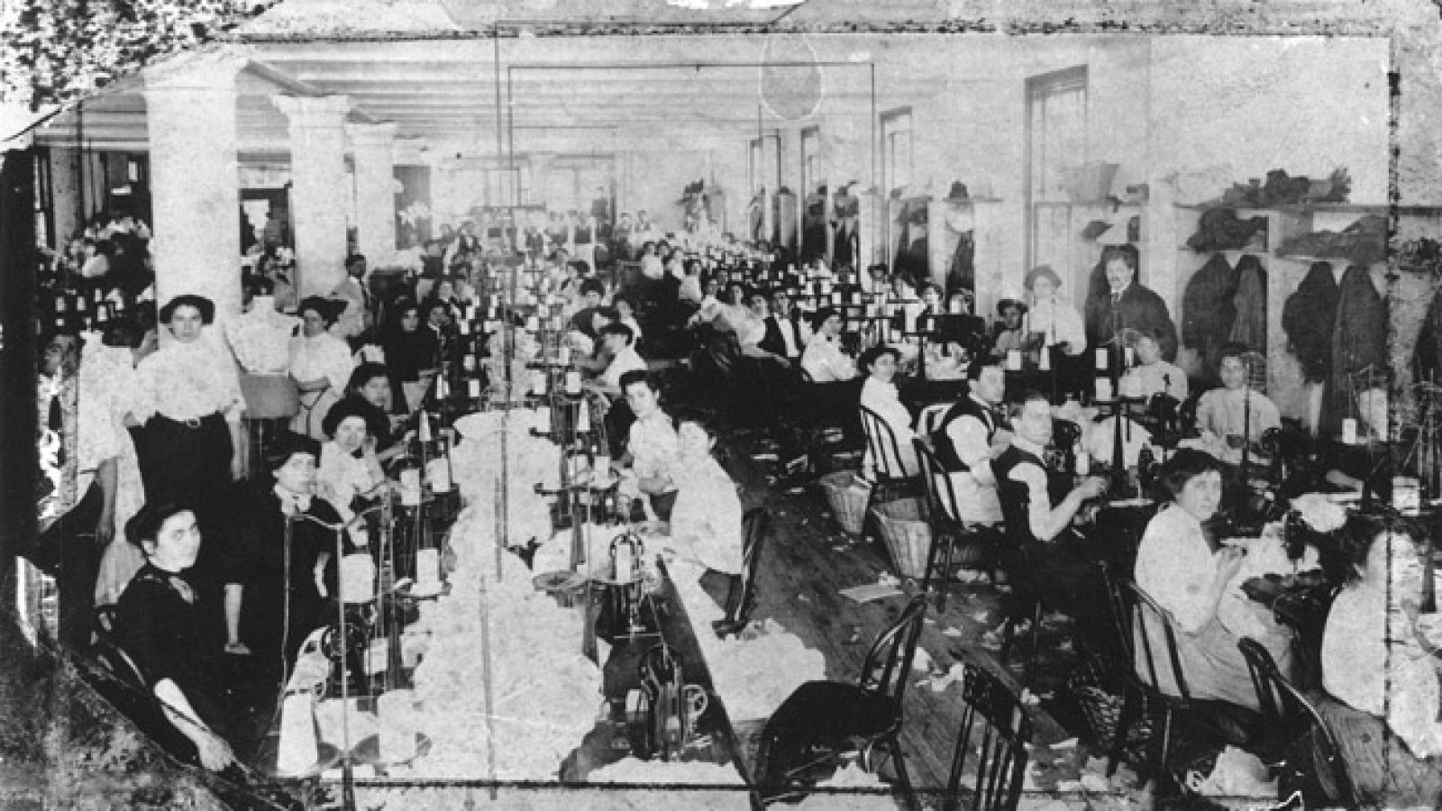

“The Triangle Factory Fire Killed 123 Women and Girls” by MAKERS Team. (https://www.makers.com/blog/day-history-triangle-factory-fire-killed-123-women-and-girls)

The picture above conveys the conditions of many factories in the early 1900’s. There were a lot of people working together in a small space. In 1911, there was a factory fire in which many women and girls died because of the lack of safety precautions. Since cigarettes were still allowed inside, someone was smoking and dropped a lit cigarette into the fabric they were working with. The whole building went up in flames. The doors were locked from the outside, so the workers had no way of escaping. In addition, the ladders on the firetrucks weren’t tall enough to get to the people on the top floors. Allowing cigarettes inside, locked doors, and inadequate fire trucks are some of the issues that sparked the movement of social reform. (Social Reform, Feb. 4, 2019).
From this information, we can see that the women and girls were not being treated fairly at work. Naturally, these women and girls wanted to be treated better. Rose Schneiderman makes a speech in effort to try to get the public on board with their intentions. She says, “I know from experience it is up to the working people to save themselves. And the only way is through a strong working-class movement” (Schneiderman, At the Memorial Meeting at the Metropolitan Opera House, 1911). In other words, she is trying to reform the system so that women and girls working in factories can have better conditions and are treated more fairly. Her hopes were that she could change working conditions, such as no locked doors, adequate firetrucks, and better escape routes, so situations such as the Triangle Shirtwaist fire would never happen again.
In the essay, Class, Gender, and Race at Home: The American Birthplace of Progressivism, McGerr recounts Rahel Golub’s story. He states, “Rahel and her father had to work and save to pay for the rest of the family’s passage to the to the United States. Against that necessity, her needs and wishes, her chance for an education, did not matter at all” (McGerr, Class, Gender, and Race at Home: The American Birthplace of Progressivism). As shown in the quote, children, including girls, were forced to work at a young age. The story continues, “…Rahel avoided changing jobs because the loss of even one day’s pay would slow her family’s arrival…” (McGerr, Class, Gender, and Race at Home: The American Birthplace of Progressivism). In addition to working at a young age, girls were also expected to work long hours. This was unsafe and not fun for the children, showing how they wanted new reforms in order to be treated better and paid more.
- In the 1920’s, women started to gain control over their own bodies and lives.
Week 5 – The “Modern” 1920’s & Women’s Suffrage (2/11/19 - 2/15/19)
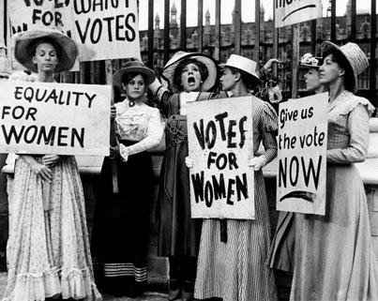

“Celebrate women’s suffrage, but don’t whitewash the movement’s racism” by Tammy L. Brown. (https://www.aclumaine.org/en/news/celebrate-womens-suffrage-dont-whitewash-movements-racism)

This is a picture showing suffragists protesting their lack of ability to vote. This picture is similar to the women in Iron Jawed Angels. In the movie, the women made signs and stood outside of the White House in hopes to get the President Wilson’s attention. In addition, the women in jail went on hunger strikes with the intention of drawing attention to the fact that they weren’t getting fair treatment such as clean water and a clean slop bucket (Iron Jawed Angels). These acts demonstrated women standing up for themselves and taking action until they got what they wanted.

Women also started to gain control over their bodies with the introduction of birth control. Birth control made it so that women could enjoy sex without having to worry about getting pregnant; they were able to choose when they wanted to have kids. In addition, jobs were starting to become popular, so birth control was useful because it enabled women to focus on their jobs rather than a family. Lastly, birth control was important in the fight for personal autonomy because it got women into debates about free speech and addressed public health issues (Crash Course #31: Women’s Suffrage).

Margaret Sanger talks about women’s independence in Happiness in Marriage. She states, “Marriage no longer means the lavish subservience of the women to the will of the man. It means, instead, the union of two strong and highly individualized natures” (Sanger, Happiness in Marriage, 1926). This is showing that when two people get married, the man is no longer in control of his wife. Instead, the women has control of her own life and the two are equal in partnership.

- During the Great Depression and World War II, the dynamics of family life changed.
Week 6 – The Depression and New Deal (2/18/19 & 2/22/19)
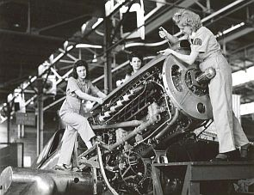

“Female trainees at Middletown, PA, 1944. The Middletown Air Service Command stockpiled parts and overhauled military airplanes. During WWII, Middletown’s workforce grew from 500 to more than 18,000, nearly half of them women.” (https://www.pophistorydig.com/topics/tag/women-aircraft-workers/)

When men went to fight in World War II, more and more women started to go to work. They started doing “men’s jobs” such as working on airplanes, shown in the picture above. Women of color were also working, but often for less money than white women. (World War II, Feb. 22, 2019). This changed the family dynamic. Up until recently, women were staying home and taking care of the children. Daily routines suddenly changed when the men went away, the women went to work, and the children were sent to childcare.
In addition to the change of daily routines, the views of the new generation changed family life. In an episode of All in the Family, the daughter is more liberal than her parents, and believes that men and women should be equal in marriage. Conversely, her parents are older and believe that than man is superior and the wife is supposed to take care of her husband. (All in the Family: The Battle of the Month, 1973). This show is important because it highlighted the changing views on important issues, such as marriage equality. (The New Right, April 10, 2019).
With the war, family life started to change in areas such as fertility, divorce, and suicide. Fertility went down because families did not want to bring a child into the world during the war and birth control was on the rise. Since women started working on their own, they started to feel empowered, causing them to be more open to the idea of divorce if they weren’t happy. Lastly, suicide increased during the depression because an increased number of people were unhappy with life. (The Depression and New Deal, Feb. 18, 2019).

- Black women were very influential during the Civil Rights Era by standing up for what they believed in, using nonviolent means.
Week 9 – The Black Freedom Movement & Social Movements of the Late 20th Century (3/18/19 & 3/20/19)
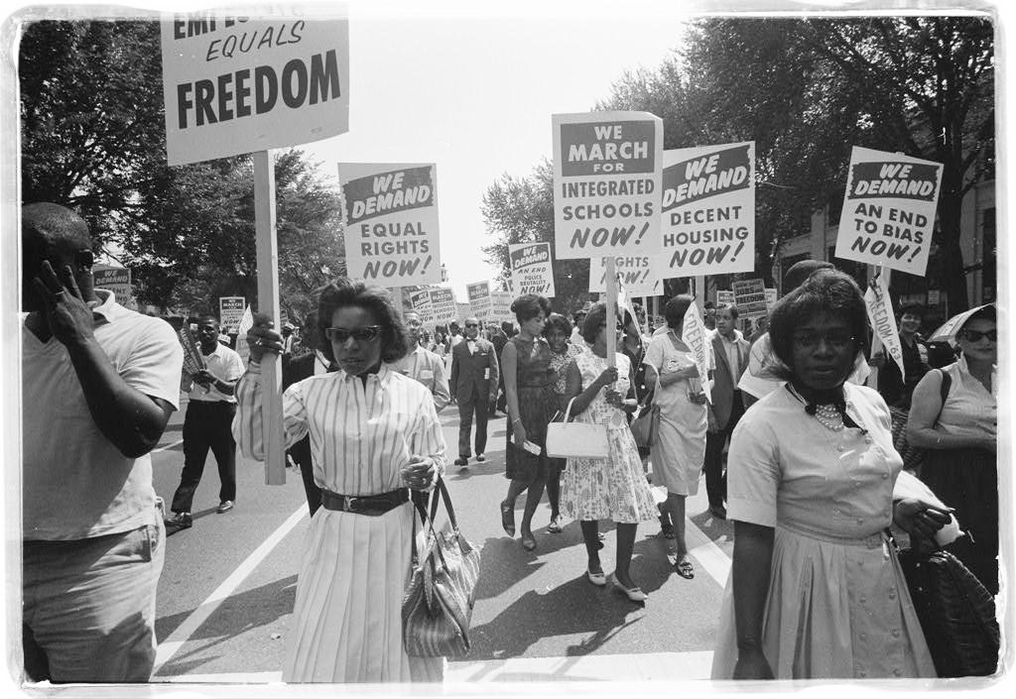

“Standing up for change – African American Women and the Civil Rights Movement” by Elizabeth L. Maurer. (https://www.womenshistory.org/exhibits/standing-up-for-change)

The picture above shows a group of women marching for equal rights for African Americans. They demanded many things, such as integrated schools, decent housing, and an end to bias, as seen in the picture. Rose Parks was an influential black woman during the Black Freedom Movement. She is known as the women who sparked the Montgomery Bus Boycott, where she refused to give up her seat to a white person. Parks was also a member of the NAACP, or the National Association for the Advancement of Colored People. (Black Freedom Movement, March 18, 2019).

“In 1951 students at Robert Russa Moton High School – the Negro high school in segregated Farmville, Prince Edward County, Virginia – went on strike to demand facilities equal to those of the white students in Farmville High School” (Moton Video). This movement was led by a young black girl named Barbara Johns. The goal of the walkout was to demand better conditions in their schoolhouse. In addition to walking out, the students of Moton High School marched in Washington to protest. As seen with Rosa Parks, and now with Barbara Johns, these women were being true to themselves during their fight, and not giving up until they got what they wanted.
In the essay, Sixties Liberalism and the Revolution in Manners, Kenneth Cmiel says, “Nonviolent resistance asked demonstrators to peaceable and lovingly call attention to the inequities of the social system” (Cmiel, Sixties Liberalism and the Revolution in Manners). In this quote, Cmiel is suggesting that the demonstrators in the Civil Rights Movement get their point across, but in a non-violent way. This is an effective way to call attention to inequality, and protesters are more likely to get what they want if they are nice about it. While this quote is addressing all activists, women have shown peaceful protests in the past and will continue to do so.
- With the rise of feminism in the 1960’s and 1970’s, women wanted more out of their lives than just her family and home duties.
Week 10 – Feminism and Women’s Movements (3/27/19 & 3/29/19)
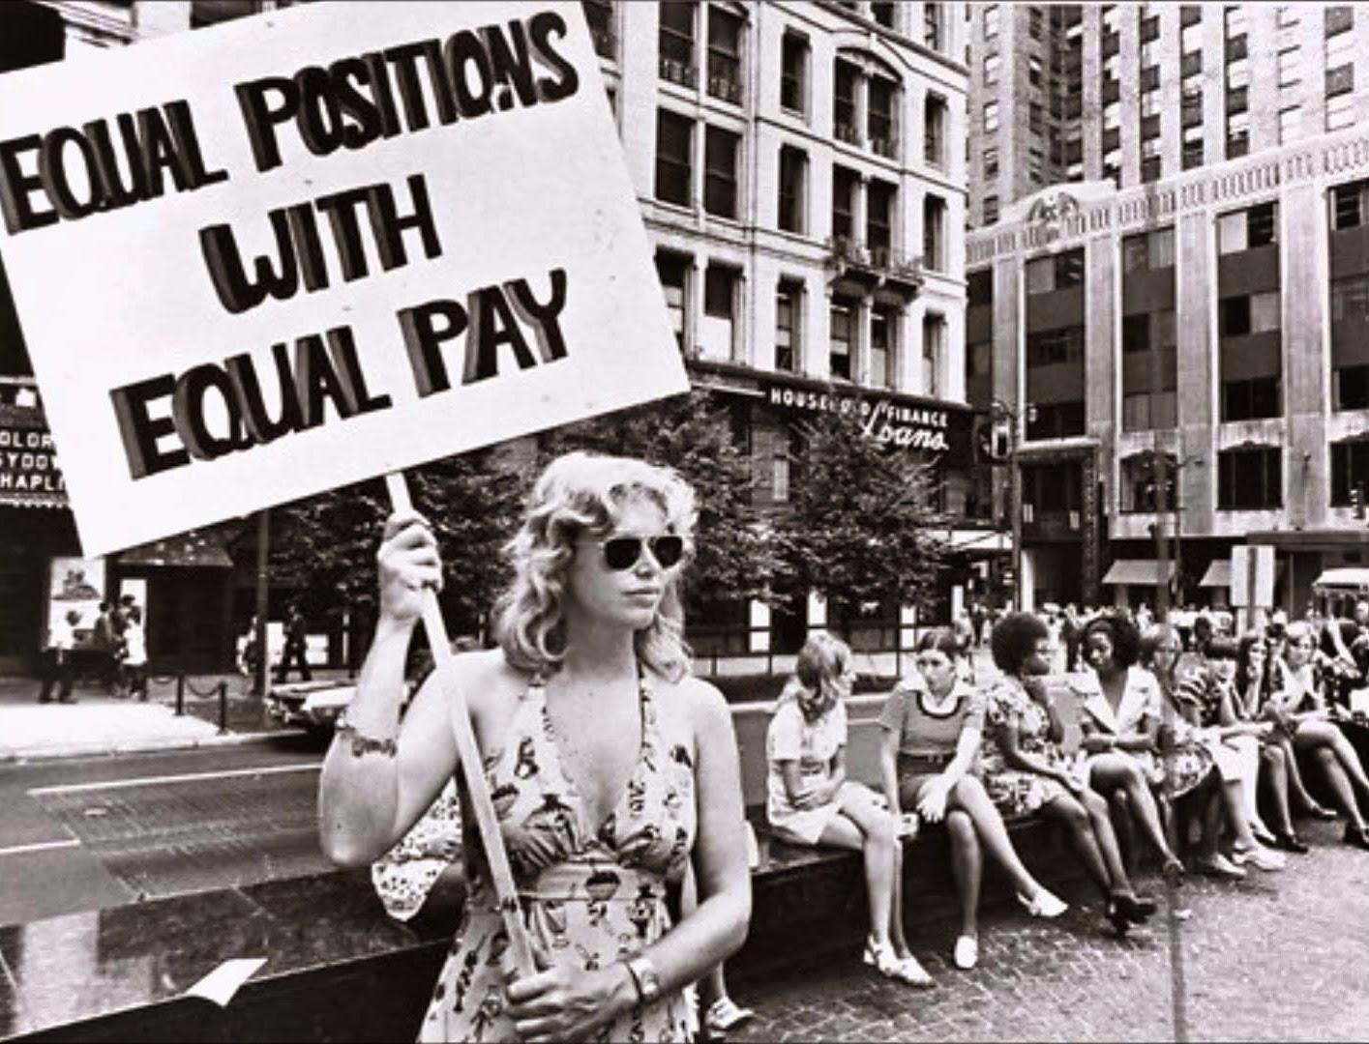

(https://www.sutori.com/story/a-history-of-radical-feminism--Pf5HsUfrBG26boQJdwtLbWUS)

The 1960’s and 1970’s brought the Feminist Movement. Similar to other trends in history, such as women in the 1920’s fighting for voting rights and black women in the Civil Rights Era fighting for equality, women in the 60’s and 70’s were also fighting for rights. They wanted to do other things than just take care of their families. Many working class women joined unions, asking for higher pay, equal pay in similar jobs, increased safety, and shorter hours. (Feminism and Women’s Movements, March 27, 2019). This idea is shown in the picture above. This women is protesting to show people that her pay isn’t equal to people (specifically men) with equal positions. This is her way of asking for change. It shows that work is important, as it is an activity other than caring for her children and cleaning. Women often viewed themselves as having a double day – working a day job and then going home to take care of the family and the house. During this time, NOW, or National Organization for Women, formed, which focused their views on employment. This organization helped them take a stand and make change. (Feminism and Women’s Movements, March 27, 2019).
Betty Friedan is considered to be the mother of the feminist movement. She wrote The Feminist Mystique, who’s theme was, “the discontent of middle class women” (Friedan, The Feminist Mystique, 1963). Friedan says, “If I am right, the problem that has no name stirring in the minds of so many American women today is not a matter of loss of femininity or too much education or the demands of domesticity…We can no longer ignore that voice within women that says, ‘I want something more than my husband and my children and my home.’” (Friedan, The Feminist Mystique, 1963). Women have been silent about their feelings for a long time; they have been holding them inside because that’s what women have done for ages. Friedan is saying that it is time for women to speak out and say what’s on their minds.
One of the ways in which women were speaking out and doing things that they were interested in was shown in She’s Beautiful When She’s Angry. The movie shows that one of the aspirations of women is to learn more about their bodies. To achieve this goal, the women started classes to inform themselves and other women about their bodies. (She’s Beautiful When She’s Angry). This shows the fact when feminists are unhappy with certain situations in their life, they have the initiative to make a change that benefits not only themselves, but all women.

