Wilck’s Lake Park  - Wilck’s Lake park has 150-acre natural area which includes a 55-acre lake.  - It has a two-mile hiking/walking trail that goes around the lake.  - It provides opportunities for bird and wildlife watching.  - There is an observation platform overlooking the marsh section of the park.  - The lake is stocked and managed by the Virginia Department of Game and Inland Fisheries.  - Amenities that Wilck’s has is a playground, a skate park, picnic shelters, and restroom facilities  Wilck's Lake Isle, Farmville, VA 23901  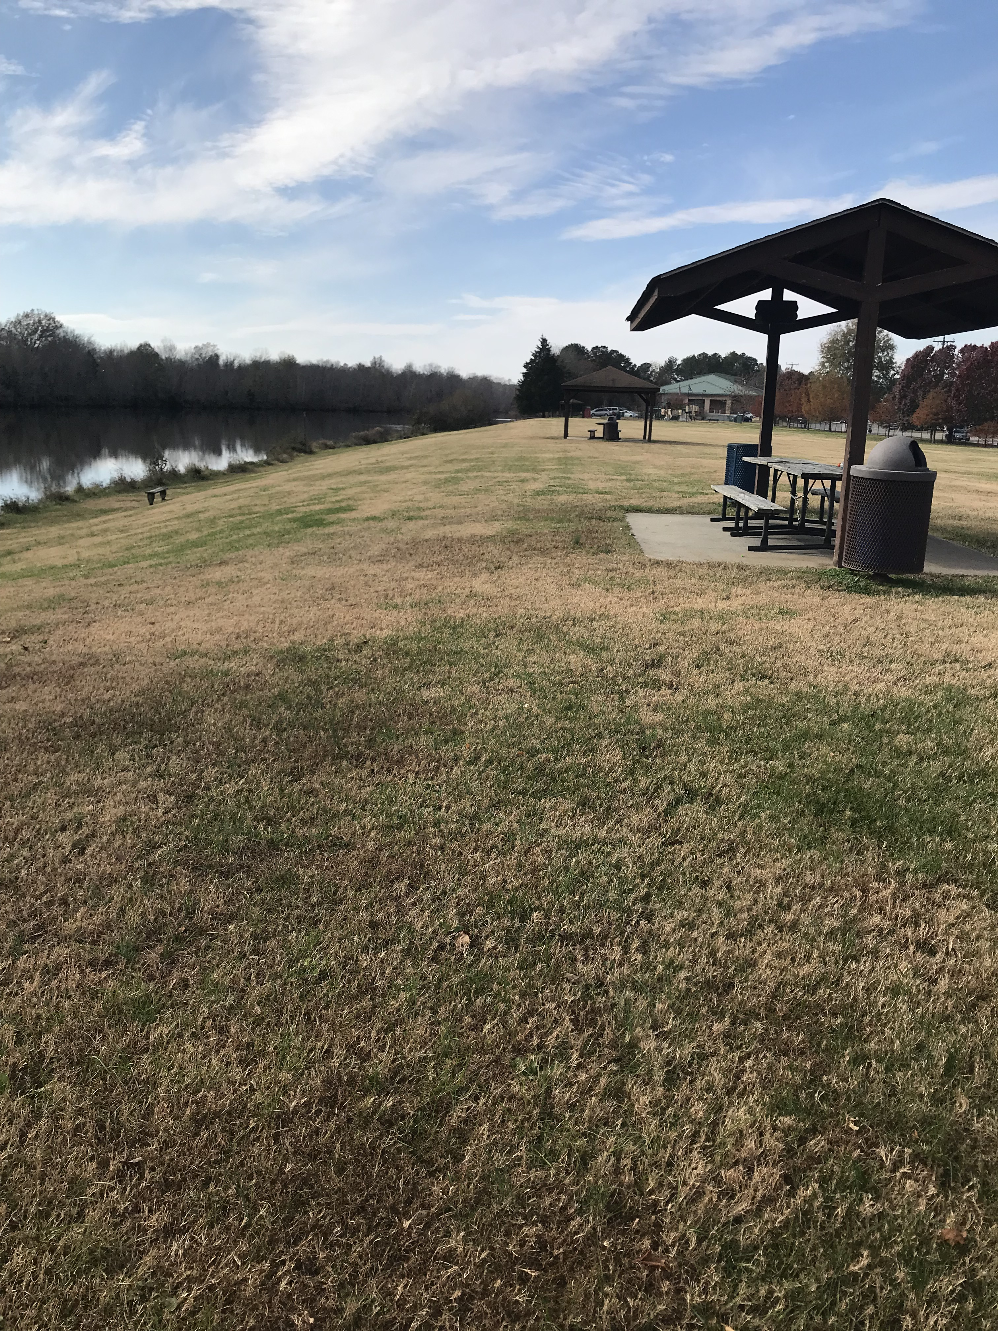 | Resources  CAPS – Longwood University  434-395-2409. This service is free to students attending Longwood.  Crossroads Community Service Board  24-hour Hotline: 1-866-307-0370. Costs vary. Sliding scale options are available  Hope for Tomorrow Counseling  434-392-4073. Costs vary.  Further Resources  Department of Game and Inland Fisheries. (n.d.). Wilck's Lake. Retrieved from https://www.dgif.virginia.gov/vbwt/sites/wilcks-lake/  High Bridge Trail State Park . (2018). Retrieved from Farmville Virginia : https://farmvilleva.com/community/tourism/high-bridge/  Virginia Department of Conservation and Recreation. (2018, October 11). Twin Lakes State Park. Retrieved from http://www.dcr.virginia.gov/state-parks/twin-lakes#other_info | Breaking the Stigma:  A guide to outdoor resources in FArmville to help alleviate mental health symptoms  - Shawna McCann, Amanda Phillips and Haley Tucker
Getting Outdoors  How does it affect Mental Illness?  Studies have shown that going outside and being in nature can significantly decrease levels of thinking of yourself in a negative light. Going outdoors can help someone suffering with anxiety and depression.  About Us  Haley Tucker is a senior at Longwood University. She is currently majoring in Psychology, which is one of the reasons why she is passionate about ending the stigma around mental health.  Shawna McCann is a senior Social Work major at Longwood University. In the future she wants to work with children who have experienced abuse and neglect.  Amanda Phillips is a senior Social Work major at Longwood University. In her free time, Amanda enjoys reading, spending time in nature, being around loved ones and traveling.  Connect with us!  https://shawnamccann.wixsite.com/breakingthestigma | High Bridge State Park  - High Bridge offers walking trails as well as bike and horse trails.  - The trails are pet friendly.  - The entirety of the High Bridge trail is 31 miles.  - There is a lot of Civil War history associated with the High Bridge.  - The battle of High Bridge took place April 6th, 1865  - It has been highlighted in the National Recreation Trail in 2013  - The High Bridge Trail is also a historic landmark.  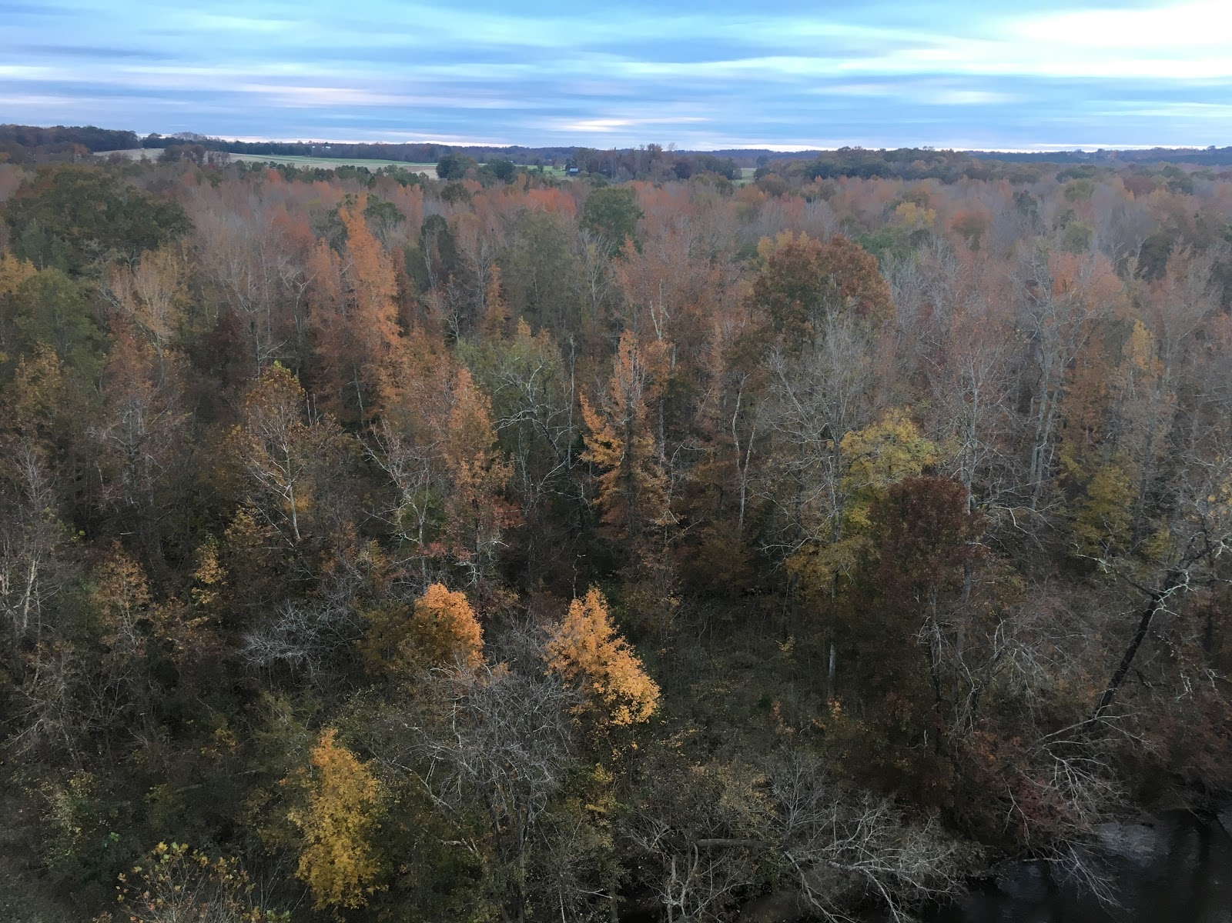  Location: 1466 Camp Paradise Road Rice, Virginia 23966 | 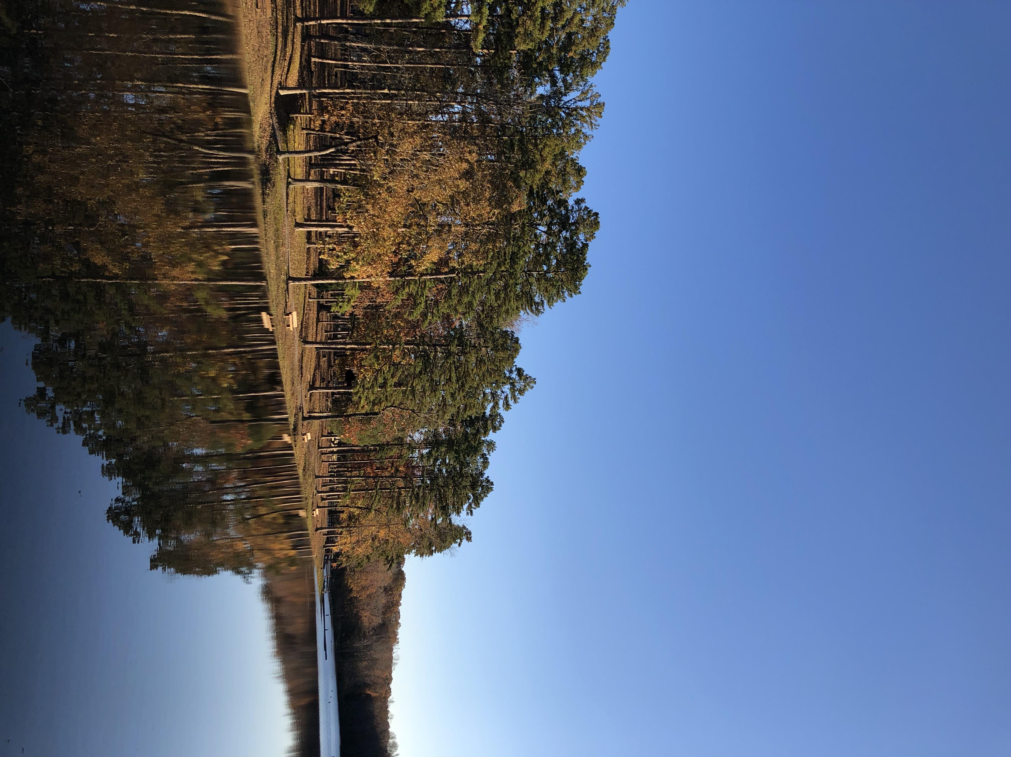  Twin Lakes State Park  - Featured trails in Twin Lakes are Goodwin Lake Trail and Otter’s Path Trail  - Other trails at the state park include Between the Lakes, Beaver Point, Dogwood Hollow, Otter’s Path Connector, and Prince Edward Gallion Multiuse.  - The entirety of the Twin Lakes trails is 14.25 miles.  - There is boat accessibility and has a dock for fishing.  - There is a beach and picnic area with a grill for relaxing and family fun.  - The Nature Nook educates people about wildlife in the area.  - They also have a snack bar, The Spot, which features hand-dipped ice cream.  Location: 788 Twin Lakes Rd., Green Bay, VA

